Abbreviations..............................................................................................................................v
1. Introduction 1
1.1. Transporters 1
1.2. Solute carrier (SLC) families of transporters 2
1.2.1. Sodium/glucose cotransporter family (SLC5) 3
1.2.2. Sodium/glucose cotransporter protein (SGLT1) 8
1.3. Pichia pastoris as an expression host 10
1.4. Photoaffinity labeling 11
2. Aim of the study 13
3. Materials and methods 14
3.1. General equipments 14
3.2. Materials 15
3.2.1. Chemicals 15
3.2.2. Enzymes and reagents for molecular biology 16
3.2.3. Antibodies 16
3.2.4. Commercial Kits and other materials 16
3.2.5. Primers for preparation of cDNA inserts 17
3.2.6. Plasmids 17
3.2.6.1. Original plasmids 17
3.2.6.2. Plasmid with insert 18
3.3. Work with E.coli 19
3.3.1. E.coli strains 19
3.3.2. Media for bacterial culture 19
3.3.3. General 20
3.3.4. Transformation of plasmid in E.coli 20
3.3.4.1. Preparation of competent cells by CaCl₂ method 20
3.3.4.2. Heat shock transformation of the plasmid 20
3.4. Work with P. pastoris 20
3.4.1. P. pastoris strains 20
3.4.2. Media for P. pastoris culture 21
3.4.3. General 21
3.4.4. Electroporation of P. pastoris with plasmid pPICZB or pPICZB-hSGLT1 22
3.5. Recombinant DNA processing and manipulation 22
3.5.1. Buffers and solutions 22
3.5.2. Restriction endonuclease digestion of DNA 23
3.5.3. Purification of the digested DNA 23
3.5.4. Ethanol precipitation of DNA 23
3.5.5. Dephosphorylation of linearized plasmid DNA by CIP 23
3.5.6. Ligation of DNA fragments 24
3.5.7. Miniprep: small-scale preparation of plasmid DNA 24
3.5.8. Large scale preparation of plasmid DNA 24
3.5.9. Qunatification of DNA and RNA solutions 25
3.5.10. Agrose gel electrophoresis 25
3.5.11. DNA recovery from agarose gel 26
3.5.12. DNA sequencing 26
3.5.13. DNA amplification of hSGLT1 gene by PCR for cloning into different expression systems 26
3.5.14. Addition or deletion mutagenesis in hSGLT1 gene 27
3.5.14.1. Addition of 30 base pairs long spacer at the C-terminal of hSGLT1 gene 29
3.5.14.2. Addition of FLAG tag in hSGLT-spacer gene 29
3.5.14.3. Deletion of N-terminal half of hSGLT1 gene 29
3.5.15. Addition of Unc-F gene at the N-terminal of hSGLT1 gene 30
3.6. Protein expression and analysis 30
3.6.1. Growth conditions of E.coli for hSGLT1 expression 30
3.6.2. Growth condition of P. pastoris for hSGLT1 expression 31
3.6.3. hSGLT1 purification from P. pastoris 31
3.7. Protein analysis 32
3.7.1. Buffers and solutions 32
3.7.2. Measurement of protein concentration 33
3.7.2.1. Enhanced alkaline copper (Lowry) protein assay 33
3.7.3. SDS-PAGE 33
3.7.4. Coomasie staining of the polyacrylamide gels 34
3.7.5. Western blot analysis 34
3.8. Functional analysis of recombinant hSGLT1 35
3.8.1. Membrane preparations for transport studies 35
3.8.2. Reconstitution of recombinant hSGLT1 36
3.8.3. Transport assay of hSGLT1 in membranes and in proteoliposomes 36
3.9. Chemical synthesis of photoaffinity probes 37
3.9.1. [(2’-Iodo-4’-(3’’-trifluoromethyldiazirinyl) phenoxy]-D-glucopyranoside (TIPDG) 37
3.9.1.1. 4-Methoxytrifluoroacetophenone (1) 37
3.9.1.2. 3-Iodo-4-methoxytrifluoroacetophenone (2) 37
3.9.1.3. 4-Hydroxy-3-iodo-trifluoroacetophenone (3) 37
3.9.1.4. [(2´-Iodo-4´-trifluoroacetyl) phenoxy]-2,3,4,6-tetra-O-acetyl-D- glucopyranoside (5) 37
3.9.1.5. [(2´-Iodo-4´-trifluoroacetyloxime) phenoxy]-2,3,4,6-tetra-O-acetyl-D- glucopyranoside (6) 38
3.9.1.6. [(2´-Iodo-4´-(3´´-trifluoromethyldiaziridinyl) phenoxy]-2,3,4,6-tetra-O-acetyl-D- glucopyranoside (7) 38
3.9.1.7. [(2´-Iodo-4´-(3´´-trifluoromethyldiazirinyl) phenoxy]-2,3,4,6-tetra-O-acetyl-D- glucopyranoside (8) 39
3.9.1.8. [(2´-Iodo-4´-(3´´-trifluoromethyldiazirinyl) phenoxy]-D-glucopyranoside (9) 40
3.9.2. [(4´-Benzoyl) phenoxy]-D- glucopyranoside (BzG) 40
3.9.2.1. [4´-Benzoyl) phenoxy] –2,3,4,6-tetra-O-acetyl-D- glucopyranoside (11) 40
3.9.2.2. [(4´-Benzoyl) phenoxy]-D- glucopyranoside (12) 40
3.9.3. 3-Azidophlorizin (3-AP) 41
3.9.3.1. 3-Nitrophlorizin (14) 41
3.9.3.2. 3-Aminophorizin (15) 41
3.9.3.3. 3-Azidophlorizin (16) 42
3.9.4. n-Methyl-6C- (Azimethyl)-D- glucopyranoside (6-AG) 42
3.9.4.1. Methyl-2,3,4-tri-O-benzyl-7-deoxy-DL-glycero-D-glucohepta-1,5- pyranoside (18) 42
3.9.4.2. Methyl-2,3,4-tri-O-benzyl-7-deoxy-D-glucohepto-1,5-pyranoside-6-ulose (19) 43
3.9.4.3. Methyl- 7- deoxy-D-glucohepta- 1, 5- pyranoside-6- ulose (20) 43
3.9.4.4. n-Methyl-6C-(Azimethyl)-D-glucopyranoside (22) 44
3.10. Photoaffinity labeling of loop 13 45
3.10.1. Isolation of small intestine brush border membrane vesicles (BBMV) 45
3.10.2. Transport measurements 45
3.10.3. Photoaffinity labeling of truncated loop 13 protein with TIPDG or BzG 45
3.10.4. Photoaffinity labeling of truncated loop 13 protein with 3-AP 46
4. Results 48
4.1. E.coli as an expression host 48
4.1.1. Construction of different clones of hSGLT1 in pET22b vector 48
4.1.2. Construction of pET22b-Unc-F and pET22b-Unc-F-hSGLT1 clones 49
4.1.3. hSGLT1 expression in E.coli 50
4.1.4. β-subunit of E.coli ATPase expression in pET22b-Unc-F and pET22b-Unc-F-hSGLT1 plasmids 51
4.1.5. Messenger RNA stability of hSGLT1 in E.coli 52
4.2. Pichia pastoris as an expression host 54
4.2.1. Construction of expression plasmid pPICZB-hSGLT1 54
4.2.2. Identification of positive clones of hSGLT1 showing protein expression 55
4.2.3. Optimization of feeding and induction in the shake flask cultures 55
4.2.4. Purification of hSGLT1 from Pichia pastoris 56
4.2.5. Functional analysis of recombinant hSGLT1 in right-side-out membrane vesicles 57
4.2.6. Functional analysis of recombinant hSGLT1 in prteoliposomes 58
4.3. Synthesis and Characterization of different photoaffinity probes 63
4.3.1. Synthesis of labels BzG and 3-AP for the identification of phlorizin interaction sites 63
4.3.2. Synthesis of label TIPDG for the identification of arbutin ineraction sites 64
4.3.3. Synthesis of label 6-AG for the identification of D-glucose interaction sites 64
4.3.4. Photochemical properties and stability of TIPDG, BzG, 3-AP and 6-AG 65
4.3.5. Inhibition of glucose uptake in rabbit small intestine BBMV by BzG and 3-AP 66
4.3.6. Inhibition of glucose uptake in rabbit small intestine BBMV by TIPDG 67
4.3.7. Inhibition of glucose uptake in rabbit small intestine BBMV by 6-AG 68
4.4. Photoaffinity labeling of truncated loop 13 with TIPDG, BzG, and 3-AP 70
4.4.1. Photoaffinity labeling of truncated loop 13 with TIPDG and BzG 70
4.4.2. Photoaffinity labeling of truncated loop 13 with 3- Azidophlorizin 71
4.4.3. Identification of the ligand contact points 72
5. Discussion 74
5.1. E. coli as an expression host 75
5.1.1. Probable reasons for not getting hSGLT1 expression in E. coli 75
5.1.1.1. Codon usage 75
5.1.1.2. Signal sequences 76
5.1.1.3. Degradation of hSGLT1 mRNA in E.coli 76
5.1.1.4. Comparison to other attempts to express hSGLT1 in E. coli 78
5.2. P. pastoris as an expression host 80
5.2.1. Expression of hSGLT1 in P. pastoris 80
5.2.2. Protein purification 81
5.2.3. Reconstitution and functional analysis of recombinant hSGLT1 82
5.2.4. Reasons for getting functional expression of hSGLT1 in P. pastoris 82
5.2.5. Advantages of our expression method 83
5.3. Photoaffinity labeling of truncated loop 13 84
5.4. Future prospective 87
6. Summary 89
7. Zusammenfassung 91
8. Reference list 93
Erklärung
Acknowledgements
Curriculum Vitae
Abbreviations

aa Amino Acids
Ac Acetate
6-AG n-Methyl-6C- (azimethyl)-D- glucopyranoside
Amp Ampicillin
3-AP 3- Azidophlorizin
Arg Arginine
ATP (ADP, AMP) Adenosine-5´-tri (Di, Mono-) Phosphate
BBMV Brush border membrane vesicles
bp Base Pair
BSA Bovine Serum Albumin
BzG [(4´-Benzoyl)phenoxy]-D- glucopyranoside
cDNA Complimentary DNA
CIAP Calf Intestine Alkaline Phosphatase
DMSO Dimethylsulphoxide
DNA Deoxyribonucleic acid
dNTP Deoxy-Nucleotriphosphate
DTT Dithiothreitol
EDTA Ethylenediaminetetraacetate
EST Expressed Sequence Tag
EtBr Ethidium bromide
g Gram
h Hours
hSGLT1 Human sodium/D- glucose cotransporter 1
IPTG Isopropyl-β-D-Thioglucoside
K_{i} Inhibition constant
M Molar
MALDI-TOF Matrix-assisted laser desorption ionization –time of flight
MCS Multiple Cloning Site
Min Minute
ml Milliliter
mM Milli Molar
NC Nitro Cellulose membrane
OD Optical Density
PAGE Polyacrylamide Gel Electrophoresis
PCR Polymerase Chain Reaction
RNA Ribonucleic acid
RT Room Temperature
SDS Sodium Dodecylsulphate
TCA Trichloroacetic acid
TEMED N, N, N´, N´ Tetramethylethylenediamine
TIPDG [(2’-Iodo-4’-(3’’-trifluoromethyldiazirinyl)phenoxy]-D-
glucopyranoside
TMH Trans Membrane Helices
Tris Tris (hydroxymethy) amino methane
Trp Tryptophan
U Unit
UV Ultraviolet

Introduction

Transporters
Transporters are the gatekeepers for all cells and organelles, facilitating influx and efflux of crucial compounds such as sugars, amino acids, nucleotides, inorganic ions and drugs. Transporters can be divided into passive and active transporters (Figure 1.1). Passive transporters, allow passage of solutes (e.g., glucose, amino acid, urea) across membranes down their electrochemical gradients. Active transporters create ion/solute gradients across membranes, utilizing diverse energy-coupling mechanisms. These active transporters are classified as primary- or secondary-active transporters according to the directness of coupling to cellular energy (e.g., ATP hydrolysis, or ion gradients).

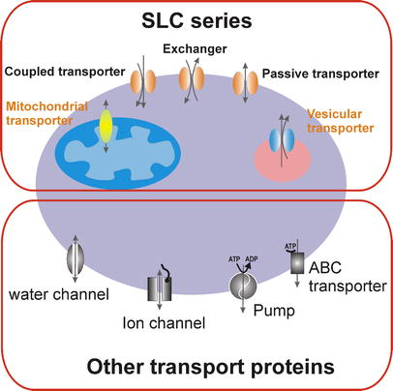
Figure 1.1 Cartoon showing a cell with different transporters. Solute carrier (SLC)- and non-SLC transporters expressed in the plasma membrane or in intracellular compartment membranes are shown.
Primary-active, ATP-dependent transporters include members of the ATP-binding cassette (ABC) transporter family and ion pumps (ATPases). Mammalian ABC transporters [e.g., P-glycoprotein/multi-drug resistance (MDR) proteins and transporter associated with antigen processing (TAP)] bind or hydrolyze ATP as a control gate for the transport of a variety of substances such as ions, carbohydrates, lipids, xenobiotics and drugs, out of cells or into organelles (Borst and Elferink, 2002). Ion pumps hydrolyze ATP to pump ions such as Na⁺, K⁺, H⁺, Ca²⁺ and Cu²⁺ out of cells or into organelles, for review see (Dunbar and Caplan, 2000; Muller and Gruber, 2003). These pumps also generate and maintain electrochemical ion gradients across membrane, and are thus called active transporters. Such ion gradients are used in turn by secondary-active, ion-coupled transporters to drive uphill transport of nutrients across biological membranes.
Similar to transporter, channels allow movement of solute down their electrochemical gradients, for review see (Armstrong, 2003; Chen, 2003; Decoursey, 2003; Jiang et al., 2003; Yu and Catterall, 2003). Transporters typically have a fixed stoichiometry of ion/solute movement per translocation cycle. Ion or solute flow through channels, on the other hand, is controlled by open probability of the channel via gating mechanisms.

Solute carrier (SLC) families of transporters
The solute carrier (SLC) series includes genes encoding passive transporters, ion compled transporters and exchangers (Hediger et al., 2004; Wright and Turk, 2004). A transporter has been assigned to a specific SLC family if it has at least 20-25% amino acid sequence identity to other members of that family (Turk and Wright, 1997). The list of currently approved SLC human gene symbols is shown in Table 1.1. The table comprises 43 different SLC transporter families of the SLC series and the number of members in each family.

Table 1.1 List of currently approved solute carrier (SLC) families.
 | The HUGO SLC Family Series | Total
SLC1  SLC2 | The high-affinity glutamate and neutral amino acid transporter family | 7
SLC1  SLC2 | The facilitative GLUT transporter family | 14
SLC3 | The heavy subunits of the heteromeric amino acid transporters | 2
SLC4 | The bicarbonate transporter family | 10
SLC5 | The Na⁺/glucose cotransporter family | 8
SLC6 | The sodium- and chloride-dependent neurotransmitter transporter family | 16
SLC7 | The cationic amino acid transporter/glycoprotein-associated amino-acid transporter family | 14
SLC8 | The Na⁺/Ca²⁺ exchanger family | 3
SLC9 | The Na⁺/H⁺ exchanger family | 8
SLC10 | The sodium bile salt cotransport family | 6
SLC11 | The proton-coupled metal ion transporter family | 2
SLC12 | The electroneutral cation-Cl cotransporter family | 9
SLC13 | The human Na⁺-sulfate/carboxylate cotransporter family | 5
SLC14 | The urea transporter family | 2
SLC15 | The proton oligopeptide cotransporter family | 4
SLC16 | The monocarboxylate transporter family | 14
SLC17 | The vesicular glutamate transporter family | 8
SLC18 | The vesicular amine transporter family | 3
SLC19 | The folate/thiamine transporter family | 3
SLC20  SLC21/SLCO | The type-III Na⁺-phosphate cotransporter family | 2
SLC20  SLC21/SLCO | The organic anion transporting family | 11
SLC22 | The organic cation/anion/zwitterion transporter family | 18
SLC23 | The Na⁺-dependent ascorbic acid transporter family | 4
SLC24 | The Na⁺/(Ca²⁺-K⁺) exchanger family | 5
SLC25 | The mitochondrial carrier family | 27
SLC26 | The multifunctional anion exchanger family | 10
SLC27 | The fatty acid transport protein family | 6
SLC28 | The Na⁺-coupled nucleoside transport family | 3
SLC29 | The facilitative nucleoside transporter family | 4
SLC30 | The zinc efflux family | 9
SLC31 | The copper transporter family | 2
SLC32 | The vesicular inhibitory amino acid transporter family | 1
SLC33 | The acetyl-CoA transporter family | 1
SLC34 | The type-II Na⁺-phosphate cotransporter family | 3
SLC35 | The nucleoside-sugar transporter family | 17
SLC36 | The proton-coupled amino acid transporter family | 4
SLC37 | The sugar-phosphate/phosphate exchanger family | 4
SLC38 | The System A and N, sodium-coupled neutral amino acid transporter family | 6
SLC39 | The metal ion transporter family | 14
SLC40 | The basolateral iron transporter family | 1
SLC41 | The MgtE-like magnesium transporter family | 3
SLC42 | The Rh ammonium transporter family (pending) | 3
SLC 43 | The Na⁺-independent, system-L-like amino acid transporter family | 2
Total |  | 298

In general the genes are named using the root symbol SLC, followed by a numeral (e.g., SLC1, solute carrier family 1), the letter A (which act as a divider between the numerals) and finally the number of the individual transporter (e.g., SLC5A1, sodium/glucose cotransporter protein). These general rules of SLC gene nomenclature have been elaborated further for a couple of families. In the nucleotide-sugar transporter family SLC35, the letter between SLC35 and family member number has been exploited to specify specific subfamilies, called A, B, C, D and E (Ishida and Kawakita, 2004). In another family, originally named SLC21, encoding the organic anion-transporting (OATP) proteins, the “21” and the “A” have been replaced by the letter “O”, which stands for organic transporter. This modification has occurred to accommodate a unique, species-independent classification and naming system that has been introduced, because this family has been the subject of rapid evolution, giving rise to new isoforms within a given species (Hagenbuch and Meier, 2004).

Sodium/glucose cotransporter family (SLC5)
The sodium/glucose cotransporter family (SLC5) has 220 members in animal and bacterial cells (Wright and Turk, 2004). An unrooted phylogenetic tree of 11 human members of the SLC5 family of cotransporters and two other vertebrate members of known function is shown in Figure 1.2. The 11 human genes (Table 1.2) are expressed in tissues such as the small intestine, kidney, brain, muscle, and thyroid gland. Despite the homology among the proteins (21-70% amino acid identity to SGLT1) there is diversity in gene structure: in eight of ten genes mapped the coding sequences are found in 14-15 exons (SGLT1-6, NIS, and the Na⁺-dependent multivitamin transporter SMVT) (Turk et al., 1994; Wang et al., 1999). On the other hand the coding sequences for the choline transporter (CHT) and SMIT are contained in eight and one exons respectively (Mallee et al., 1997; Okuda et al., 2000). In SGLT4-6 and SMIT there is evidence for alternative splicing (Roll et al., 2002).

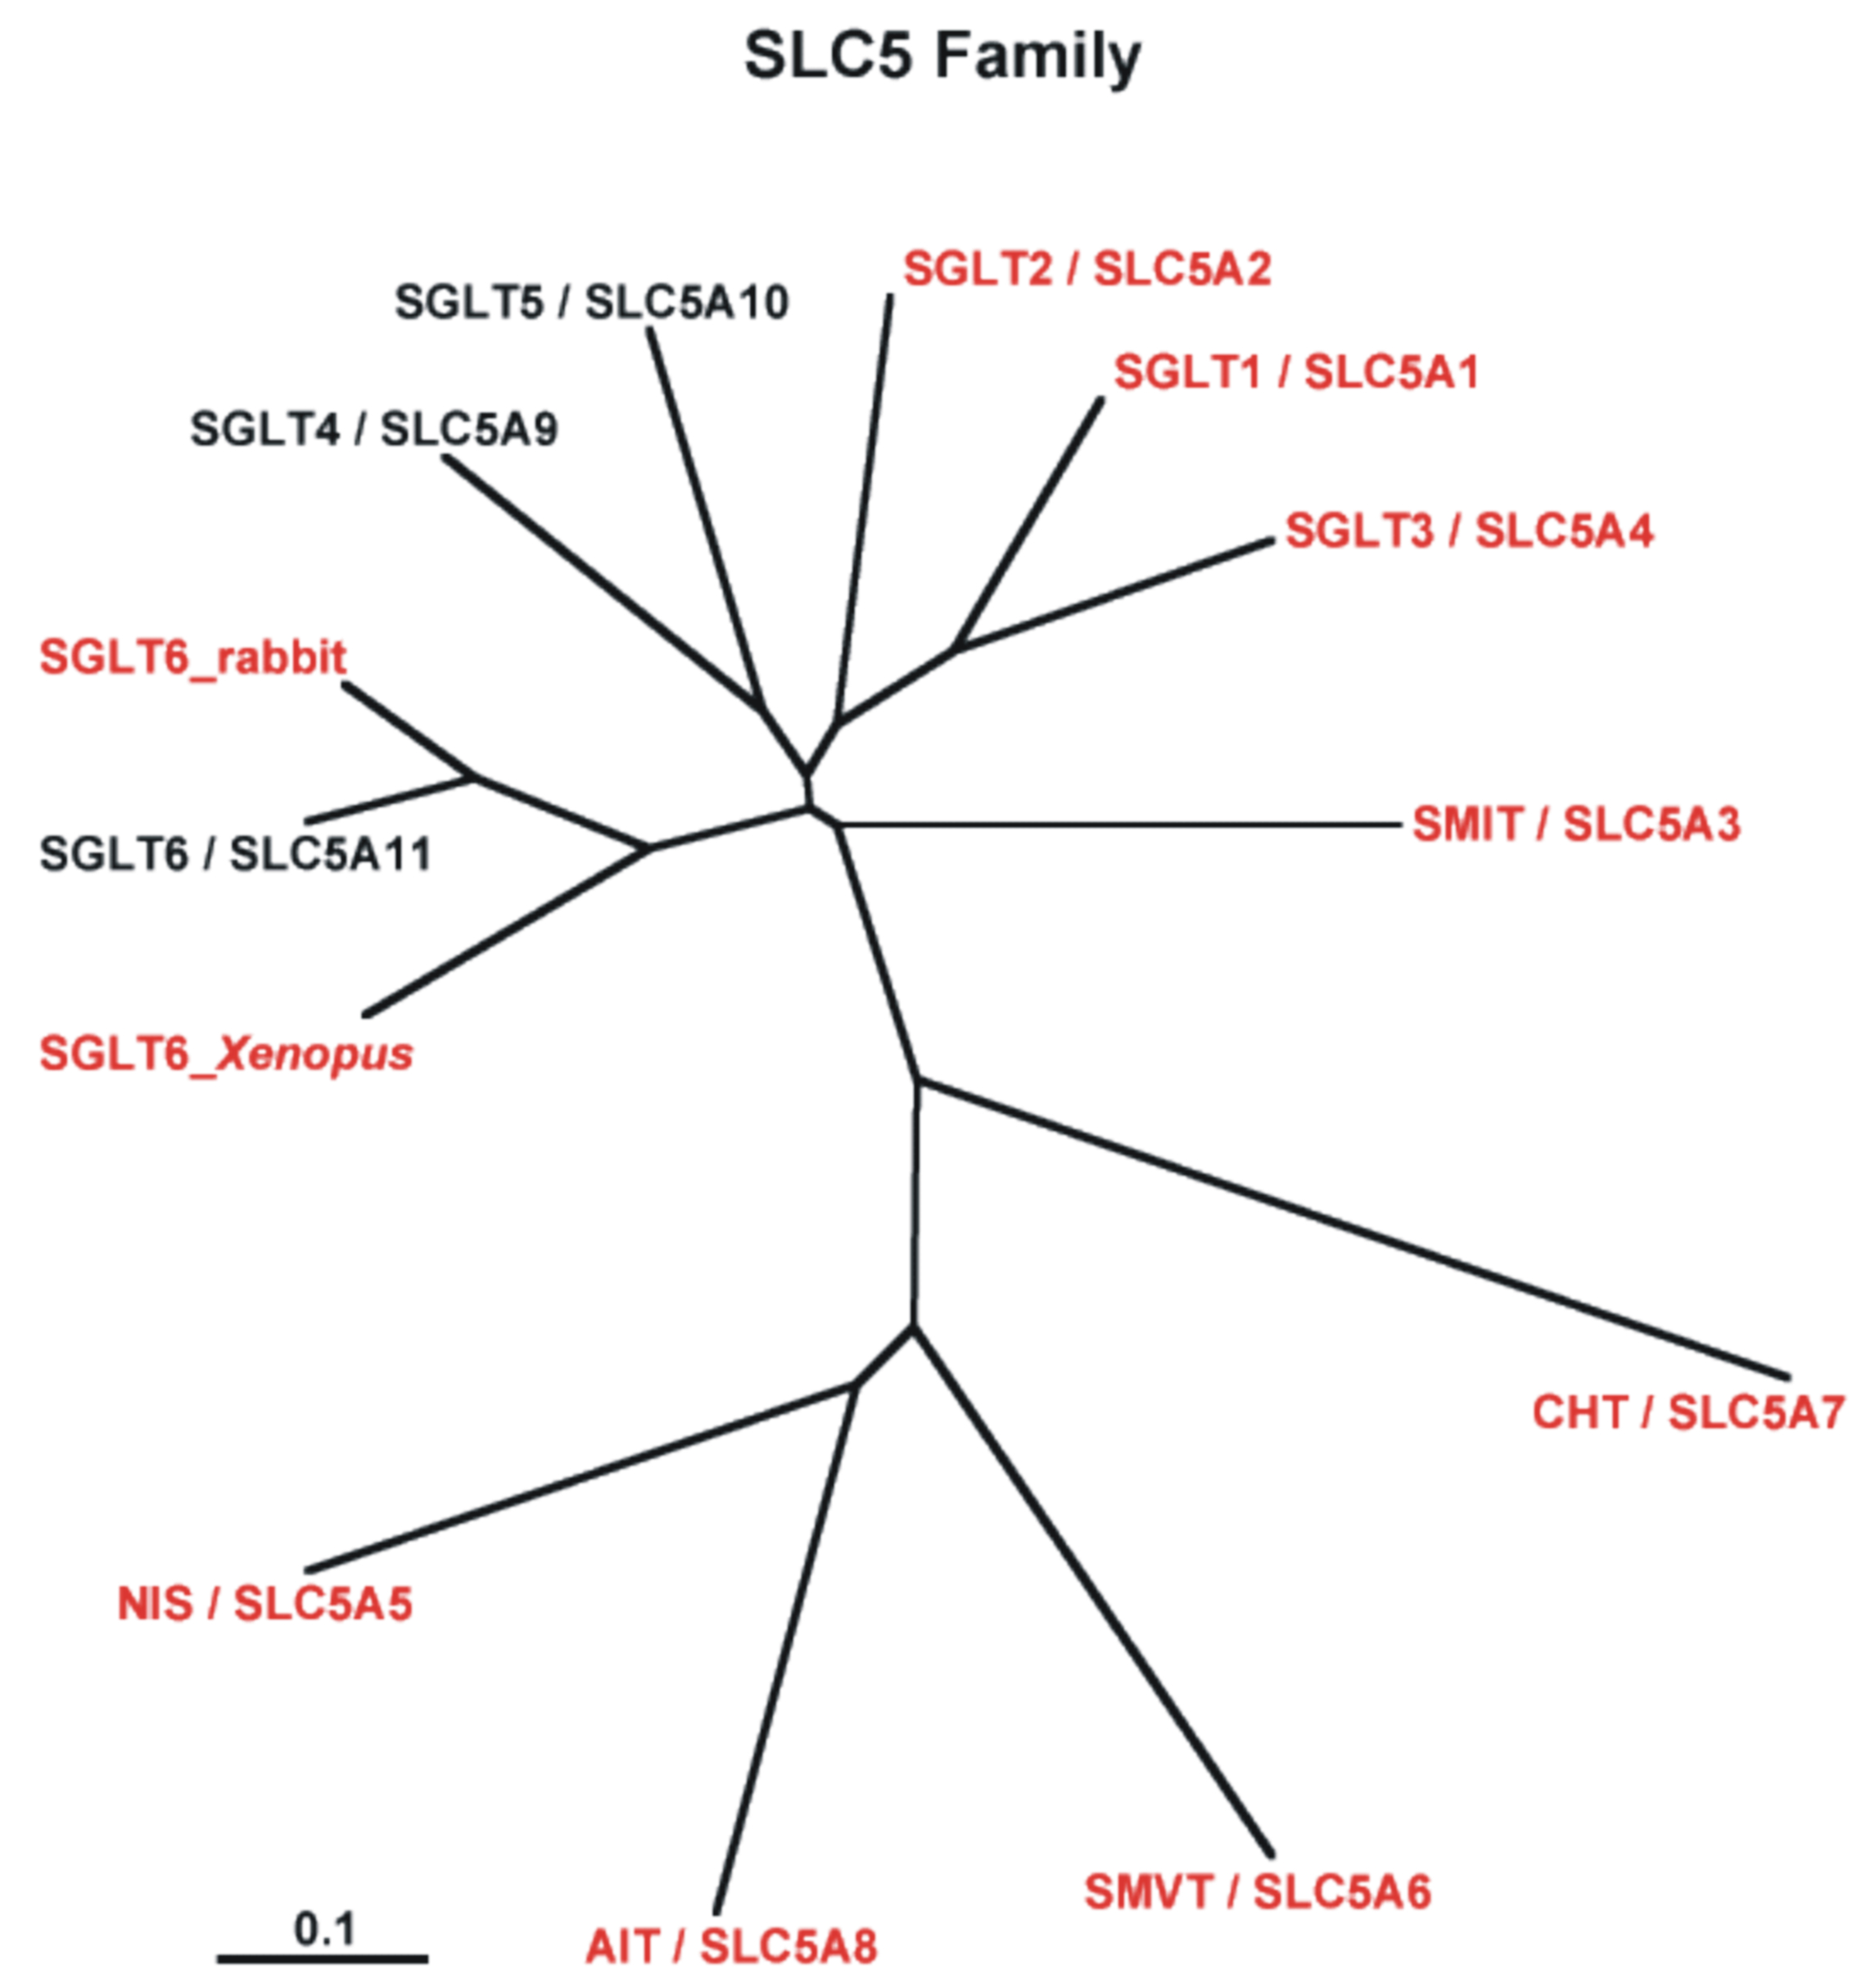
Figure 1.2 Unrooted phylogenetic tree of the 11 human members of the SLC5 family of cotransporters and two other vertebrate members of known function. Members for which transport functions have been demonstrated experimentally are shown in red. Members shown in black have yet to have their function determined. In a pairwise basic local alignment search tool (BLAST) analysis the amino acid identities relative to SGLT1 were 59% SGLT2, 70% SGLT3, 56% SGLT4, 57% SGLT5, 50% SGLT6, 55% SMIT, 24% SMVT, 24% CHT, and 21% NIS (SGLT Na⁺/glucose transporter, SMIT Na⁺/myo-inositol transporter, SMVT Na⁺/multivitamin transporter, CHT choline transporter, AIT apical iodide transporter, NIS Na⁺/iodide transporter).
Table 1.2 The SLC5 sodium/glucose cotransporter family (OMIM Online Mendelian Inheritance in Man Database, TMH transmembrane helix, aa amino acids).
Human gene name | Protein name | Aliases | Predominant substrates | Transport type/coupling ion* | Tissues distribution and cellular/subcellular expression^{T} | Link to disease | Human gene locu | Sequence Accession ID | Splice variants and their specific features^{S}
SLC5A1 | SGLT1 | None | Glucose and galactose (urea and water) | C/Na⁺ (H⁺) F/Na⁺ (H⁺). Channel: urea and water | Small intestine>>trachea, kidney and heart; plasma membranes | Glucose galactose malabsorption^{G} OMIM 182380 | 22q13.1 | NM_000343
SLC5A2 | SGLT2 | None | Glucose | C/Na⁺ | Kidney cortex | Familial renal glycosuria^{G} OMIM 182381 | 16p12-p11 | NM_003041
SLC5A3 | SMIT | None | myo-inositol (glucose) | C/Na⁺ | Brain, heart, kidney and lung; plasma membranes | Down’s syndrome? OMIM 600444 | 21q22.12 | NM_006933
SLC5A4 | SGLT3 | SAAT1 | Na⁺ (H⁺) | Glucose activated Na⁺ (H⁺) channel | Small intestine (cholinergic neurons), skeletal muscle, kidney, uterus and testis; plasma membranes |  | 22q12.2-q12.3 | NM_14227
SLC5A5 | NIS |  | I– (ClO₄ –, SCN–, NO₃ –, Br–) | C/Na⁺ Uniporter Na⁺ channel Urea water | Thyroid, breast, colon and ovary; plasma membranes | Thyroid hormonogenesis^{G} OMIM 601843 | 19p13.2-p12 | NM_ 000453
SLC5A6 | SMVT |  | Biotin, lipoate and pantothenate | C/Na⁺ | Brain, heart, kidney, lung and placenta; plasma membranes |  | 2p23 | NM _021095
SLC5A7 | CHT | CHT1 | Choline | C/Na⁺/Cl– | Spinal cord and medulla (intracellular vesicles) |  | 2q12 | NM _021815
SLC5A8** | SGLT4 |  |  |  | Small intestine, kidney, liver, lung and brain |  | 1p32 | HCT1951464 | Internal splice in Exon 14 adds either 38 or 53 aa between TMHs13-14
SLC5A9 | SGLT5 | Rabbit RK-D |  |  | Kidney |  | 17p11.2 | XM_064487 | Exon 7 may be spliced out deleting 26 aa between TMHs 5–6; internal splice in exon 10 means either 36 or 52 aa between TMHs 8–9; and an internal splice in exon 12 adds either 12 or 37 aa between TMHs 11–12
SLC5A10 | SGLT6 | KST1 Rabbit ST1 Rabbit SMIT2 | Rabbit ortholog: myo-inositol, chiro-inositol, glucose and xylose. Xenopus laevis ortholog: myo-inositol and glucose | C/Na⁺ | Small intestine, brain, kidney, liver, heart, and lung |  | 16p12.1 | NM_052944 | Splicing eliminates exon 6 and TMH 4
SLC5A11 | AIT |  | Iodide |  | Thyroid; apical plasma membrane |  | 12q23.1 | NM_145913
*C cotransporter; F uniporter. Function based on results obtained with heterologous expression systems
** Provisional SGLT4 exons identified by mining the Celera databases
^{T} Tissue distribution of SGLT1-6 was determined RNAase protection assays using gene specific probes. Also includes data from the original cloning papers and GeneCard (EST, and/or DNA array)
^{G} Gene defect
^{S} Potential alternative splice sites
Note: single nucleotide polymorphisms (SNPs) and variants in the NCBI SNP database are not included.

Sodium/glucose cotransporter protein (SGLT1)
SGLT1 (SLC5A1) was expression-cloned in 1987 (Hediger et al., 1987). SGLT1 is expressed primarily in the brush border membrane of mature enterocytes in the small intestine where it plays a central role for the homeostasis of glucose, galactose, salt and water (Kinne, 1976; Wright et al., 1994; Wright and Loo, 2000; Wright et al., 2001). The most well known genetic disease caused by SGLT1 is glucose-galactose malabsorption (GGM) (Kasahara et al., 2001; Lam et al., 1999; Martin et al., 1997; Martin et al., 1996; Turk et al., 1991; Wright et al., 2001; Wright et al., 2002). This is a rare autosomal recessive disease (Online Mendelian Inheritance in Man database accession No. OMIM 182380) that presents in newborn infants as a life-threatening diarrhea. The diarrhea ceases promptly on removing dietary glucose, galactose and lactose, but returns immediately on reintroducing one of the offending sugars into the child’s diet. In some 46 patients tested sofar mutations have been identified in the SGLT1 gene that cause the defect in sugar transport. These include missense, nonsense, frame-shift, and splice-site mutations. The missense mutations were studied using the oocytes expression system, where the defect in transport in 22 out of 23 mutants was due to missorting of the protein in the cell. Surprisingly, some very conservative GGM mutations cause the trafficking defect; e.g., four are alanine to valine trafficking mutants. Normal trafficking is restored when valine is replaced by cysteine, suggesting that slight conformational changes in the protein interfere with interactions between the transport vesicles containing SGLT1 and motor proteins responsible for delivery of the vesicle to plasma membrane.
Human isoforms of SGLT1 are 664 amino acids long with 14 transmembrane α-helices and both the N- and C-terminals facing the extracellular fluid (Turk and Wright, 1997) (Figure 1.3). A secondary structure model as shown in Figure 1.3 is indicating position of loop 13 as intracellular (Turk and Wright, 1997), while our group (Lin et al., 1999) results with 6× Histidine tagged mutant in COS-7 cells indicates that the last large group (loop13) towards the C-terminal end faces the cell exterior where it might be involved in substrate recognition. However both the secondary structure models are not able to explain all the functional properties of SGLT1, so both models are not 100% correct, but it might be the case that this loop exists in dynamic equilibrium between extracellular and intracellular orientations, which takes place during the interaction with substrates.
Extensive molecular biological and biophysical studies of hSGLT1 in Xenopus laevis oocytes revealed that the N-terminal half of the protein contains the Na⁺-binding sites (Meinild et al., 2001) while the solutes and inhibitors binding sites lies in the C-terminal half of protein (Panayotova-Heiermann et al., 1997; Panayotova-Heiermann et al., 1996). Further studies in this direction indicate that residue Gln-457, Thr-460 (Diez-Sampedro et al., 2001; Napoli et al., 1995) and negative charge at residue Asp-454 form the sugar-binding and translocation pathway (Diez-Sampedro et al., 2004). The mechanism by which SGLT1 couple their substrates across the cell membrane is still unknown. A commonly proposed kinetic model for sodium/glucose cotransport is a six-state ordered kinetic model (Loo et al., 1993; Loo et al., 1998; Parent et al., 1992a; Parent et al., 1992b; Peerce and Wright, 1984). The model describes sodium/glucose cotransport as a series of ligand-induced conformational changes (Figure 1.4). On the external surface of the membrane, two Na⁺ ions bind to the transporter before sugar. The empty transporter C (states 1 and 6), Na⁺-loaded transporter CNa₂ (states 2 and 5), and the sugar-loaded transporter CNa₂S (states 3 and 4) can “cross” the membrane. Membrane voltage affects Na⁺-binding and translocation of the empty transporter.

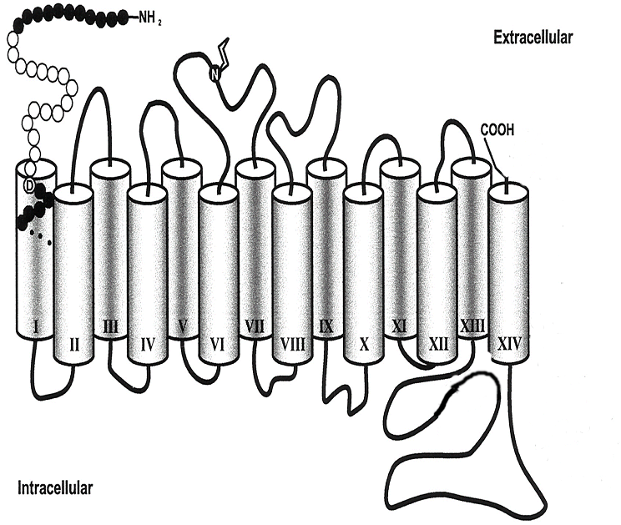
Figure 1.3 Tentative secondary structure model of hSGLT1. hSGLT1 consists of 14 α-helical transmembrane domains (shaded columns) with the N- and C-terminal located on the extracellular phase of membrane. The N-glycosylation site (Asn-248; N) is indicated (Quick and Wright, 2002).
Heterologous expression of hSGLT1 has been described in Xenopus laevis oocytes (Hediger et al., 1987), COS-7 cells (Birnir et al., 1990), CHO cells (Lin et al., 1998), Sf9 cells (Smith et al., 1992), and Escherichia coli (Quick and Wright, 2002) and has increased our knowledge about functions of transporter significantly but the amount of protein produced in the above mentioned systems is not sufficient for most of the biochemical, biophysical and structural studies which need tens or some times hundreds of milligrams of highly purified protein. In view of these difficulties our group’s previous success in the expression and purification of different fragments of SGLT1 (Raja et al., 2003; Xia et al., 2003) and their subsequent use as a model for the identification of phlorizin-binding site and alkyl glucosides-binding site as studied by fluorescence spectroscopy and affinity labeling (Raja et al., 2004; Raja et al., 2003; Tyagi and Kinne, 2003; Xia et al., 2003) provided valuable information about different inhibitors mechanism. However there lies an urgent need to express hSGLT1 in full-length and sufficient quantity. To achieve high-level expression of hSGLT1 we chose to use the methyltropic yeast Pichia pastoris because in the last 15 years this expression system has emerged as the most successful expression system for the heterologous expression of a wide variety of foreign proteins (Cereghino and Cregg, 2000; Cregg et al., 2000; Higgins and Cregg, 1998), especially membrane proteins, which were either not possible to express in E. coli or if possible, express in very low amounts often with loss of functionality.
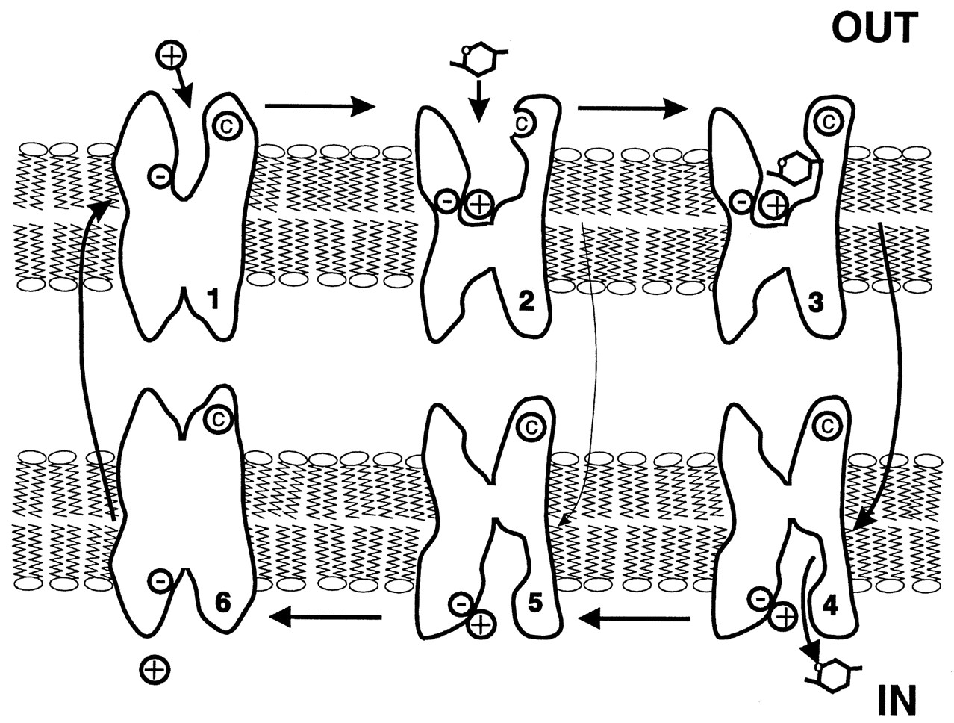
Figure 1.4 Cartoon of the 6-state ordered kinetic model for sodium/glucose cotransport. States 1-3 face the external and states 4-6 internal membrane surfaces, respectively. In the absence of ligands, the transporter exists in 2 states (1 and 6). At the external surface, 2 Na⁺ ions bind to the transporter to form the complex CNa₂ (state 2). The fully loaded transporter CNa₂S (state 3) undergoes a conformational change (states 3 to 4) resulting in sodium/glucose cotransport. The reaction from state 2 to 5 represents a uniport (“leak”) pathway for the sugar (Loo et al., 1998).

Pichia pastoris as an expression host
Pichia pastoris has become a highly successful system for the expression of heterologous genes. Several factors have contributed to its rapid acceptance, the most important of which include:
- A promoter derived from the alcohol oxidase I (AOX1) gene of P. pastoris that is uniquely suited for the controlled expression of foreign genes;
- The similarity of techniques needed for the molecular genetic manipulation of P. pastoris to those of Saccharomyces cerevisiae, one of the most well-characterized experimental systems in modern biology;
- The strong preference of P. pastoris for respiratory growth, a key physiological trait that greatly facilitates its culturing at high cell densities relative to fermentative yeasts; and
- A 1993 decision by Phillips Petroleum Company to release the P. pastoris expression system to academic research laboratories, the consequences of which has been an explosion in the knowledge base of the system.
As a yeast, P. pastoris is a single-celled microorganism that is easy to manipulate and to culture. However, it is also a eukaryote and capable of many of the posttranslational modifications performed by higher eukaryotic cells, such as proteolytic processing, protein folding, and disulfide bond formation. Thus many proteins that end up as inactive inclusion bodies in E. coli are produced as biologically active molecules in P. pastoris. The P. pastoris system is also generally regarded as being faster, easier, and less expensive to use than expression systems derived from higher eukaryotes, such as insect and mammalian tissue culture cell systems, and usually gives higher expression levels.
A second role played by P. pastoris in research is not directly related to its use as a protein expression system. P. pastoris serves as a useful model system to investigate certain areas of modern cell biology, including the molecular mechanisms involved in import and assembly of peroxisomes, the selective autophagic degradation of peroxisomes, and the organization and function of the secretory pathway in eukaryotes. More detailed information on the P. pastoris system can be found in the numerous reviews describing the system (Cereghino and Cregg, 2000; Cregg et al., 2000; Higgins and Cregg, 1998) and the Pichia Expression Kit Manual (Invitrogen Corporation, Carlsbad, CA, USA). The DNA sequence of many P. pastoris expression vectors and other useful information can be found on the Invitrogen web site (http:// www.invitrogen.com).
In the last few years the following membrane proteins have been successfully expressed in P. pastoris, Na⁺, K⁺-ATPase (Strugatsky et al., 2003), multidrug resistance protein1 (Cai et al., 2001), ATP-binding cassette transporter (Cai and Gros, 2003), NOP-1 (Bieszke et al., 1999), mammalian intestinal peptide transporter (Doring et al., 1998), human μ-opioid receptor (Talmont et al., 1996) and 5HT_{5A}-serotoninergic receptor (Weiss et al., 1998).

Photoaffinity labeling
Photoaffinity labeling and cross-linking refer to a variety of important biochemical techniques that are used to investigate structural and functional properties of biological systems, for review see (Bayley, 1983; Bayley and Knowles, 1977; Brunner, 1993; Dorman and Prestwich, 2000). These techniques make use of reagents, which, after targeting to a biological system or component, can be activated with UV light to generate highly reactive intermediates capable of forming covalent bonds with adjacent molecules. Labeling reagents can be divided into three main classes: first, probes designed to report on general properties of a system (for example, small apolar molecules and lipids which partition into membranes and, upon activation, label selectively integral membrane proteins) (Brunner et al., 1980; Do et al., 1996; D'Silva and Lala, 2000; Heinrich et al., 2000; Mothes et al., 1997), second, affinity labeling reagents intended to interact with and label components (receptors, cotransporters, and channels) in a specific, functionally relevant manner (Addona et al., 2002; Jahn et al., 2002; Kipp et al., 1997; Leite et al., 2003; Thiele et al., 2000; Tyagi and Kinne, 2003), and third, heterobifunctional photo cross-linkers, containing a photactivatable and a conventional (thermal) reactive functional group, preferentially connected via a cleavable linker. These later reagents are primarily used to study the spatial relationship between components in complex systems.
Several successful examples of photoaffinity labeling of membrane proteins have been reported; among these are the glucose transporters in the plasma membrane of erythrocytes and of adipocytes (Trosper and Levy, 1977), the β-galactoside transport in E. coli membrane vesicles (Rudnick et al., 1975), the dipeptide and oligopetides transporters in E. coli (Staros and Knowles, 1978), rhodopsin (Borhan et al., 2000), the ATP-binding cassette transporter LmrA (van Veen et al., 2000), fatty acid binding proteins in E. coli (Mangroo and Gerber, 1992), alpha 1-adrenegic receptors of rat heart (Terman and Insel, 1986), anion channel-1 in rat brain (Darbandi-Tonkabon et al., 2003), the ion channel of F-ATP synthase (von Ballmoos et al., 2004), the synaptic vesicle protein SV2A (Lynch et al., 2004), the bovine γ-aminobutyric acid type receptor (Sawyer et al., 2002), and nicotinic acetylcholine receptor (Chiara et al., 2003; Pratt et al., 2000; Wang et al., 2000; Ziebell et al., 2004).

Aim of the study
Large-scale purification of recombinant human membrane proteins represents a rate-limiting step towards understanding their role in health and disease. There are only four mammalian membrane proteins of known structure and these were isolated from natural sources. However, heterologous expression of hSGLT1 has been described in Xenopus laevis oocytes, COS-7, CHO, Sf9 cells, and Escherichia coli but the amount of protein produced in the above mentioned systems is not sufficient for most of the biochemical, biophysical and structural studies. In order to shed more light on the structure-functions of hSGLT we intend to express full-length transporter in high yield to fulfill our requirements of protein amount, which is necessary for most of the biochemical and biophysical experiments.
The elucidation of molecular interactions leading to transport of sugar and its translocation pathway through SGLT1 is a major objective of this work. Different methods have been widely used for the identification of sugar translocation pathway into SGLT1, but all methods were unable to provide an insight into protein structure at molecular level. To overcome this problem we proposed the use of photoaffinity labeling of functional domains of SGLT1 with different ligands and inhibitors based photoaffinity probes for the identification of sugar translocation pathway and inhibitor binding sites. To achieve this aim we proposed the synthesis and application of four new photoaffinity probes.
Therefore the main objectives of this work are:
- To achieve high-level heterologous expression, purification and reconstitution of full-length functional hSGLT1.
- Functional characterization of recombinant hSGLT1 by sugar uptake assays.
- Synthesis of sugar and phlorizin based photoaffinity probes for the identification of sugar translocation pathways and inhibitor binding sites.
- Photoaffinity labeling of loop 13 with [(2’-Iodo-4’-(3’’-trifluoromethyldiazirinyl) phenoxy]-D-glucopyranoside (TIPDG), [(4’-Benzoyl) phenoxy)]-D-glucopyranoside (BzG), and 3-Azidophlorizin (3-AP).
- Photoaffinity labeling of recombinant full-length hSGLT1.

Materials and methods
Protocols were adapted from standard methods (Sambrook and Russell, 2001) unless otherwise mentioned.
All solutions and media were prepared with ultra-pure water (Milli-Q Plus ultra purification pak, Milli-RO Plus purification pak; Millipore, Molsheim, France).

General equipments
Autoclave Autoclave 23; MELAG Medizintechnick (Berlin, Germany) Bioclav; Schütt Labortechnik GmbH (Göttingen, Germany)
Centrifuges Biofuge pico, Omnifuge 2.OR, Megafuge 1.ORS, Heraeus (Osterode, Germany) Centrikon H-401, with Rotors A8.24 and A6.9; Kontron-Hermle (Gosheim, Germany)
Chromatography System Automated Econo System; Biorad (Hercules, CA)
Electroporation apparatus Gene pulser II; Biorad (Hercules, CA)
Freezer, -70°C ULT1706; Revco Scientific (Asheville, NC),
Gel documentation camera Polaroid MP-4 land camera; Polaroid USA
Gel Electrophoresis Biorad (Hercules, CA)
Incubators WTB Binder (Tuttlingen, Germany), Forma Scientific (USA)
JULABO Labortechnik GmbH
Liquid nitrogen tank BT40; L’air liquide (Champigny, France)
Magnetic stirrer MR3001; heidolph (Kelheim, Germany)
MALDI-MS PE-Biosystems, Shelton, USA
Microscope IX50; Olympus Optical GmbH (Hamburg, Germany)
Oriel photochemical Oriel, Stratford, CT, USA
reactor
Rayonet photochemical Southern New England, Branford, CT, USA
reactor
pH meter Model 765 Calimatic; Knick (Berlin, Germany)
Scales Model BP 2100S; Sartorius (Göttingen, Germany)
Sonicator SONOPLUS Bandelin electronic GmbH (Berlin, Germany)
Spectrophotometer UVICON 930; Kontron instruments (Echingen, Germany)
Thermocycler Mastercycler gradient; Eppendorf (Hamburg, Germany)
Thermomixer Thermomixer compact; Eppendorf (Hamburg, Germany)
Ultracentrifuge OptimaTM TLX, with rotor TLA 100.4; BeckMan Instruments Fullerton, CA
Vortexer REAX top; Heidolph (Kelheim, Germany)
Water baths GFL GmbH (Burgwedel, Germany)
Densitometer Pharmacia LKB (Sweden)
UV illuminator Model N90M; UniEquip (Martinsried, Germany)

Materials

Chemicals
Acryl/Bis 37.5:1; 40% (w/v) Solution AMRESCO Inc. USA
α-D-Acetobromoglucose Mo Bio Laboratories, USA
Agar Mo Bio Laboratories, USA
Agarose Sigma, Munich, Germany
Ammonium persulphate Sigma, Munich, Germany
Ampicillin Sigma, Munich, Germany
Bromophenol blue Sigma, Munich, Germany
4-Bromoanisol Sigma, Munich, Germany
BSA (bovine serum albumin) Sigma, Munich, Germany
G250 Brilliant Blue Serva, Heidelberg, Germany
α-Cyano-4-hydroxycinnamic acid Sigma, Munich, Germany
Dideoxynucleotides Stratagene Inc USA
2,5-dihydroxybenzoic acid Sigma, Munich, Germany
3,5-Dimethoxy-4-hydroxycinnamic acid Sigma, Munich, Germany
DMSO Sigma, Munich, Germany
DTT Sigma, Munich, Germany
EDTA Sigma, Munich, Germany
Ethidium Bromide Sigma, Munich, Germany
Formamide Fluka AG, Neu-Ulm, Germany
FosCholine-12 Anatrace, Maumee, OH, USA
D-[6-³H] Glucose Perkin-Elmer, LAS, Germany
Glycerol Merck, Darmstadt, Germany
HEPES Sigma, Taufkirchen, Germany
4-Hydroxybenzophenone Sigma, Munich, Germany
IPTG peqLab Biotechnologie, Erlangen, Germany
Methyl-α-D-[¹⁴C] glucopyranoside Perkin-Elmer, LAS, Germany
SDS Sigma, Munich, Germany
Sodium Azide Serva, Heidelberg
Phlorizin Sigma, Munich, Germany
TEMED Sigma, Munich, Germany
Triton X-100 Sigma, Munich, Germany
Tryptone Sigma, Munich, Germany
Tween 20 Sigma, Munich, Germany
Yeast extracts Sigma, Munich, Germany
Zeocin Invitrogen, Carlsad, USA
All other Chemicals were of analytical grade and obtained from commercial sources.

Enzymes and reagents for molecular biology
Restriction enzymes New England Biolabs GmbH, Frankfurt, Germany
Taq DNA polymerase New England Biolabs GmbH, Frankfurt, Germany
Pfu Ultra HF DNA polymerase Stratagene, Netherlands
Thermoscript reverse transcriptase Invitrogen GmbH, Karsruhe, Germany
Calf Intestine alkaline phosphatase Roche Diagnostic, Mannheim, Germany
T4 DNA ligase New England Biolabs GmbH, Frankfurt, Germany
RNaseA Sigma, Munich, Germany
DNase I Roche Diagnostic, Mannheim, Germany
DNase (Rnase free) Qiagen, Hiden, Germany
Lysozyme Sigma, Munich, Germany
dNTP Stratagene, Netherlands
T4 Polynucleotide kinase New England Biolabs GmbH, Frankfurt, Germany

Antibodies
Anti-FLAG M2 monoclonal antibody peroxidase conjugate Sigma, Munich, Germany
Mouse anti-His-tag (27E8) monoclonal antibody Cell Signaling Technology
Baverly, USA
Rabbit anti-human SGLT1 antibody Acrirs Antibodies,
Hiddenhausen, Germany

Commercial Kits and other materials
QIAquickTM PCR-Purification kit Qiagen, Hiden, Germany
QIAquickTM Gel-extraction kit Qiagen, Hiden, Germany
QIA®Spin Miniprep kit Qiagen, Hiden, Germany
QuickChange® XL Site directed mutagensis kit Stratagene, Netherlands
Rapid DNA ligation kit Roche Diagnostic, Mannheim, Germany
Expend High Fidelity PCR system Roche Diagnostic, Mannheim, Germany
Easy SelectTM Pichia Expression Kit Invitrogen, Carlsbad, USA
Lowry Protein assay kit Sigma, Munich, Germany
HybondTM-C extra blotting membrane Amersham Biosciences, Germany
SuperSignal®West Pico chemiluminiscent Pierce, Rockland, USA
Substrate
Photographic film Polapan; Polaroid, Offenbach, Germany

Primers for preparation of cDNA inserts
Primer | Sequence | Type, restriction site
SGLT_F | TATTGAATTCGATGGACAGTAGCACCTG | Sense, EcoR1
SGLT_R | AATACTCGAGGGCAAAATATGCATGGC | Antisense, Xho1
ΔN12-377SGLT_F | CTGCGAGGCCTGATGCTATCAGTCATGCTG | Sense
ΔN12-377SGLT_R | GGTGGTCTTGGGGCTCCAGGTGCTACTGTC | Antisense
Spacer_His_SGLT_F | GGTGGTAGCCCGGGTCACCACCACCACCACCACTGAGAT | Sense
Spacer_His_SGLT_R | GCTTTTATACAGCACGGCAAAATATGCATGGCAAAAGAC | Antisense
T7 promoter_F | TAATACGACTCACTATAGGG | Sense
Unc-F_R | TTTATTACAGTTCAGCGACAAG | Antisense
SGLT_FLAG_F | GACGACGATAAGATCCAAGAAGGCCCTAAGGAGAC | Sense
SGLT_FLAG_R  PBAD_SGLT_R | ATCCTTGTAATCCAGGTCAATACGCTCCTCTTTGC TAATTAAGCTTTTAGGCAAAATATGCA  TGG | Antisense  Antisense, Hind III
pPICZ_SGLT_F | TATTGAATTCAAAATGGACAGTAGCACCTG | Sense, EcoR1
pPICZα_SGLT_R | ATTATTGCGGCCGCGGCAAAATATGCATGCC | Antisense, Not1

Plasmids

Original plasmids
Plasmid | Description | Reference
pET22b | Expression vector, T7-lac promoter, Signal sequence at N-terminal of gene, at C-terminal His tag, Amp^{R}, origin of replication pBR322. | Novagen, San Diego, CA, USA
pBAD24 | P_{BAD} promoter, His tag at C-terminal of gene, Amp^{R}, pUC origin of replication. | Invitrogen, Carlsbad, CA, USA
pPICZB | AOX1 promoter, His-tag at the C-terminal of gene, Zeo^{R}; CoLE1 origin of replication. | Invitrogen, Carlsbad, CA, USA
pPICZαA | AOX1 promoter, α-factor secretion signal at the N-terminal of gene, His-tag at the C-terminal of gene, Zeo^{R}; CoLE1 origin of replication. | Invitrogen, Carlsbad, CA, USA

Plasmid with insert
Plasmid | Description | Reference
DKFZp686N20230Q2 | Plasmid containing full-length hSGLT1 gene | RZPD, Berlin, Germany
pET22b-hSGLT1 | hSGLT1 gene cloned in pET22b | This study
pET22b-hSGLT1-Spacer | hSGLT1 gene cloned in pET22b with DNA sequence encoding for a 10 amino acids long spacer at the C-terminal of gene | This study
pET22b-ΔN12-377 hSGLT1 | hSGLT1 gene cloned into pET22b after deletion of DNA sequence encoding amino acids 12-377 | This study
pET22b-ΔN12-377 hSGLT1-Spacer | Clone pET22b-ΔN12-377 hSGLT1 with DNA sequence encoding for a 10 amino acids long spacer at the C-terminal of gene | This study
pET22b-Unc-F | Unc-F gene encodes β-subunit of E. coli ATPase under the control of bacteriophage T7 promoter | This study
pET22b-Unc-F-hSGLT1 | Unc-F gene cloned in pET22b plasmid encoding full-length hSGLT1 | This study
pET22b-Unc-F-hSGLT1-Spacer | Unc-F gene cloned in pET22b plasmid encoding full-length hSGLT1 with C-terminal spacer | This study
pET22b-Unc-F-ΔN12-377 hSGLT1 | Unc-F gene cloned in pET22b plasmid encoding hSGLT1 gene shorten at N-terminal from 12-377 amino acids | This study
pET22b-hSGLT1-FLAG-Spacer | pET22b vector containing full-length hSGLT1 gene with C-terminal spacer and FLAG tag at position D₅₇₄. | This study
pBAD24-hSGLT1-FLAG-Spacer | pBAD24 vector containing full-length hSGLT1 gene with C-terminal spacer and FLAG tag at position D₅₇₄. | This study
pBAD24-ΔN12-377 hSGLT1-FLAG-Spacer | pBAD24 plasmid encoding hSGLT1 gene shorten at N-terminal from 12-377 amino acids and FLAG tag at position D₅₇₄ | This study
pPICZB-hSGLT1 | P. pastoris plasmid pPICZB containing full-length hSGLT1 gene with FLAG tag at D₅₇₄ | This study
pPICZαA-hSGLT1 | P. pastoris plasmid pPICZαA containing full-length hSGLT1 gene with FLAG tag at D₅₇₄ | This study

Work with E.coli

E.coli strains
Strain | Genotype | Source
C41 (DE3) | BL21 (DE3) derivative with uncharacterized mutations | Avidis
C43 (DE3) | BL21 (DE3) derivative with uncharacterized mutations | Avidis
C43 (DE3) Rosetta | C43 (DE3) and Rosetta derivative | This study
DH5α | F⁻φ80dlacZΔM15 Δ(lacZYA-argF)U169 deoR recA1endA1 hsdR17(r_{k}⁻, m_{k}⁺) phoA supE44λ−thi-1
Origami (DE3) | ∆ (ara-leu)7697∆ lacX 74∆phoA PvuII phoR araD139ahpC galK rpsL F´[lac⁺ lacI^{q} pro] (DE3) gor522:: Tn 10trx (Kan^{R}, Str^{R}, Tet^{R}) | Novagen
RosettaTM (DE3) | F⁻ ompT hsdS_{B} (r_{B}⁻ m_{B}⁻) gal dcm (DE3) pRARE (Cam^{R}) | Novagen
XL10-Gold | Tet^{R} ∆(mcrA)183 ∆(mcrCB-hsdSMR-mrr)173endA1 supE44 thi-1 recA1 gyrA96 relA1 lac Hte [F´ proAB lacI^{q}Z∆M15 Tn10 (Tet^{R}) Amy Cam^{R}] | Stratagene
TOP10F⁻ | F´proAB, lacI^{q}, lacZΔM15, Tn10 (Tet^{R}) mcrA, Δ(mrr-hsdRMS-mcrBC), φ80lacZΔM15, ΔlacX74, deoR, recA1, λ-araD139, Δ(ara-leu) 7697, galU, galK, rpsL, (str^{R}), endA1, nupG | Invitrogen

Media for bacterial culture
LB-medium 1.0% tryptone
0.5% yeast extract
1.0% NaCl
pH 7.2

Terrific Broth 1.2% tryptone
2.4% yeast extract
0.4% glycerol
17 mM KH₂PO₄
72 mM K₂HPO₄
1.5% agar was added to the media for production of agar plates.
The following concentrations of the antibiotics were used if required:
Table 3.3 Antibiotic stock solutions and its working concentration.
Antibiotic | Stock solution |  | Working concentration
Ampicillin  Chloramphenicol  Zeocin  Tetracycline | 100 mg/ml in water  30 mg/ml in ethanol  100 mg/ml in water  5 mg/ml in ethanol |  | 100 µg/ml  30 µg/ml  100 µg/ml  10 µg/ml

General
E. coli were cultured at 37°C with LB medium or terrific broth. Bacteria transformed with an antibiotic resistance-conferring plasmid were selectively propagated by supplementing the LB medium with respective antibiotic (see Table 3.3). All solutions and supplements used for work with E. coli were autoclaved for 20 min at 121°C or filter-sterilized. Bacterial strains for long-term were stored at –70°C in LB medium supplemented with glycerol to a final concentration of 15 %.

Transformation of plasmid in E.coli

Preparation of competent cells by CaCl₂ method
LB medium (100 ml ) was inoculated with an overnight culture of E. coli DH5α and grown at 37°C with shaking to an OD₆₀₀ of 0.4. This culture was transfer to sterile, disposable, ice-cold 50-ml plastic tubes and store on ice for 10 minutes. After incubation, cells were centrifuged at 4,000 rpm for 15 min at 4°C. The pellet was resuspended in 50 ml ice-cold 100 mM MgCl₂, incubated for 30 min on ice, and centrifuged at 4°C. The cells were resuspended in 2 ml ice-cold 100 mM CaCl₂, incubated for 24 h at 4°C, supplemented with ice-cold 0.6 ml glycerol and 2.4 ml 100 mM CaCl₂ and stored in 200µl aliquots at –70°C.

Heat shock transformation of the plasmid
Treatment of competent bacterial cells with a brief heat shock enables transformation of DNA. Plasmid DNA or a plasmid ligation reaction (not more than 15ng or in a volume 2.5μL) was mixed with 50µl thawed competent bacteria and incubated for 30 min on ice. The bacteria were treated for 90s by heat shock of 42°C, placed on ice for 1-2 min, diluted with 950 µl LB medium and incubated for 1 h at 37°C with shaking. An aliquot of 50-200 µl or resuspended pellet was spread on LB/antibiotic agar plate and incubated overnight at 37°C to select for transformed bacteria. In case of ligation mixture, the transformed cells were pelleted by centrifugation at 13,000 rpm for 30 seconds, and the pellet was resuspended in 100μl of LB medium. The whole suspension was spread on the agar plate.

Work with P. pastoris

P. pastoris strains
Strain | Genotype | Phenotype
X-33 | Wild-type | Mut⁺
GS115 | his4 | His⁻, Mut⁺
KM71H | arg4 aox1::ARG4 | Mut^{S}, Arg⁺
GS115/Albumin | His4 | Mut^{S}
GS115/pPICZ/lacZ | his4 | His⁻, Mut⁺

Media for P. pastoris culture
Low Salt LB (Luria-Bertani) Medium 1.0 % tryptone
0.5% yeast extract
1.0% NaCl
pH 7.0
Low salt LB medium is needed for use with Zeocin antibiotic.
Low salt LB agar plates were made by the addition of 1.5% agar before autoclaving.

Yeast Extract Peptone Dextrose Medium (YPD or YEPD)
% yeast extract
2% peptone
2% dextrose (glucose)

Yeast Extract Peptone Dextrose Medium (YPD ± Zeocin)
1% yeast extract
2% peptone
2% dextrose (glucose)
± 2% agar
± 100 μg/ml Zeocin

Buffered Glycerol/ Methanol complex Medium (BMGY and BMMY)
1% yeast extract
2% peptone
100mM KH₂PO₄, pH 6.0
1.34% YNB
4× 10⁻⁵% biotin
1% glycerol or 1% methanol

Breaking Buffer 50 mM KH₂PO₄, pH 6.0
Protease inhibitors cocktails
10% glycerol

General
P. pastoris was grown at 28-30°C in YPD medium. Cells transformed with pPICZB-hSGLT1 plasmid were selectively propagated by supplementing the YPD medium with Zeocin antibiotic (see Table 3.3). For protein expression pPICZB-hSGLT1 plasmid transformed cells were grown in BMGY medium supplemented with Zeocin. P.pastoris cells for long-term were stored at –70°C in YPD medium supplemented with glycerol to a final concentration of 15 %.

Electroporation of P. pastoris with plasmid pPICZB or pPICZB-hSGLT1
The purified DNA samples of pPICZB and pPICZB-hSGLT1 were linearized by PmeI digestion at 37°C for 3 h and the linearized plasmids DNA were purified by enzyme removal column.
YPD medium (100 ml) was inoculated in a 1-liter flask with 0.2 ml of overnight culture of P. pastoris strain GS115 and the cells were grown at 28°C overnight to an OD₆₀₀ of 2-4. Overnight grown culture was centrifuged at 1500 × g at 4°C for 5 min. The supernatant was removed and the pellet was resuspended with 25 ml of ice-cold sterile water. The resuspended cells were centrifuged again as above and the pellet was resuspended in 8 ml of ice-cold sterile 1 M sorbitol. The cells were centrifuged as above and then the pellet was resuspended with 1 ml of ice-cold sterile 1 M sorbitol. The suspension of competent cells was kept on ice and used the same day.
The suspension of competent cells (40 μl) and of linearized DNA (10 μl, 10 μg) were mixed and transferred to an ice-cold electroporation cuvette. The cuvette with the mixture of cells and DNA was incubated on ice for 5 min. The cells were pulsed at 1.5 kV, 50 μF and 200 Ω and 1 ml of ice-cold 1 M sorbitol was added to the cuvette. The cuvette contents were transferred to a sterile 15 ml tube and incubated at 30°C without shaking for 2 h. 200 μl of these cells were plated on YPD medium with 100, 500, and 1000 μg/ml Zeocin and incubated at 30°C for 2 days.

Recombinant DNA processing and manipulation

Buffers and solutions
TBE buffer (5X) Tris-base 54 g
(Working solution 0.5X) boric acid 27.5 g
EDTA 20 ml of 0.5 M, pH 8.0 Final volume 1 Liter
TE 10mM Tris (pH 7.6), ImM EDTA (pH8.0)

DNA loading buffer (6X) 0,25% (w/v) bromophenol blue
0,25% (w/v) xylene cyanol
30% (v/v) glycerol
50 mM EDTA
Ethidium bromide 1% (w/v) in water
DNA standard SmartLadderTM Eurogentec GmbH, Germany

Restriction endonuclease digestion of DNA
For preparative purposes, 1-5 µg DNA was digested with 1-20 U of restriction enzyme in a volume of 10-50 µl of reaction buffer. Complete digestion was confirmed by agarose gel electrophoresis. For analytical purposes, 0.2-1 µg DNA were digested with 1-5 U enzyme in a volume of 10-20 µl of reaction buffer. In both cases digests were incubated for 3h at 37°C. Reaction buffers were supplied by the manufacturer. Enzymes were heat-inactivated as recommended by the supplier or removed by purification of the digested DNA by column chromatography.

Purification of the digested DNA
To inactivate and remove the proteins e.g. restriction enzymes, digested DNA was purified by using the QIAquick PCR purification kit (Qiagen) according to the manufacturer’s instructions with slight modification. Buffers were provided in the kit and all centrifugation steps were carried out at 13,000 rpm at RT in a tabletop microcentrifuge. The 5 volume of the buffer PB and one volume of isopropanol were added to the DNA solution. The sample was then applied to QIAquick spin column (Qiagen) and centrifuged for 1 min in order to bind DNA to the column. For washing of DNA on the column, 0.75 ml of buffer PE was added to the column and spun down for 1 min. The flow-through was removed and the column was centrifuged for an additional 1 min to remove the residual ethanol. The column was then placed into a clean 1.5 ml tube and the DNA was eluted by the addition of 30-50 µl of buffer EB (10 mM Tris/HCl, pH 8.5) or dH₂O to the column followed by centrifuging for 1 min. If needed the DNA could be concentrated by precipitating with ethanol.

Ethanol precipitation of DNA
5 M NaCl solution was added to the DNA sample to a final concentration of 250 mM. Three volumes of ethanol (-20°C) were added to the solution and stored on ice for 30 min and then centrifuged at 13,000 rpm for 15 min at 4°C. The pellet was washed with one volume of ice-cold 70 % ethanol, recentrifuged for 5 min and dried at room temperature on desk. The DNA was dissolved in water or TE (pH 8) for 20 min at 37°C at an appropriate concentration.

Dephosphorylation of linearized plasmid DNA by CIP
In order to prevent self-ligation of vector ends in cloning strategies linearized plasmid DNA was treated with calf intestine alkaline phosphatase (CIP). CIP catalyzes the hydrolysis of 5'-phosphate residues to 5'-hydroxyl ends. Since T4 DNA ligase requires 5'-phosphate residues to catalyze new phosphodiester bonds, ligation is only possible between vector ends and inserts, but not between vector ends themselves. Dephosphorylation was carried out directly following plasmid linearization. CIP was added to the digestion mixture at a concentration of 1 U per pmol linearized vector DNA. After 45 min incubation at 37°C, CIP and the restriction enzymes were removed as described previously.

Ligation of DNA fragments
Ligation was carried out using Rapid DNA ligation kit according to the manufacturer’s instructions with slight modification. All the buffers were provided with the kit. The insert DNA was employed at a 2-5 molar excess relative to the linearized and dephosphorylated vector DNA. The vector DNA and insert mixture were diluted in dilution buffer to a final volume of 10μl. 10μl of ligation buffer was added in diluted DNA mixture. 5unit of T4 DNA ligase was added and mix thoroughly. The ligation reaction mixture was incubated 5-10 minutes at 15-25°C. The 5μl of ligation reaction mixture was used directly for transformation of the 200μl competent cells.

Miniprep: small-scale preparation of plasmid DNA
Plasmid DNA was purified from bacteria cultures by alkaline lysis of the bacterial cells by using QIAprep Spin miniprep kit according to the manufacture instructions. In brief, A small culture (10ml) of bacteria was grown in order to amplify in vivo the plasmid of interest. The bacteria were harvested by centrifugation at 13,000 rpm for 1 min at room temperature. This pellet was resuspended in 250µl buffer P1 (50 mM Tis·Cl pH 8.0, 10 mM EDTA, 100 µg/ml RNase A). 250µl lysis buffer P2 (0.2 N NaOH, 1 % SDS) was added in resuspended pellet followed by gently mixing and incubated for 5 minutes at room temperature. It causes denaturation of the DNA by NaOH and of the bacterial proteins by SDS. The alkaline mixture was neutralized by 350µl of buffer N3 (containing guanidine hydrochloride, 3M potassium acetate, pH 5.5) causing reannealing of plasmid DNA and precipitation of SDS. The white precipitate, containing Proteins, chromosomal DNA, SDS and cell debris was removed by centrifugation for 10 minutes at 13,000 rpm while the plasmid DNA wasleft in the solution. The supernatant was passed through the spin column by centrifugation at 13,000 rpm for 1 minute. After washing of the column with 0.75ml buffer PE, the column was additionally centrifuged for 1 minute to remove residual buffer. The DNA was eluted by adding 50µl water or TE and centrifugation of the column at 13,000 rpm for 1 min.

Large scale preparation of plasmid DNA
100 ml of bacterial culture was centrifuged at 4,000 rpm for 15 min at 4°C. The pellet was resuspended in 10 ml of P1 (50mM Tris.Cl, pH 8.0; 10mM EDTA; 100μg/ml Rnase A). Resuspended pellet was lysed with 10 ml P2 (200mM NaOH, 1% SDS) by incubating for 5 min at room temperature. The lysis was stopped by adding 10 ml ice-cold P3 (3M potassium acetate, pH 5.5) and the white precipitated mixture was poured into the barrel of QIAfilter cartidge and incubated for 10 min. After 10 minutes, the plunger was inserted into the QIAfilter cartidge and filtered the cell lysate into the 50ml tube. The lysate was loaded on an equilibrated anion exchange column that was subsequently washed twice with 30 ml of buffer QC (1.0M NaCl, 50mM MOPS, pH7.0; 15% isopropanol). The bound DNA was eluted with elution buffer QN (1.6M NaCl, 50mM MOPS, pH7.0; 15% isopropanol) by gravity flow. The eluted DNA was precipitated by adding 0.7 volumes isopropanol at room temperature and subsequent centrifugation at ≥15,000xg for 30 min at 4°C. The pellet was washed with 5 ml 70 % ethanol, re-centrifuged for 10 min, dried under vacuum and re-dissolved in 1ml of endothelial electroporation buffer or TE.

Qunatification of DNA and RNA solutions
The concentration of nucleic acid solutions was determined by spectrophotometry. The ultraviolet (UV) absorption was measured at a wavelength of 260 nm (OD₂₆₀) using a quartz cuvette of 1 cm width. For double-stranded DNA an OD₂₆₀ =1.0 corresponds to approximately 50 µg DNA/ml. For RNA an OD₂₆₀ = 1.0 corresponds to approximately 40 µg RNA/ml. In addition the OD₂₆₀ was measured to estimate the purity of the nucleic acid sample. A ratio OD₂₆₀/OD₂₈₀ of significantly less than 1.8-2.0 indicates protein contamination.

Agarose gel electrophoresis
Agarose gel electrophoresis was used for analytical and preparative purposes. The method is based on the migration of the negatively charged DNA towards the anode in an electric field. The fragments migrate through the gel matrix at rates inversely proportional to the logarithm (log₁₀) of the number of base pairs. DNA bands were visualized within an agarose gel by staining with the intercalating fluorescent dye ethidium bromide and subsequent illumination under UV light. The length of a DNA fragment is determined by comparison of its mobility to that of DNA standards. For casting gel, 1-2 % (w/v) agarose was melted in 0.5xTBE electrophoresis buffer and supplemented with 0.5 µg/ml ethidium bromide and cast in casting tray of desired size. The gel was placed in an electrophoresis tank and submerged in 0.5xTBE buffer. The DNA samples were mixed with DNA loading buffer and loaded into the gel wells. In addition 5 µl of a DNA standard was loaded in parallel with the samples. Horizontal electrophoresis was carried out at approximately 100 V. The stained gel was photographed under UV light.

DNA recovery from agarose gel
For preparative purposes DNA fragments of interest were cut out from stained agarose gels with a razor blade under UV illumination. The gel slices were solubilized and DNA was purified by using the QIAquick Gel extraction kit (Qiagen) according to the manufacturer’s instructions.
Agarose gel slices were weighed (= 1 volume) and dissolved each slice in 3 volumes of solubilization buffer QG by incubation for 10 min at 50°C. 1 volume isopropanol was added and the solution was applied to a silica-gel QIAquick spin column. The column was centrifuged at 13,000 rpm for 1 min, washed with washing buffer PE and centrifuged again. The extra centrifugation was done to remove residual buffer. DNA was eluted by adding 30-50µl water or TE on the column and centrifugation of the column at 13,000 rpm for 1 min. All the buffers were provided by the manufacturer.

DNA sequencing
The sequence of specific target regions in recombinant plasmid DNA was determined by a commercial sequencing service (Agowa GmbH Berlin, Germany). The sequence data were verified on the basis of the corresponding fluorescence electropherogram and subjected to computer analysis.

DNA amplification of hSGLT1 gene by PCR for cloning into different expression systems
Primers for PCR amplification of SGLT1 cDNA were commercially synthesized (MWG Biotech, Ebersberg, Germany). They were designed corresponding to the DNA segment to be amplified, provided with restriction sites for endonuclease digestion. Pairs of primers were designed to have equivalent melting temperatures (Tm), calculated according to the formula Tm [°C] = (A+T)·2 + (G+C)·4. The annealing temperature for each PCR was typically estimated by experimentally. For preparative DNA amplification as part of cloning strategies, High fidelity DNA polymerase was used in preference to Taq DNA polymerase, due to its 3'→5' proofreading exonuclease activity which minimizes the risk of nucleotide misincorporation during elongation.

PCR reaction composition for DNA amplification was as follows:
Template DNA 20-50ng
Sense primer (forward) 100 pMoles
Antisense primer (reverse) 100 pMoles
dNTPs 200μM each
PCR reaction buffer 1x
DMSO 5-10% (Optional, to increase yield, specificity, consistency)
DNA polymerase 1-2.5 units
Final reaction volume 100μl (preparative PCR), 20-50μl (analytical PCR)
Th PCR amplified products of hSGLT1 gene were analyzed by agrose gel electrophorsis, they were further proceeding for cloning into their respective vectors.
Thermal cycle parameters for PCR was as follows:
Lid temperature 105°C
Initial denaturation 94°C, 5 minutes
Denaturation 94°C, 30 seconds
Annealing 50-55°C (primer pair and template specific), 1minute
Elongation 72°C, 1 miunte/kb
Cycles 30
Final elongation 72°C, 10 minutes
cDNA sequence encoding full length human SGLT1 was amplified by using plasmid DKFZp686N20230Q2 as a template and subcloned into the EcoR1 and Xho1 sites of the bacterial expression vector pET22b. Primers used for the amplification were SGLT1_F and SGLT1_R (see section 3.2.5).
For cloning into pBAD24 bacterial expression vector, pET22b-hSGLT1-FLAG-Spacer plasmid (see section 3.5.14.2 for detail) was used as a PCR template. The primers pPICZ_SGLT_F and PBAD_SGLT_R containing EcoR1 and HindIII restriction sites respectively were used for PCR amplification.
For cloning hSGLT1 gene into eukaryotic expression system Pichia pastoris, pET22b-hSGLT1-FLAG-Spacer plasmid (see section 3.5.14.2 for detail) was used as a PCR template. hSGLT1-FLAG-Spacer gene product contains a FLAG epitop at postion of 574 amon acid and a 10 amino acids spacer at the end of hSGLT1 gene. The primers used for PCR amplification were pPICZ_SGLT_F and pPICZα_SGLT_R primer containing EcoR1 and Not1I restriction sites respectively

Addition or deletion mutagenesis in hSGLT1 gene
This method is a PCR-based site directed mutagenesis system that eliminates the necessity to subclone the amplified mutated DNA fragment. This procedure starts with a supercoiled, dsDNA vector with an insert of interest and two synthetic oligonucleotide primers containing the desired mutation. The oligonucleotide primers, each complementary to opposite strands of the vector, are extended during temperature cycling by PfuUltra® high-fidelity DNA polymerase. On incorporation of the oligonucleotide primers, a mutated plasmid is generated. After temperature cycling, the product is treated with Dpn I. Dpn I is used to digest the parental DNA template and select for the synthesized DNA containing mutations. Since DNA isolated from most E. coli strains is dam methylated, it is susceptible to Dpn I digestion, that will cut only fully or hemimethylated 5′-Gm6ATG-3′ DNA sequences. The nicked vector DNA incorporating the desired mutations is then transformed into the commercial XL10-Gold cells. This method is very rapid and generates mutants with the efficiency greater than 80%.
The specific primer design consideration was applied which are as follows.
Both the primers must anneal to different strands of the plasmid.
Primers should be >22 bases in length
The mismatched portions should be at or near the 5´ end of one or both of the primers with 15 or more bases of correct sequence on the 3´ end.
For deletion, the primers should be designed in frame of the coding sequence of the gene. The forward primer and reverse primer should be designed at 3′ and 5′end of the deletion sequence respectively. For addition of base pairs in the cDNA of hSGLT1 the additional base pairs should incorporated at the 5’end of the primers.
One or both of the primers must be 5´ phosphorylated. T4 polynucleotide kinase used for the 5´ phosphorylation of an oligonucleotide primers.
The reaction composition of the phosphorylation reaction is as follows
Primer 1μl (100pmole)
Kinase buffer 0.5μl (1x)
T4 polynucleotide kinase 1μl (10 units)
Water 2.5μl
The reaction mixture was incubated for 1 hour. The 1.25μl of the reaction mixture was directly used for PCR.
The mutant strands synthesis reaction was setup for PCR according to the manufacturer’s instructions. The PCR reaction composition and PCR cycling parameter were as follows:
Template DNA 30ng
Sense primer (forward) 125ng
Antisense primer (reverse) 125ng
dNTPs 200μM each or 1μl(supplied with the kit)
PCR reaction buffer 1x
Quik solution reagent 3μl (supplied with the kit)
Water was added to a final volume of 50μl
Then 1μl of PfuUltra HF DNA polymerase was added and PCR was done with the following thermal cycling parameters.

Lid temperature 105°C
Initial denaturation 94°C, 2 minutes
Denaturation 94°C, 50 seconds
Annealing 60°C, 1minute
Elongation 68°C, 1 miunte/kb
Cycles 18
Final elongation 68°C, 10 minutes
After the PCR the reaction mixture was cooled to ≤37°C on ice. 1μl of Dpn I was added directly to reaction mixture and kept for 2 hours for digestion at 37°C. The PCR product was purified by PCR purification kit as described before. The 5μl of purified PCR product was ligated with rapid DNA ligation kit and transformed into DH5α cells. The positive clone was confirmed by DNA sequencing.

Addition of 30 base pairs long spacer at the C-terminal of hSGLT1 gene
cDNA sequence encoding a 10 amino acids long spacer (VLYKSGGSPG) was introduced at the C-terminal of hSGLT1 gene. For the addition of spacer sequence, two primers (each containing 5 additional amino acids coding base pairs). The primers used for this mutation were Spacer_SGLT_His_F and Spacer_SGLT_His_R (see section 3.2.5) and designed as shown in Figure 3.5. The resultant plasmid was designated as pET22b-hSGLT1-Spacer.
Spacer_SGLT_His_R
Spacer_SGLT_His_F
pET22b
pET22b
3’
3’
5’
hSGLT1
His tag
5’

Figure 3.5 Positions of the mutation primers in pET22b-hSGLT1 plasmid. 15 base pairs were added to each primers. After Ligation 30 bps were incorporated between hSGLT1 gene and His tag.

Addition of FLAG tag in hSGLT-spacer gene
For better immunological detection and to provide ease in the purification process, the FLAG epitope was introduced in hSGLT1 by mutating the native hSGLT1 sequence D₅₇₄ AEEEN to D₅₇₄YKDDDDK. In pET22b-hSGLT1-Spacer plasmid 21 base pairs endcoding the FLAG tag were inserted at the postion 574. During this mutation 15 base pairs encoding wildtype 5 amino acids (574-579) were deleted. The forward primer (SGLT1_FLAG_F) and reverse primer (SGLT1_FLAG_R) were designed similarly as shown in Figure 3.5. The resultant plasmid was designated as pET22b-hSGLT1-FLAG-Spacer.

Deletion of N-terminal half of hSGLT1 gene
To construct N-terminal truncated hSGLT1 gene, the base pairs 34 to 1131 (Amino acids 12-377) were deleted by deletion mutagenesis as described above. The primers ΔN12-377_SGLT_F and ΔN12-377_SGLT_FR were designed with a similar approach as describe in section 3.5.14.1 following the primer design rules as described in section 3.5.14.

Addition of Unc-F gene at the N-terminal of hSGLT1 gene
pAVD10 vector (Avidis, Saint-Beauzire, France) encodes for the intra membrane inducer Unc-F gene product (i.e. the β-subunit of the E. coli ATPase) under the control of the bacteriophage T7 promoter. Unc-F gene was subcloned into pET22b vector pAVD10 plasmid was digested with XbaI enzyme and purified on agarose gel. The purified Unc-F gene fragment was ligated into similarly treated dephosphorylated pET22b and pET22b-hSGLT1 plasmids. After ligation 5 μl of ligated mixture was transformed into DH5α cells and positive clones were identified by XbaI digestion. In order to further confirm the correct orientation of Unc-F gene in pET22b-Unc-F and pET22b-Unc-F-hSGLT1 clones PCR reaction of these clones were performed with following primer: T7 promoter, sense, 5´-TAATACGACTCACTATAGGG-3´and Unc-F primer, antisense, 5´-TTTATTACAGTTCAG CGACAAG-3´.

Protein expression and analysis

Growth conditions of E.coli for hSGLT1 expression
Each clone was tested for protein expression in different conditions:
Clone name | Types of E. coli cells |  |  |  |  | Expression conditions*
Clone name | DH₅α | Rosetta | C41 | C43 | C43 Rosetta | Expression conditions*
pET22b-hSGLT1 | Yes | Yes | Yes | Yes | Yes | Condition 1, 2, 3, 4, 5 and 6 in Rosetta, C43 and C43R cells
pET22b-hSGLT1-Spacer | Yes | Yes | Yes | Yes | Yes | Same
pET22b-ΔN12-377 hSGLT1 | Yes | Yes | Yes | Yes | Yes | Same
pET22b-ΔN12-377 hSGLT1 Spacer | Yes | Yes | Yes | Yes | Yes | Same
pET22b-Unc-F | Yes | Yes | No | Yes | Yes | Same
pET22b-Unc-F-hSGLT1 | Yes | Yes | No | Yes | Yes | Same
pET22b-Unc-F-hSGLT1-Spacer | Yes | Yes | No | Yes | Yes | Same
pET22b-Unc-F-ΔN12-377 hSGLT1 | Yes | Yes | No | Yes | Yes | Same
pET22b-hSGLT1-FLAG-Spacer | Yes | Yes | Yes | Yes | Yes | Same
pBAD24-hSGLT1-FLAG-Spacer | Yes | Yes | Yes | Yes | Yes | Conditions 7 and 8 in Rosetta, C43 and C43R cells
pBAD24-ΔN12-377 hSGLT1-FLAG-Spacer | Yes | Yes | Yes | Yes | Yes | Same
*Specification of different expression conditions;
- LB medium, 1 mM IPTG, 37°C growing temperature.
- LB medium, 1 mM IPTG, 37°C growing temperature with 45 min heat shock before induction of IPTG.
- LB medium, 1 mM IPTG, 22°C growing temperature with 45 min heat shock before induction of IPTG.
- LB medium, 0.5 mM IPTG, 16°C growing temperature with 45 min heat shock before induction of IPTG.
- TB medium, 0.5 mM IPTG, 16°C growing temperature with 45 min heat shock before induction of IPTG.
- TB medium with 1 M sorbitol, 0.5mM IPTG, 22°C growing temperature with 45 min heat shock before induction of IPTG.
- LB medium, 0.2% L- (+) arabinose, 22°C growing temperature.
- LB medium, 0.2% L- (+) arabinose, 22°C growing temperature with 45 min heat shock before Arabinose induction.

Growth condition of P. pastoris for hSGLT1 expression
In pilot experiments, single colonies of transformed cells were used to inoculate 2.5 ml of BMGY medium (1% (w/v) yeast extract, 2% (w/v) peptone, 100 mM potassium phosphate, pH 7.0, 1.34% (w/v) yeast nitrogen base, 4×10⁻⁵% (w/v) biotin, and 1% (v/v) glycerol). After 16-20 h of incubation at 30°C, the cells were pelleted at 1000 × g and were resuspended in BMMY medium (BMGY medium in which the glycerol was replaced by 1% (v/v) methanol) to induce protein expression. The positive colonies for recombinant protein expression were identified by Western blot analysis by using anti-FLAG antibody (Sigma). The clone with the highest protein yield was selected for medium-scale protein expression in 2-liters flasks. In all subsequent preparations, the cells were harvested at ~24 h of methanol induction.

hSGLT1 purification from P. pastoris
Membranes were prepared from P. pastoris cells as described below in the functional analysis of recombinant hSGLT1 section. Peripheral proteins and proteins adhering to the membrane were removed by washing with 4 M urea in breaking buffer containing protease inhibitor cocktail (Roche) at 4°C for 2 h and resulting membranes were centrifuged at 100,000 × g at 4°C for 40 min. The stripped membranes were solublized in buffer TG [20 mM Tris.Cl, pH 8/1 M NaCl/20% (v/v) glycerol] supplemented by 1.2% FosCholine-12 (Anatrace, Maumee, OH) and protease inhibitor cocktail, resulted membrane solution was shaken at 4°C, overnight. After removal of insoluble fraction by ultracentrifugation at 100,000 × g for 40 min at 4°C, the clear supernatant was bound to the preequilibrated Protino Ni 2000 prepacked (Macherey-Nagel) polyhistidine-tag purification column at 4°C, unbound proteins were removed by washing with 3 column volume of buffer TG plus 0.2% FosCholine-12. Recombinant hSGLT1 was eluted with 9 ml of buffer TG plus 0.2% FosCholine-12 supplemented with 250 mM imidazole and protease inhibitor cocktail. The purified protein containing fractions were concentrated to 0.35 ml by ultrafiltration in Centricon YM100 devices (Millipore) and stored at -20°C for further use.

Protein analysis

Buffers and solutions
SDS sample buffer (2x) 100 mM Tris·HCl (pH 6.8)
20 % (v/v) glycerol
4 % (w/v) SDS
0.01 % (w/v) bromphenol blue
10% β-mercaptoethanol
acrylamide/bis-acrylamide 40% (w/v) acrylamide/bis-acrylamide ratio 37.5:1 (Amersco)
Stacking gel buffer 0.5 M Tris-HCl, pH 6.8
Resolving gel buffer 1.5 M Tris-HCl, pH 8.8
APS 10% (w/v) APS in water, aliquots were stored at -20°C
SDS 10% (w/v) SDS in water
Electrophoresis Buffer (10x) 30g Tris-base
142g glycine
10g SDS
Water was up to 1 liter
Transfer buffer 5.82g (48mM) Tris-base
2.93g (39mM) glycine
200ml methanol
Water was added up to 1 liter
TBST buffer 10mM Tris-base (pH 7.6)
150mM NaCl
0.05% (v/v) Tween 20
Blocking solution 5% blocking milk (BioRad) in TBST
Phosphatase cocktail (1:100)
0.1% SDS
Coomassie staining solution 0.25% coomassie Brilliant Blue R-250
10%Acetic acid
40% methanol in water (filtered)
Coomassie destaining solution 10%Acetic acid
40% methanol in water

Measurement of protein concentration

Enhanced alkaline copper (Lowry) protein assay
The method is based on Peterson’s modification of the micro-Lowery method (Peterson, 1977). An alkaline cupric tartrate reagent (Lowery reagent) complexes with the peptide bonds of proteins and becomes reduced to cuprous (Cu⁺). The Cu⁺ as well as the R groups of tyrosine, tryptophan, and cysteine residues then react with the Folin reagent. The reagent reacts by first producing an unstable product which is slowly reduce to become molybdenum/tungsten blue color complex. The absorbance is read at a suitable wavelength between 500 nm and 800 nm (preferably 750nm) for spectroscopic quantification of proteins in aqueous solution.
Lowry protein assay kit (Sigma) was used for protein quantification according to the manufacturer instructions. Using BSA stock solution (400 μg/ml), a set of protein standards with 0-300 μg/ml was prepared. The protein samples were dilute to 1.0 ml with water. To each set of protein standards and samples, 1 ml of Lowry reagent was added and incubated for 20 minutes at room temperature. With rapid and immediate mixing, 0.5 ml of Folin & Ciocalteu’s phenol reagent was added in each tube and allowed color to develop for 30 minutes. The absorbance was measured at the wavelength of 750 nm in a spectrophotometer. Based on the absorption values of the protein standards a calibration curve was calculated and used for determination of the protein concentrations in the samples. All protein standards and samples were prepared in duplicate.

SDS-PAGE
Table 3.4 Compostion of staking and resolving gel.
Components | Stacking gel 5% (5ml final vol.) | Resolving gel 10% (10ml final Vol) | Resolving gel 12% (10ml final vol.)
Water  Acrylamide mix  1.5M Tris (pH8.8)  1.0M Tris (pH6.8)  10% SDS  10% ammonium persulphate  TEMED | 3.2ml  0.83 ml  0.63 ml  0.05 ml  0.05 ml  0.005 ml | 4ml  3.3ml  2.5ml  0.1ml  0.1ml  0.004ml | 3.3ml  4ml  2.5ml  0.1 ml  0.1 ml  0.004 ml
Protein samples were resolved for analytical purposes by polyacrylamide gel electrophoresis (PAGE). The use of the anionic detergent sodium dodecyl sulfate (SDS) enables separation according to the molecular weight of the proteins. It binds to the polypeptides and confers a negative charge, which is in direct proportion to their size. The gel matrix is prepared by polymerization of acrylamide and N,N'-methylenebisacrylamide via free radicals. Initial radicals arise from chemical decay of ammonium persulfate (APS) catalyzed byN,N,N',N'-tetramethylethylenediamine (TEMED). The electrophoresis towards the anode is carried out in a discontinuous buffer system that first concentrates SDS-protein complexes within a stacking gel before they migrate into the resolving gel. The size of proteins is determined by comparing their mobility with that of a protein standard.
The resolving gel solution was prepared, poured between two clean glass plates and overlaid with water or butanol. After polymerization, the top of the gel was washed with water and the residual water was removed by filter paper. Freshly prepared stacking gel solution was filled and allowed to polymerize. The plastic comb was inserted in poured stacking gel to prepare the wells for sample loading. After polymerization comb was removed and the wells were washed with water to remove un polymerized acrylamide Subsequently the gel was placed in a vertical electrophoresis apparatus filled with 1x electrophoresis buffer. SDS-PAGE protein samples were prepared by mixing protein samples with 2x SDS sample buffer in the ratio of 1:1, if not already prepared with 1x SDS sample buffer. The SDS-PAGE protein samples and a protein standard were denatured at 95°C for 5 min and loaded onto the gel. Electrophoresis was carried out at 200 V. The resolving gel was subsequently subjected to western blot analysis or gel staining.

Coomasie staining of the polyacrylamide gels
Coomassie Brilliant Blue is an aminotriarylmethane dye that forms strong covalent cpmplexs with proteins, most probably by a combination of van der Waals forces and electrostatic interactions with NH₃⁺ groups. The uptake of dye is approximately proportional to the amount of protein.
The polyacrylamide gel was immersed in at least 5 volumes of the coomassie staining solution and placed on a slowly rotating plateform for 15-30 minutes at room temperature. The gel was destained in coomassie destaining solution on a slowly rotating plateforms, changing the destaining solution three to four times. The rapid destaing can also achevied by keeping the staining gel in hot water (80°C). The reaming background was removed by leaving the gel overnight in water.

Western blot analysis
Western blotting consists of the transfer of electrophoretically separated proteins from a SDS-PAGE gel to a nitrocellulose membrane by electoblotting. The membrane-immobilized target protein is identified by an appropriate primary antibody and a horseradish peroxidase (HRP)-conjugated secondary antibody directed against the primary antibody. Detection of the antigen-antibody-antibody complex occurs by HRP-mediated oxidation of the chemilumin escent substrate luminol, a cyclic diacylhydrazide. The reaction product exhibits an excited state which decays to ground state via a light emitting pathway, and is detectable by exposure of the membrane to an autoradiography film.
After SDS-PAGE, the gel, nitrocellulose membrane pads and electrode papers were equibilirated with pre chilled transfer buffer. The gel cassette was placed with the gray side down on a clean surface. The fiber pad, electroblotting papers (7papers on each side), gel and nitrocelloluse membrane were arranged in the cassette.
The firmly closed cassette was put into the blotting module and then placed into the electroblotting buffer tank with ice cooling unit. The proteins were transferred to the membrane towards the anode at 200 mA for 1 h at 4°C in ice-cooled transfer buffer with continuous stirring. Non-specific binding sites on the blotted membrane were blocked by shaking in blocking solution for 2 h at room temperature. After blocking, the membrane was washed thrice with TBST for 5 minutes each wash. The washed membrane was sealed in polybag along with the primary antibody and incubated at 4°C for over night with an end-to-end shaking. The membrane was washed thrice for minutes each washing and incubated with the secondary antibody in blocking solution for 45 minutes. The membrane was washed thrice for 5 minutes each washing. The freshly prepared chemiluminescent substrate working solution was added to the surface of the membrane (approx. 0.2 ml/cm²) and incubated for 4 min at room temperature. The membrane was wrapped in plastic foil and exposed in the darkroom for 10 s - 30 min to an autoradiographic film that was subsequently developed in dark room conditions.

Functional analysis of recombinant hSGLT1
Sugar uptake assays were carried out in membranes prepared from Pichia GS115 cells harboring pPICZB-hSGLT1 plasmid and with purified recombinant hSGLT1 reconstituted into liposomes.

Membrane preparations for transport studies
Cells cultured in BMMY medium were harvested at O.D₆₀₀ of 4-6/ml by centrifugation at 3000 × g at 4°C for 10 min, washed once with ice-cold breaking buffer (50 mM sodium phosphate, pH 7.4, 10% glycerol) and resuspended in breaking buffer supplemented with protease inhibitor cocktail. An equal volume of acid- washed chilled glass beads (0.5 mm diameter) was added to the suspension, and cells were disrupted by vigorous vortexing ten times for 1 min, with intervening 1 min incubations on ice. Unbroken cells were removed by centrifugation at 2000 × g at 4°C for 5 min. Membranes were pelleted at 100,000 × g at 4°C for 30 min and resuspended in membrane suspension buffer (100 mM Mannitol, 20 mM HEPES- Tris, pH 7.4) with protease inhibitor cocktail. Aliquots were snap-frozen and stored at -80°C. The protein concentration of the membrane preparation was determined by using a micro-BCA kit.

Reconstitution of recombinant hSGLT1
Proteoliposomes were made using Triton X-100 destabilized liposomes (Jung et al., 1998; Heiermann et al., 1999; Rigaud and Daniel, 2003). Liposomes were composed of 90% (w/v) asolectin soy lecithin and 10% (w/v) cholesterol. 10 mg cholesterol and 90 mg asolectin soy lecithin were dissolved in 5 ml of chloroform in a beaker. The solvent was evaporated under a stream of argon to obtain a thin layer of dry lipids. Last traces of solvent were removed under vacuum in a desiccator overnight. Before each reconstitution the lipids were suspended in 5 ml of 100 mM potassium phosphate, pH 7.5/2 mM β-mercaptoethanol to yield a lipid concentration of 20 mg/ml and subsequently sonicated in argon atmosphere in a tip probe sonicator (until the suspension became slightly clear), and resulting liposomes were stored in liquid nitrogen. Triton X-100 was added at concentrations corresponding to the onset and or total solublization of lipids as determined by turbidity measurements (Rigaud et al., 1995). Detergent-destabilized liposomes were mixed with purified protein in a 400:1 (w/w) and incubated at room temperature under gentle agitation for 10 min. Detergent was removed by adding Bio-Beads SM-2 activated according to (Holloway, 1973) at a wet weight beads: detergent ratio of 6:1. After 1 h of incubation at room temperature, fresh Bio-Beads were added, and incubation was continued for an additional hour. After the third addition of Bio-Beads, incubation was continued overnight at 4°C. Bio-Beads were removed by filtration on glass silk. Proteoliposomes were concentrated by centrifugation at 300,000 × g for 45 min and stored in liquid nitrogen. Proteoliposomes pellet for sugar uptake assay were resuspended in 100 mM potassium phosphate, pH 7.5/2 mM β-mercaptoethanol for final protein concentration of 0.1 μg/ml.

Transport assay of hSGLT1 in membranes and in proteoliposomes
Sugar uptake by right-side-out membrane vesicles was performed as described for E. coli right-side-out membrane vesicles (Jung et al., 1998; Turk et al., 2000). Proteoliposomes (preloaded with 100 mM potassium phosphate, pH 7.5/2 mM β- mercaptoethanol) were subjected to three sonication/freeze/thaw cycles before uptake assays at 22°C. Uptake was initiated by mixing 10 μl of proteoliposomes with 10 μl of transport buffer 2X (200 mM choline.Cl, 50 mM NaCl, 100 mM mannitol, 20 mM Tris, 20 mM HEPES, 300 mM KCl, 6 mM MgSO₄, 2 mM CaCl₂) with methyl α-D- [¹⁴C] glucopyranoside ([¹⁴C] α-MDG). Each reaction was stopped by with 1 ml of ice-cold stop solution (10 mM Tris, 10 mM HEPES, 100 mM mannitol, 150 mM KCl, 50 mM choline.Cl, 50 mM NaCl, 3 mM MgSO₄, 1 mM CaCl₂, 0.2 mM phlorizin), applied centrally to a 0.22 μm nitrocellulose filter GSWP (Millipore) over vacuum and washed with 3 ml of ice-cold stop solution, and the filter was assayed by scintillation counting. All experiments were performed at least in triplicate, and errors indicate the SE of the mean values.

Chemical synthesis of photoaffinity probes
TIPDG, BzG, 3-AP and 6-AG were synthesized according to schemes given in Figure 3.2, Figure 3.3, Figure 3.4 and Figure 3.5.

[(2’-Iodo-4’-(3’’-trifluoromethyldiazirinyl) phenoxy]-D-glucopyranoside (TIPDG)

4-Methoxytrifluoroacetophenone (1)
The titled compound in (Figure 3.6) was synthesized as previously reported (Delfino et al., 1993; Hatanaka et al., 1994) in 95% yield.

3-Iodo-4-methoxytrifluoroacetophenone (2)
A mixture of 10 g (0.5 mol) of 1, 21.6 g (1.0 mol) of HgO, 5 ml of concentrated H₂SO₄, and 12.7 g (0.5 mol) of iodine in 250 ml of CCl₄ was heated to reflux with vigorous stirring for 4 h. The reaction mixture was cooled to room temperature, and then filtered through a pad of celite. The filtrate was washed with 2 N aqueous sodium thiosulfate solution and brine, and dried over Na₂SO₄. The residue obtained after evaporation was purified by column chromatography (hexane: EA = 9:1) to give 13.87 g (85%) of 2 as a white solid; mp 52-54ºC. ¹H NMR (CDCl₃, 400MHz): δ = 3.98 (s, 3H), 6.89 (d, 1H, J = 8.8Hz), 8.04 (d, 1H, J = 8.8Hz), 8.47 (s, 1H). ¹³C NMR (CDCl_{3,} 100MHz): δ = 56.9, 86.5, 110.3, 116.6, 124.3, 132.7, 141.7, 163.6, 177.9.

4-Hydroxy-3-iodo-trifluoroacetophenone (3)
O-Demethylation of 2 was carried out as follows. A mixture of 6.70 g (20 mmol) of 2 and 2.6 g (62 mmol) of LiCl in 50 ml of DMF was heated at reflux under argon for 2 h. The reaction mixture was cooled to room temperature, poured into water (200 ml) and acidified with 10% HCl. The product was extracted with Et₂O .The ethereal layer was washed with brine twice, dried over MgSO₄, and the residue obtained after evaporation of solvent was purified by column chromatography (CH₂Cl₂) affording 5.59 g (88%) of 3 as a white solid; mp 87-88ºC. ¹H NMR (CDCl₃, 400MHz): δ = 6.13 (s, 1H), 7.09 (d, 1H, J = 8.8Hz), 7.98 (d, 1H, J = 8.6Hz), 8.40 (d, 1H, J = 0.4Hz). ¹³C NMR (CDCl₃, 100MHz): δ = 86.3, 115.3, 118.0, 124.6, 125.9, 132.9, 141.2, 160.8, 178.4. DEI-MS 316 (M⁺); HRMS calcd for (C₈H₄F₃IO₂)⁺ 315.9208, found 315.9208.

[(2´-Iodo-4´-trifluoroacetyl) phenoxy]-2,3,4,6-tetra-O-acetyl-D- glucopyranoside (5)
To a solution of α-D-acetobromoglucose 4, 4.0 g (9.73 mmol) in 80 ml of dry benzene-nitro methane 1:1, 3.07 g (9.71 mmol) of compound 3, 2.45 g (9.73 mmol) mercuric cyanide, and 3.0 g molecular sieves (4Å) were added. The resulting suspension was stirred for 12 h at 50ºC. The solvent was evaporated in vacuum and the residue was purified by column chromatography (EA: P.E = 3:1) to yield 4.71 g (75%) compound 5. ¹H NMR (CDCl₃, 400MHz): δ = 2.01, 2.03, 2.07, 2.09 (s, 3H, H-Ac), 4.01-4.16 (m, 1H, H-5), 4.20-4.28 (m, 2H, H-6), 4.88 (dd, 1H, J_{1, 2} = 4.5Hz, H-1), 5.07 (t, 1H, J = 11.7Hz, H-4), 5.18-5.33 (m, 1H, H-2), 5.53 (t, 1H, J_{3, 4} = 11.7Hz, H-3), 7.03 (d, 1H, J = 10.75Hz, Ar-H), 7.92-7.96 (m, 1H, Ar-H), 8.41 (s, 1H, Ar-H). ¹³C NMR(CDCl₃, 100MHz): δ = 21.05, 21.16, 21.17, 21.23, 62.40, 67.43, 68.87, 70.27, 71.46, 95.73, 115.36, 118.25, 124.39, 132.84, 141.81, 161.71, 169.92, 170.41, 170.49, 171.19, 177.57, 177.70, 178.05, 178.83. FAB-MS 646.09 (M-H)⁻, 670.04 (M+Na)⁺, HRMS calcd for (C₂₂H₂₃O₁₁F₃NaI)⁺ 670.0134, found 670.0122.

[(2´-Iodo-4´-trifluoroacetyloxime) phenoxy]-2,3,4,6-tetra-O-acetyl-D- glucopyranoside (6)
A solution of 5, 4.0 g (6.18 mmol) and hydroxylamine hydrochloride 1.27 g (18.28 mmol) in 10 ml absolute ethanol and 30 ml dry pyridine was stirred at 60ºC for 8 h. After evaporation of the solvent, the residue was partitioned between water and ether. The organic layer was washed with 1 N HCl and dried over MgSO₄. After evaporation of the solvent, the crude oxime was purified by column chromatography on silica gel (CH₂Cl₂: MeOH = 10:1) to leave 3.68 g (90%) of a colorless syrupy product 6. ¹H NMR (CDCl₃, 400MHz): δ = 2.01, 2.04, 2.06, 2.09 (s, 3H, H-Ac), 4.09-4.15 (m, 1H, H-5), 4.22-4.30 (m, 2H, 2H-6), 4.88 (dd, 1H, J_{1, 2} = 4.5Hz, H-1), 5.08 (t, 1H, J = 11.7Hz, H-4), 5.20-5.34 (m, 1H, H-2), 5.54 (t, 1H, J_{3, 4} = 11.7Hz, H-3), 7.04 (d, 1H, J = 10.75Hz, Ar-H), 7.92-7.96 (m, 1H, ArH), 8.36 (s, 1H, NOH), 8.41 (s, 1H, ArH). ¹³C NMR (CDCl₃, 100MHz): δ = 21.06, 21.15, 21.18, 21.24, 62.33, 67.36, 68.89, 70.33, 71.49, 95.73, 115.38, 118.25, 124.40, 132.84,141.41, 141.83, 161.71, 169.92, 170.49, 177.58, 177.70, 178.15, 178.83 . FAB-MS 661.96 (M+H)⁺, 683.94 (M+Na)⁺, HRMS calcd for (C₂₂H₂₄NO₁₁F₃I)⁺ 662.0347, found 662.0356, calcd for (C₂₂H₂₃NO₁₁F₃NaI)⁺ 684.0165, found 684.0197.

[(2´-Iodo-4´-(3´´-trifluoromethyldiaziridinyl) phenoxy]-2,3,4,6-tetra-O-acetyl-D- glucopyranoside (7)
To a solution of oxime 6, 3.5 g (5.28 mmol), triethylamine 1.44 g (10.54 mmol) and (N,N-dimethylamino) pyridine 25 mg (0.02 mmol) in 20 ml CH₂Cl₂ at 0ºC, was added p-toluenesulfonyl chloride 1.0 g (5.28 mmol) portion wise with stirring. After the addition, the reaction mixture was stirred at room temperature for 45 min. The mixture was washed with water, and the organic phase was dried over MgSO₄. After evaporation of the solvent, the crude oxime tosylate was dissolved in 20 ml dry CH₂Cl₂, and the solution is cooled to –78 ºC in a sealed tube. Liquid ammonia 3 ml was added and the mixture was stirred at room temperature for 16 h in a sealed tube. The excess ammonia was allowed to evaporate at room temperature. The residue was partitioned between water and CH₂Cl₂, and the organic layer was dried over MgSO₄. After evaporation of the solvent, the residual syrupy product was purified by column chromatography on neutral alumina (CH₂Cl₂) to give 2.27 g (65%) of a pale yellow syrupy compound 7. ¹H NMR (CDCl₃, 400MHz): δ = 2.00, 2.01, 2.06, 2.08 (s, 3H, H-Ac), 4.00- 4.28 (m, 5H, H-5, H-6, NH), 4.78 (dd, 1H, J_{1, 2} = 4.4Hz, H-1), 5.02 (t, 1H, J = 11.6Hz, H-4), 5.12-5.27 (m, 1H, H-2), 5.43 (d, 1H, J_{3, 4} = 11.7Hz, H-3), 7.02 (d, 1H, J = 10.75, Ar-H), 7.90-7.96 (m, 1H, Ar-H), 8.41 (s, 1H, Ar-H).
FAB-MS 659.73 (M)⁺, 661.06 (M+H)⁺, 683.08 (M+Na)⁺, HRMS calcd for (C₂₂H₂₄N₂O₁₀F₃I)⁺ 661.3408, found 661.0506, calcd for (C₂₂H₂₄N₂O₁₀F₃NaI)⁺ 683.3226, found 683.0297

[(2´-Iodo-4´-(3´´-trifluoromethyldiazirinyl) phenoxy]-2,3,4,6-tetra-O-acetyl-D- glucopyranoside (8)
To a vigorously stirred solution of 7, 1.0 g (1.51 mmol) and triethylamine 0.3 g (3.0 mmol) in 10 ml MeOH was added portionwise I₂ total 0.39 g (1.54 mmol). After being stirred for 30 min at room temperature, the dark brown reaction mixture was partitioned between Et₂O and saturated aqueous citric acid. The Et₂O phase was washed with solutions of citric acid, sodium hydrogen sulfite and finally with water. The organic layer was dried over MgSO₄ and concentrated in vacuo to give syrupy residue, which was purified by column chromatography on silica (CH₂Cl₂) to give 0.9 g (91%) yellow color syrupy compound 8. ¹H NMR (CDCl₃, 400MHz): δ = 2.00, 2.01, 2.06, 2.08 (s, 3H, H-Ac), 4.00-4.10 (m, 1H, H-5), 4.18-4.24 (m, 2H, H-6), 4.76 (dd, 1H, J_{1, 2} = 4.4Hz, H-1), 5.02 (t, 1H, J = 11.6Hz, H-4), 5.12-5.26 (m, 1H, H-2), 5.40 (d, 1H, J_{3, 4} = 11.7Hz, H-3), 7.00 (d, 1H, J = 10.75, Ar-H), 7.90-7.96 (m, 1H, Ar-H), 8.40 (s, 1H, Ar-H).
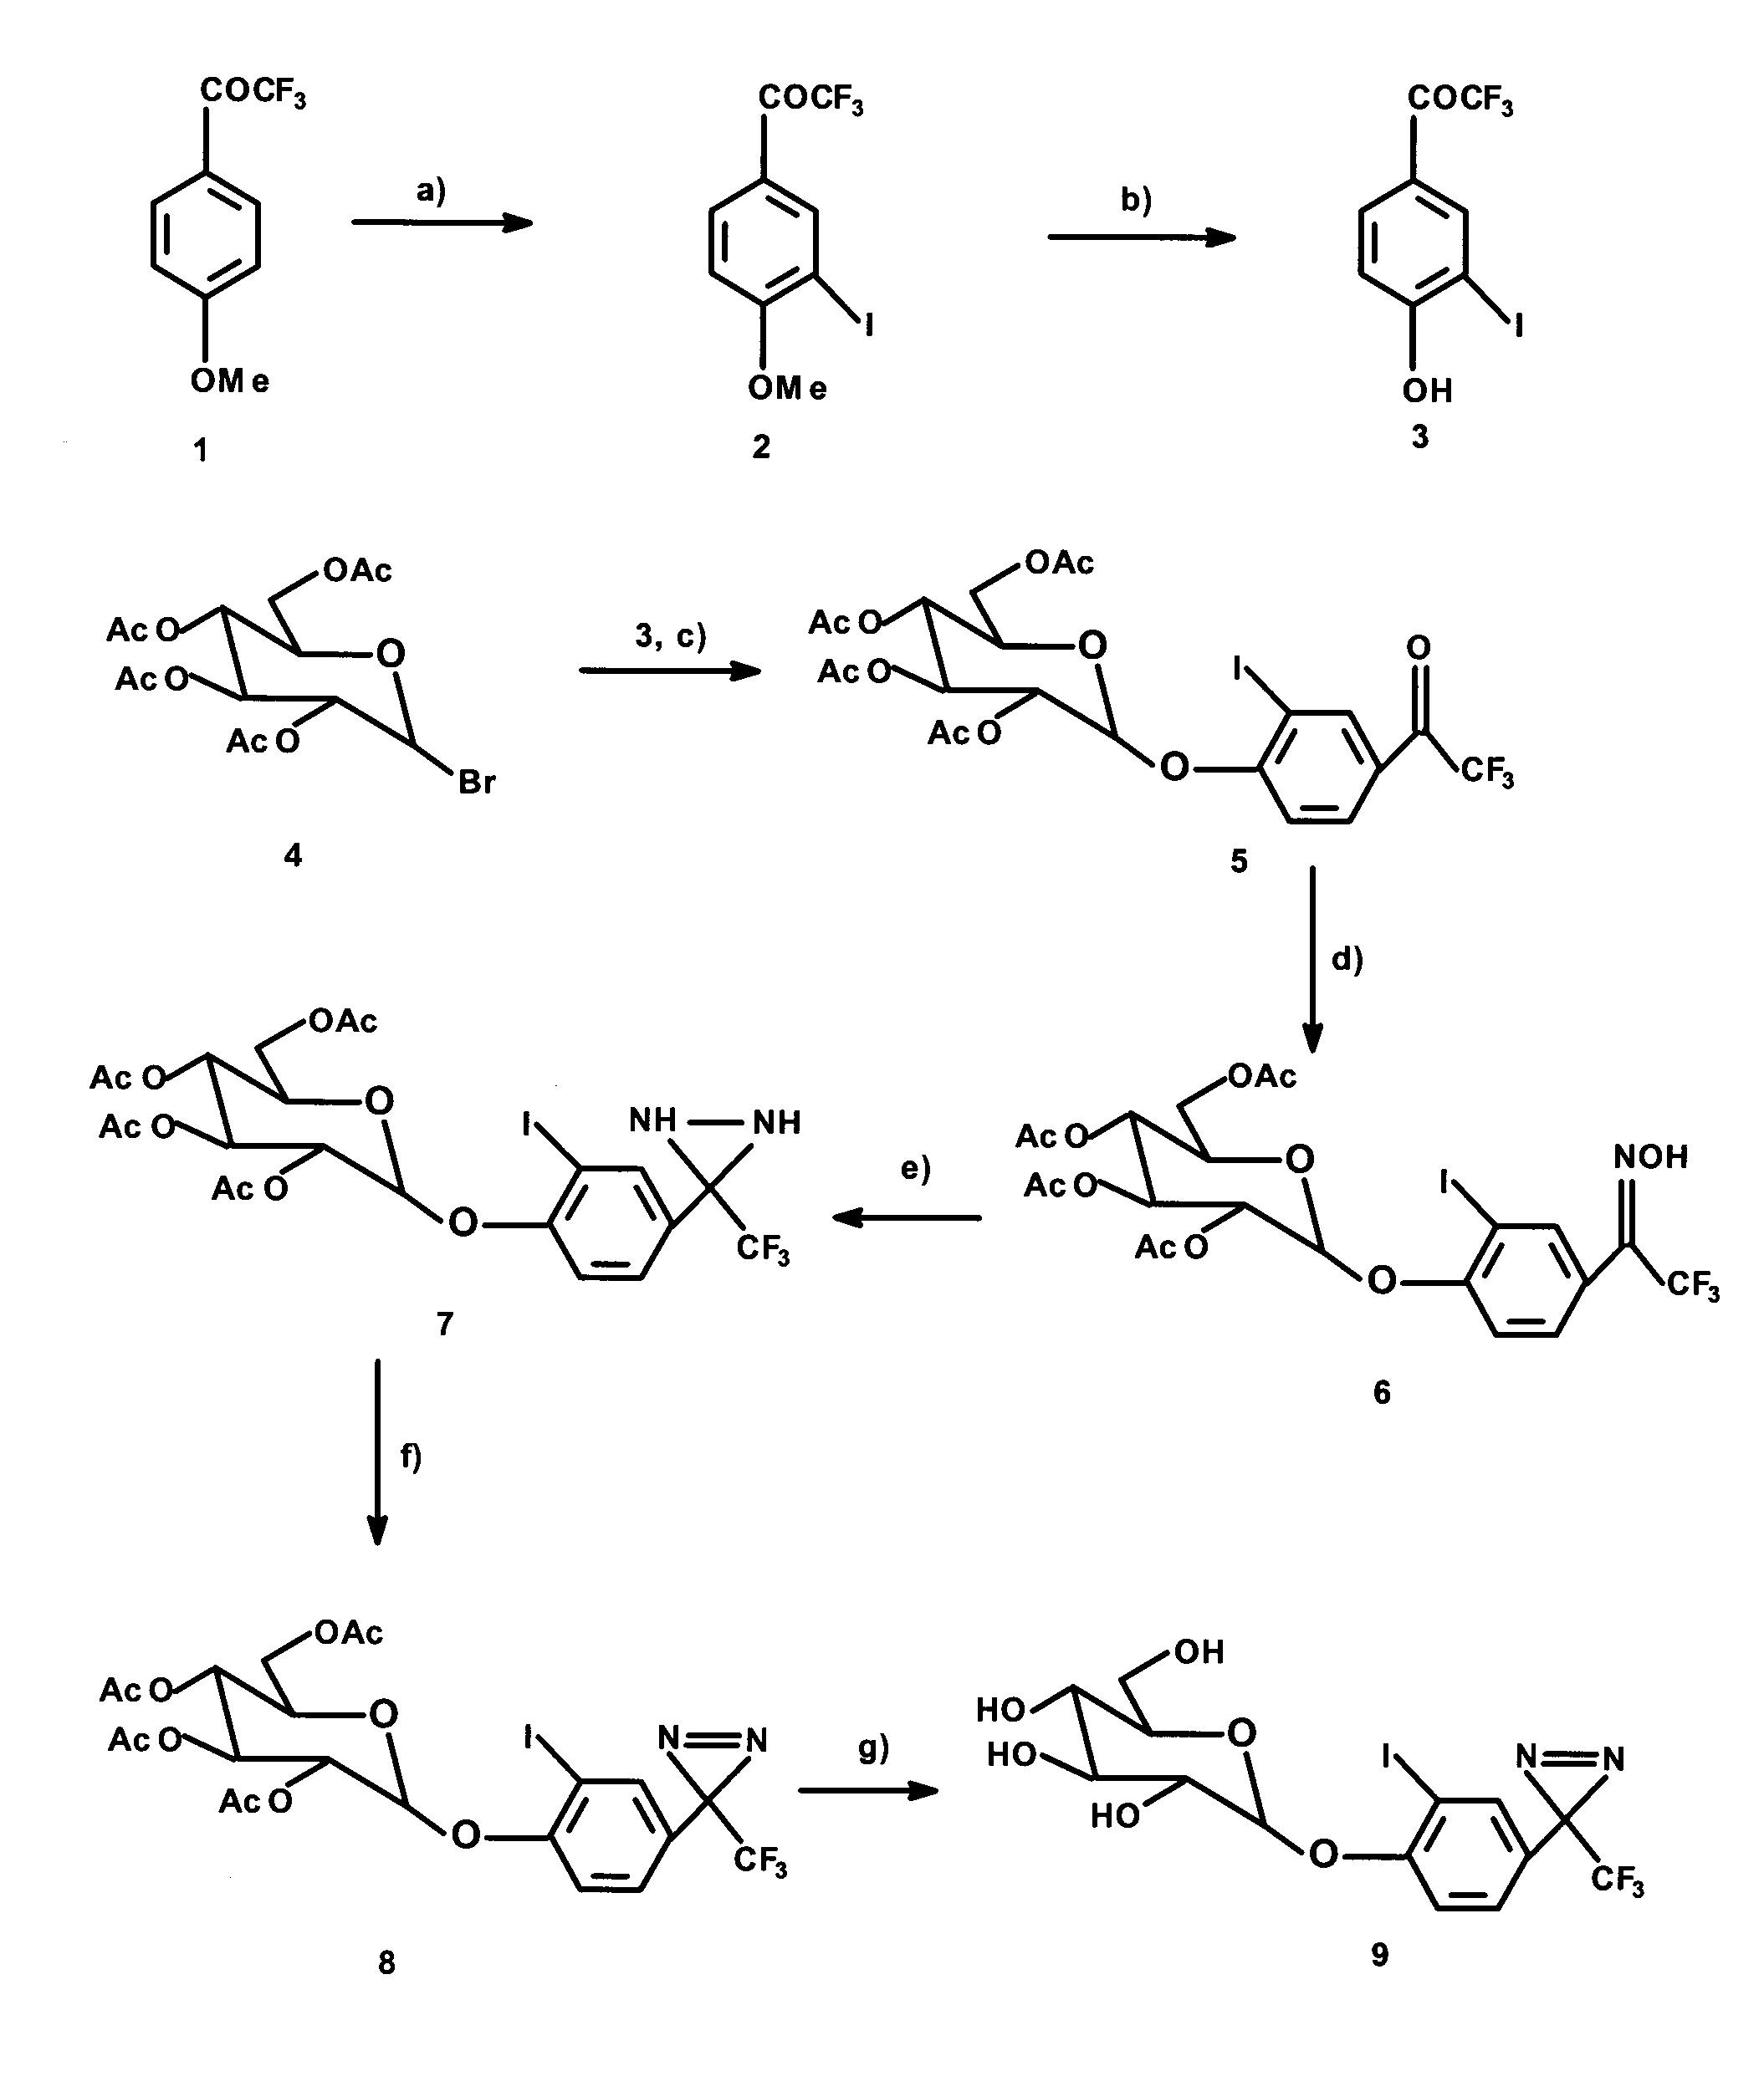
FAB-MS 658.00 (M)⁺, 681.04 (M+Na)⁺, HRMS calcd for (C₂₂H₂₂O₁₀N₂F₃NaI)⁺ 681.0168, found 681.0159.

Figure 3.6 Reaction scheme for the synthesis of TIPDG 9. The reagents were (a) I₂, HgO, conc. H₂SO₄, CCl₄; (b) LiCl, DMF; 3,4-hydroxy-3-iodo-trifluoroacetophenone; (c) Hg(CN)₂, nitro methane, benzene; (d) NH₂OH.HCl, EtOH, pyridine; (e) tosyl chloride, DMAP, Et₃N, DCM, NH₃; (f) I₂, Et₃N, MeOH; (g) NaOMe.

[(2´-Iodo-4´-(3´´-trifluoromethyldiazirinyl) phenoxy]-D-glucopyranoside (9)
Compound 8, 0.5 g (0.75 mmol) was deacylated by stirring with 10 ml dry MeOH containing 0.9 g (22.5 mmol) NaOH for 2 h at room temperature. The solution was neutralized with ion exchange resin (Amberlite IR 120, H⁺), the solvent was evaporated in vacuo and the residue was purified on a silica column (CHCl₃: MeOH = 9:1) to yield 0.36 g (98%) 9, λ_{max} (ME) = 358 nm (ε = 290 M⁻¹.cm⁻¹). ¹H NMR (CD₃OD, 400MHz): δ = 3.25 (dd, 1H, J = 7.7Hz,H-2), 3.30-3.39 (m, 3H, H-3, H-4, H-5), 3.70-3.82 (dd, 1H, J = 6.0Hz, H-6), 3.88-3.91 (dd, 1H, J = 1.6Hz, H-6), 4.27 (d, 1H, J = 7.8Hz, H-1), 7.06 (d, 1H, J = 10.8, Ar-H), 7.94-7.98 (m, 1H, Ar-H), 8.41 (s, 1H, Ar-H).
¹³C NMR (CD₃OD, 100MHz): δ = 71.51, 71.56, 75.15, 78.03, 78.15, 103.0, 117.37, 120.52, 126.92, 134.82, 171.20, 176.67, 178.07, 179.05, 179.93.FAB-MS 489.98 (M)⁺, 490.99 (M+H)⁺, HRMS calcd for (C₁₄H₁₄N₂O₆F₃I)⁺ 489.9846, found 489.9846, calcd for (C₁₄H₁₅N₂O₆F₃I)⁺ 490.9925, found 490.9927.

[(4´-Benzoyl) phenoxy]-D- glucopyranoside (BzG)

[4´-Benzoyl) phenoxy] –2,3,4,6-tetra-O-acetyl-D- glucopyranoside (11)
A solution of α-D-Acetobromoglucose 4, 5.0 g (12.16 mmol) in 50 ml of benzene and in 50 ml of nitro methane was mixed with 4-hydroxybenzophenone 10, 2.41 g (12.16 mmol), mercuric cyanide 3.07 g (12.16 mmol) and 3.9 g of molecular sieves (4Å) and the resulting mixture was stirred at 60ºC for 15 h. The reaction mixture was partitioned in between water and Et₂O and the resulting organic phase was washed with brine and dried over MgSO₄. After evaporation of the solvent in vacuo, the resulting residue was purified by column chromatography on silica (EA: PE = 1:1) to yield 4.36 g (68%) white solid compound 11. ¹H NMR (CDCl₃, 400MHz): δ = 2.01, 2.02, 2.06, 2.07 (s, 3H, H-Ac), 4.08-4.11 (m, 1H, H-5), 4.21-4.26 (m, 2H, H-6), 4.88 (dd, 1H, J_{1, 2} = 4.5Hz, H-1), 5.06 (t, 1H, J = 11.7Hz, H-4), 5.20-5.28 (m, 1H, H-2), 5.53 (t, 1H, J_{3, 4} = 9.4Hz, H-3), 6.80 (dd, 2H, J = 8.42 and 2.45Hz, Ar-H), 7.43-7.47 (m, 2H, Ar-H), 7.52-7.56 (m, 1H, Ar-H), 7.70-7.75 (m, 4H, Ar-H).
¹³C NMR (CDCl₃, 100MHz): δ = 21.08, 21.16, 21.18, 21.22, 67.34, 68.89, 70.36, 71.51, 95.67, 115.51, 128.42, 129.55, 132.27, 133.23, 138.26, 161.15, 169.99, 170.50, 170.58, 171.30, 196.61.

[(4´-Benzoyl) phenoxy]-D- glucopyranoside (12)
Deacetylation of compound 11 was carried out as follows. A mixture of 2.0 g (3.78 mmol) of 11 and 4.53 g (151.2 mmol) NaOH in 20 ml dry methanol was stirred at room temperature for 5 h. After completion of reaction the resulting reaction mixture was neutralized with ion exchange resin (Amberlite IR 120, H⁺), the solvent was evaporated in vacuo and crude product was purified by column chromatography on silica (CHCl₃: MeOH = 3:1) to yield 1.22 g (90%) white solid compound 12; mp 163 ºC; λ_{max} (ME) = 293 nm (ε = 290 M⁻¹.cm⁻¹). ¹H NMR (CD₃OD, 400MHz): δ = 3.22 (dd, 1H, J = 7.6Hz, H-2), 3.27-3.38 (m, 3H, H-3, H-4, H-5), 3.68-3.71 (dd, 1H, J = 5.9Hz, H-6), 3.87-3.90 (dd, 1H, J = 1.6Hz, H-6), 4.27 (d, 1H, J = 7.8Hz, H-1), 7.51 (t, 2H, J = 7.8Hz, Ar-H), 7.62 (tt, 1H, J = 1.7 and 6.4Hz, Ar-H), 7.69 (d, 2H, J = 8.1Hz, Ar-H), 7.83 (m, 4H, Ar-H).
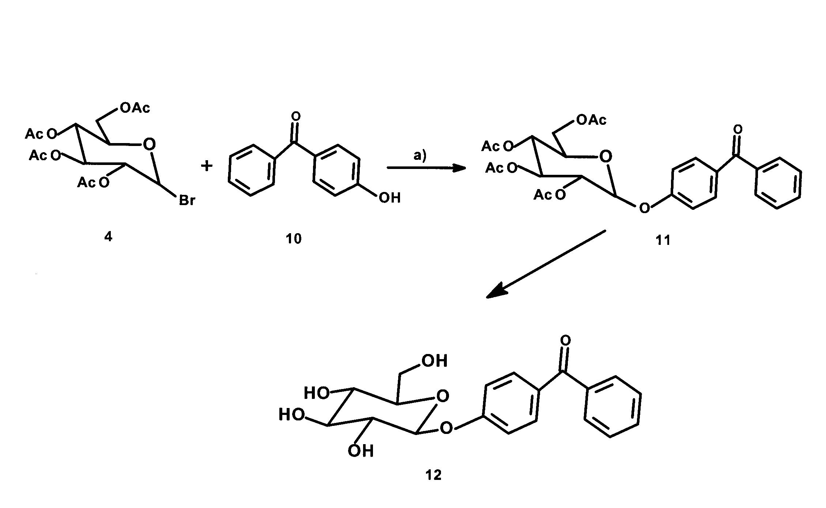

Figure 3.7 Synthesis of BzG 12. The reagents were (a) Hg(CN)₂, nitro methane, benzene; (b) NaOMe.

3-Azidophlorizin (3-AP)

3-Nitrophlorizin (14)
472 mg Phlorizin 13 was dissolved in 10 ml of glacial acetic acid. The temperature of the solution was brought to 15°C. 75 μl of nitric acid (specific gravity 1.4) was added dropwise to the solution under vigorous stirring. At the end of the reaction, the color of the solution turned to red-brown. The solution was then poured onto 20 g ice. The green precipitates were collected and dried under vacuum. For further purification, the dry precipitates were dissolved in tetrahydrofurane. The solution was passed through a neutral aluminum oxide column. The yellow solution was then concentrated and a small amount of petroleum ether 30-60°C was added until the solution became slightly turbid. After some time crystals developed. Melting point 217-218°C.

3-Aminophorizin (15)
482 mg 3-Nitrophlorizin 14 was dissolved in 5 ml ethanol and mixed with 150 mg palladium/carbon (10% Pd). Hydrogen gas was introduced into the solution gently for a period of 1 h at room temperature. The catalyst was then removed by filtration. The ethanolic solution was diluted with 10 ml of deoxygenated water and frozen immediately. Solid 3-Aminophlorizin was obtained by freeze-drying. The yield of reduction product was almost 100%. Melting point 91-93°C. During the whole procedure the reaction mixture was protected from light by aluminum foil.
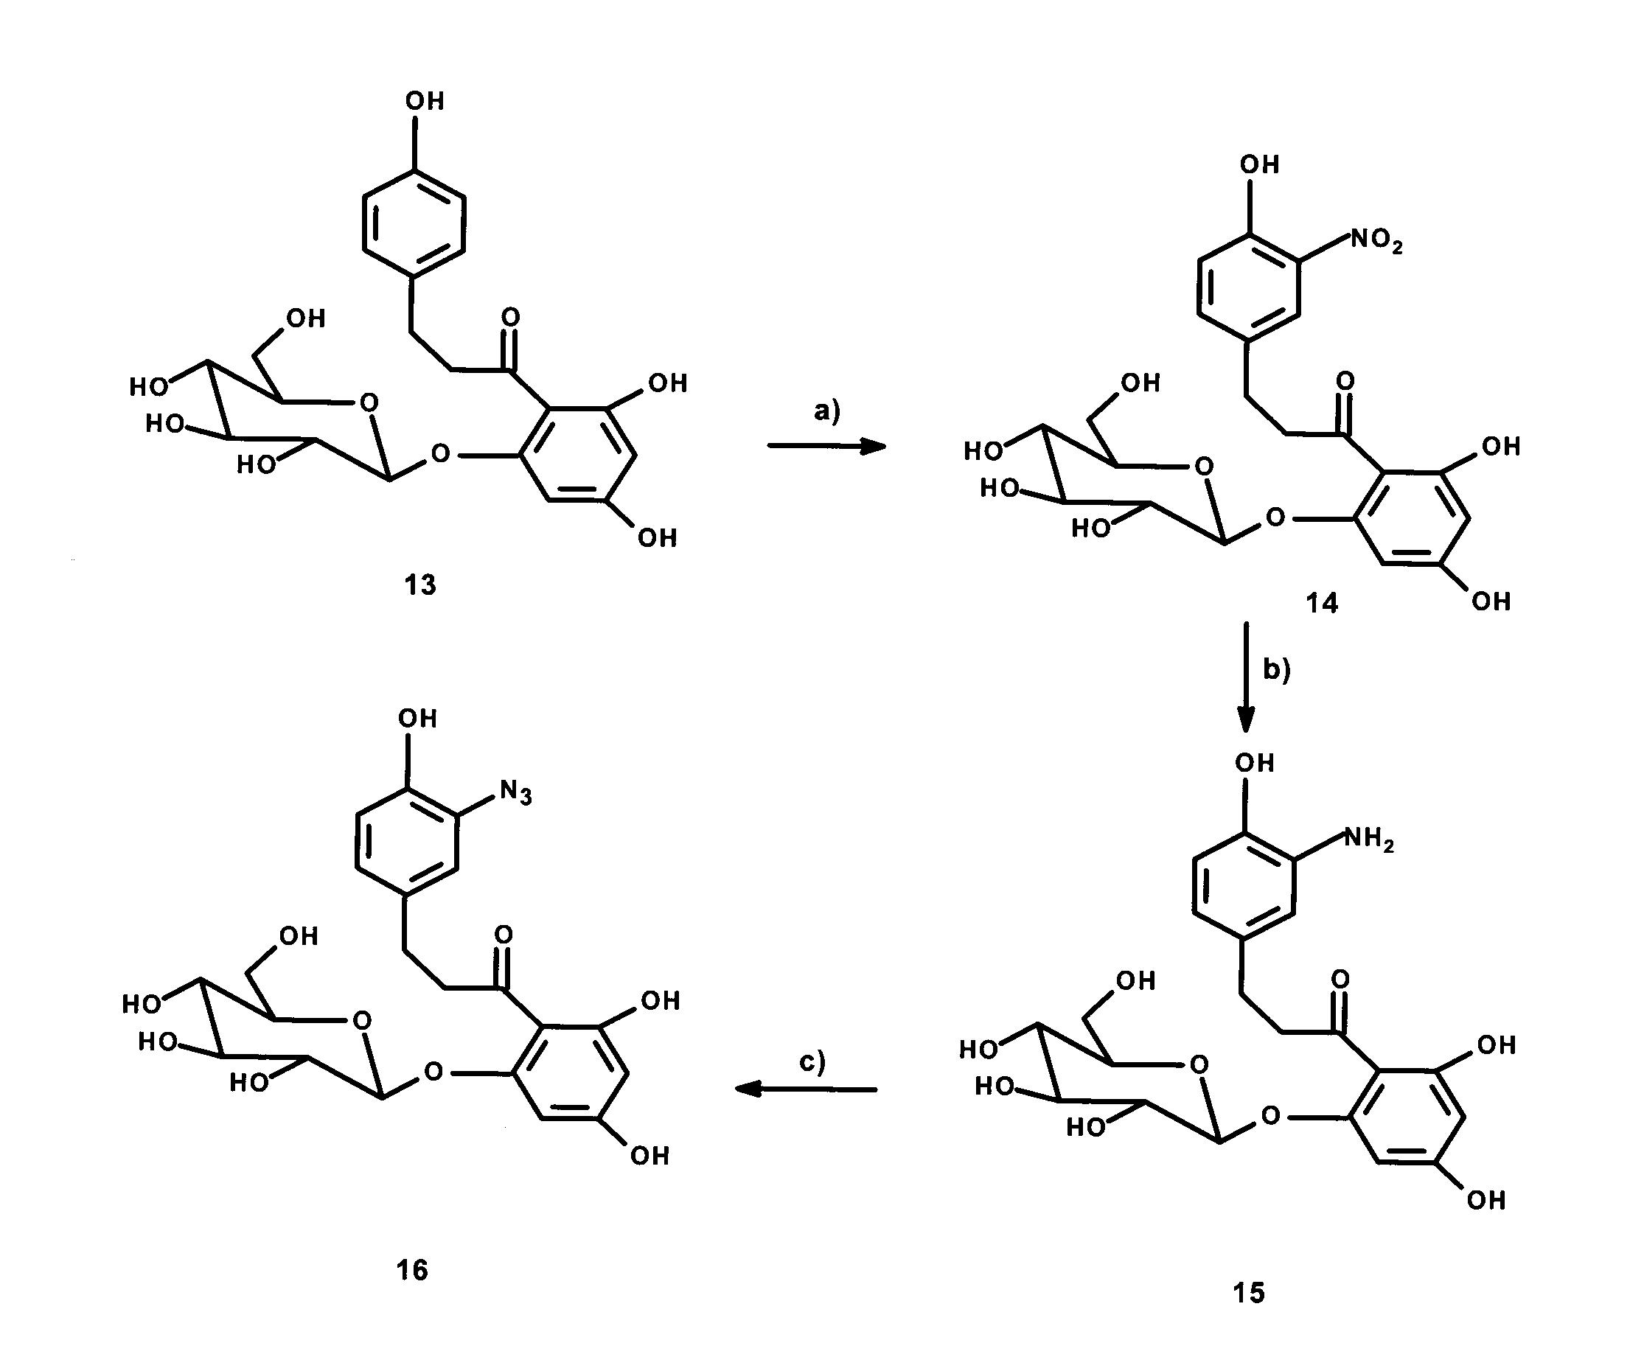

Figure 3.8 Reaction scheme for the synthesis of 3-AP. The reagents were (a) HNO₃, CH₃COOH; (b) H₂, Pd/C, EtOH; (c) NaNO₂, NaN₃.

3-Azidophlorizin (16)
45 mg of 3-Aminophlorizin were dissolved in 3 ml of 0.5 N ice-cold hydrochloric acid. The solution was cooled down to -5°C. To this solution 0.5 ml 0.2 M cold sodium nitrite was added. The reaction was allowed to proceed at -5 °C for 10 min. A deep green color developed. Subsequently, 0.5 ml of 0.2 M sodium acetate was added. The solution changed its color rapidly to red brown while bubbling occurred because of nitrogen release. A gel-like precipitate was obtained by centrifugation (low speed). The dry precipitate was then dissolved in an excess of THF. The deep brown solution was decolored by passing through a short silica gel column. After part of THF had been evaporated, a few drops of water were added to obtain 3-Azidophlorizin precipitate. Melting point 85°C (decomposed).

n-Methyl-6C- (Azimethyl)-D- glucopyranoside (6-AG)

Methyl-2,3,4-tri-O-benzyl-7-deoxy-DL-glycero-D-glucohepta-1,5- pyranoside (18)
Compound 17, 11.5 g (25 mmol) (Lehmann and Thieme, 1986) dissolved in 200 ml dry ether was added at room temperature over a period of 45 min to a stirred solution of methylmagnesium iodide prepared from 5.4 g (0.18 mol) magnesium turnings and 24.8 g (0.18 mol) methyl iodide in 310 ml dry ether. The mixture was stirred for 1 h at room temperature and poured on 400 g ice, and saturated aqueous NH₄Cl was added until precipitated magnesium salts dissolve. The organic phase was separated and the aqueous layer was extracted three times with 150 ml ether. The combined ether extracts were washed with water, dried with MgSO₄, evaporated in vacuo to yield 11.5 g (97%) as syrup. The crude product was used without further purification in next step.

Methyl-2,3,4-tri-O-benzyl-7-deoxy-D-glucohepto-1,5-pyranoside-6-ulose (19)
Compound 18, 11.5 g (24 mmol), 14.0 g (69 mmol) DCC, and 1.0 g anhydrous phosphoric acid were dissolved in 170 ml anhydrous dimethyl sulxfoside and the mixture was stirred for 19 h at room temperature. The suspension was added slowly with stirring to an ice-cold solution of 9.5 g (0.11 mol) oxalic acid in 20 ml methanol within 15 min; the mixture was stirred for 30 min and diluted with 350 ml saturated aqueous NaCl. After stirring for a further 30 min, the precipitated solid was filtered and stirred two times with 250 ml ether and filtered again. The combined ether extracts were neutralized with saturated aqueous NaHCO₃, washed with water, dried with MgSO_{4,} and evaporated in vacuo. The syrupy crude product was dissolved in boiling ethyl acetate (40 ml) and after addition of 40 ml petroleum ether it was crystallized at -20°C to yield 5.5 g (48%) 19, melting point 97°C.
¹H NMR (CDCl₃, 500MHz): δ = 2.16 (s, 3H, H-7), 3.39 (s, 3H, OCH₃), 3.54 (dd, 1H, H-2, J₂, ₃ = 9.6Hz), 3.62 (t, 1H, H-4, J₄, ₅ = 9.9Hz), 4.01 (t, 1H, H-3, J₃, ₄ = 9.5Hz), 4.12 (d, 1H, H-5), 4.61 (d, 1H, H-1, J₁, ₂ = 3.5Hz), 4.60-5.00 (m, 6H, H-Bn), 7.72-7.36 (m, 15H, H-Ph).
¹³C NMR (CDCl₃, 125.8MHz): δ = 27.85, 55.55, 74.22, 73.46, 74.84, 75.79, 78.59, 79.57, 81.77, 98.53, 127.58-128.43, 137.84, 137.96, 138.55, 204.36.

Methyl- 7- deoxy-D-glucohepta- 1, 5- pyranoside-6- ulose (20)
Compound 19, 5.8 g (12 mmol) dissolved in 200 ml methanol-ethyl acetate was debenzylated in the presence of 3.0 g palladium (10% C) by catalytic hydrogenation for 5 h with shaking using a hydrogen pressure of 3 bar at room temperature. The suspension was filtered from the catalyst and evaporated in vacuo to yield 2.5 g (100%) 20 as syrup.
For further characterization 0.86 g (4.2 mmol) 17 was per-O-acetylated by stirring with 30 ml pyridine-acetic anhydride (2:1) for 15 h at room temperature. The mixture was poured on 250 g ice, stirred for 30 min, and extracted three times with 50 ml dichloromethane. The combined organic extracts were washed with water, dried with MgSO₄, and concentrated in vacuo. The resulting syrup was purified on silica gel column to yield 0.97 g (67%) acetylated compound 21.
¹H NMR (CDCl₃, 500MHz): δ = 2.01, 2.02, 2.09 (s, 3H, H-Ac), 2.26 (s, 3H, H-7), 3.45 (s, 3H, OCH₃), 4.09 (d, 1H, H-5), 4.89 (dd, 1H, H-2, J₂, ₃ = 10.2Hz), 5.03 (d, 1H, H-1, J₁, ₂ = 3.6Hz), 5.10 (t, 1H, H-4, J₄, ₅ = 10.3Hz), 5.50 (t, 1H, H-3, J₃, ₄ = 9.8Hz).
¹³C NMR (CDCl₃, 125.8MHz): δ = 20.51- 20.63, 25.82, 55.85, 68.93, 69.47, 70.72, 73.32, 97.03, 169.64, 169.79, 170.09, 203.65.

n-Methyl-6C-(Azimethyl)-D-glucopyranoside (22)
A stream of dry NH₃ was introduced into a solution of 2.5 g (12 mmol) 20 in 100 ml dry methanol at -30°C until the volume increased about 20%. Then 2.0 g (17 mmol) hydroxyl-O-sulfonic acid was added in small portions over a time period of 1 h to the vigorously stirred mixture. The suspension was stirred for 3 h at -30°C, allowed to attain room temperature overnight, filtered, and concentrated in vacuum. A solution of the residue in 100 ml dry methanol containing 20 ml Et₃N was cooled to 0°C and iodine was added until the red color persisted. The solution was then concentrated and the residue was purified on a silica gel column to give 1.6 g (61%) pure compound 22. λ_{max} (Methanol) = 335 nm (ε = 52 M⁻¹. cm⁻¹).
For further characterization of compound 22, 0.2 g of it was per-O-acetylated as described for compound 20, to yield 0.16 g (76%) compound 23.
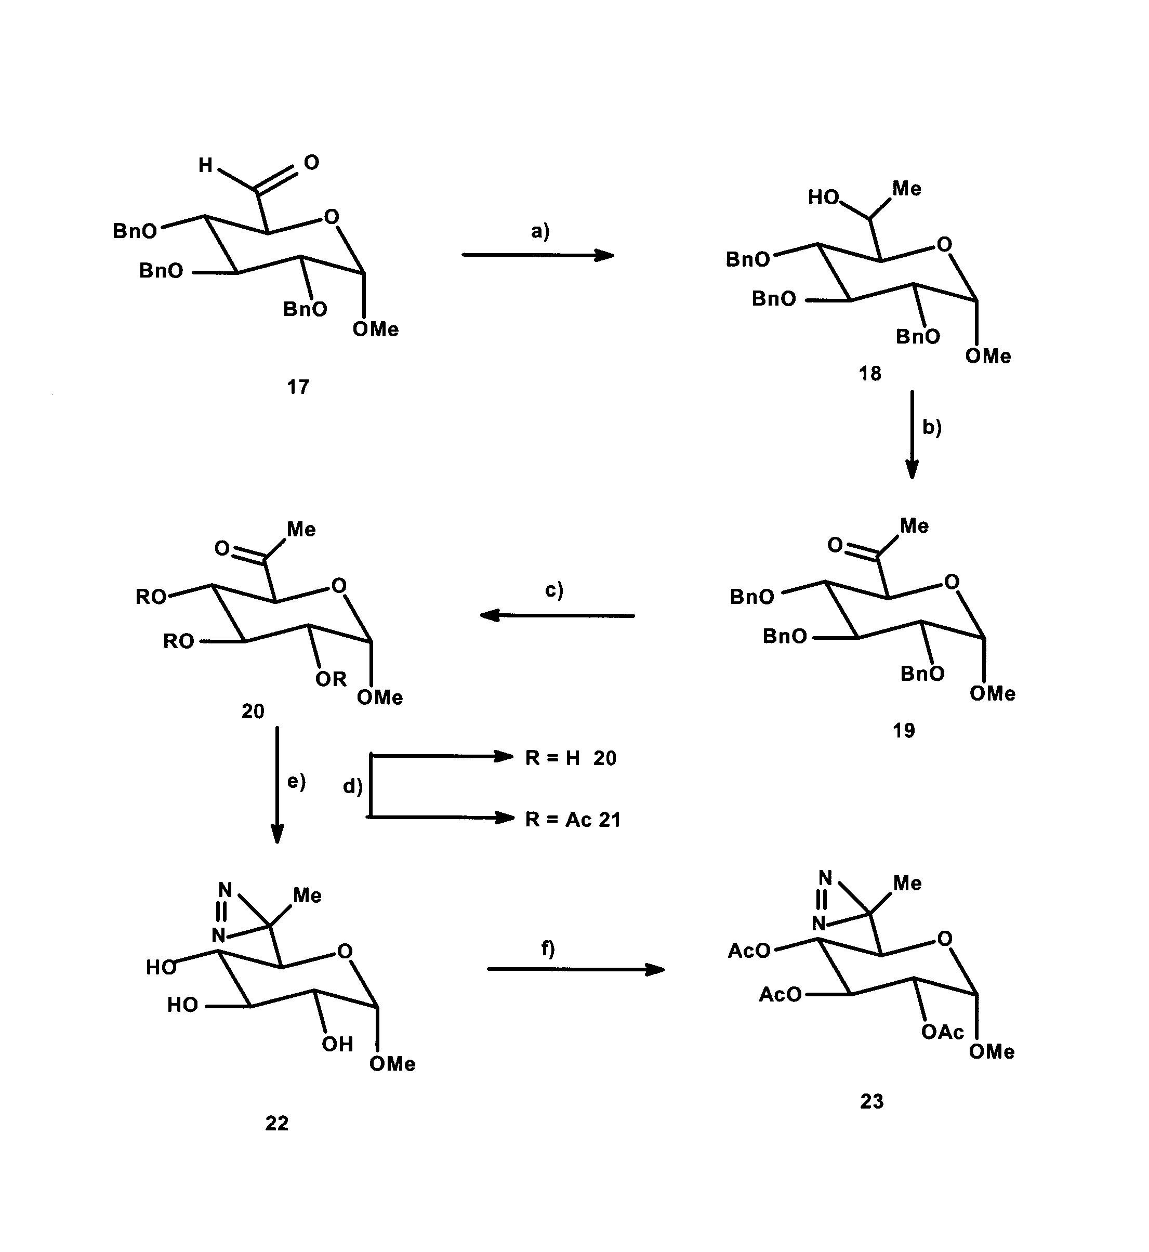
¹H NMR (CDCl₃, 500MHz): δ = 1.08 (s, 3H, H-7), 2.02, 2.07, 2.15 (s, 3H, H-Ac), 3.02 (d, 1H, H-5), 3.39 (s, 3H, OCH₃), 4.82 (dd, 1H, H-2, J_{2, 3} = 10.2Hz), 4.96 (d, 1H, H-1, J_{1, 2} = 3.6Hz), 5.03 (t, 1H, H-4, J_{4,5} = 10.3Hz), 5.37 (t, 1H, H-3, J₃, ₄ = 10.1Hz).
¹³C NMR (CDCl₃, 125.8MHz): δ = 15.15, 20.47-20.83, 25.09, 55.33, 68.58, 69.52, 70.48, 71.19, 96.56, 169.54, 169.72, 169.90.

Figure 3.9 Synthesis of 6-AG. The reagents were (a) MeMgI, H₂O; (b) Me₂SO, N, N´-dicyclohexylcarbodiimide; (c) H₂, Pd/C, EtOH; (d) Ac₂O, pyridine; (e) NH₃, hydroxylamine-O-sulfonic acid, I₂; (f) Ac₂O, pyridine.

Photoaffinity labeling of loop 13
Truncated loop 13 protein used in this study was a gift from Mobeen Raja. Before using these photoprobes as a label for truncated loop 13 we performed transport assays of these probes with rabbit small intestine brush border membrane vesicles.

Isolation of small intestine brush border membrane vesicles (BBMV)
Rabbit small intestines were obtained immediately after sacrifice of the animals. Brush border membrane vesicles (BBMV) from rabbit small intestine epithelial scratching were prepared by the magnesium precipitation method of Booth and Kenny (Booth and Kenny, 1974). Final BBMV were suspended at a concentration of 16 mg protein/ml in mannitol-Hepes-Tris (MHT) buffer (100 mmol/l mannitol, 20 mmol/l Hepes-Tris, pH 7.4, and protease inhibitor: Aprotinin 20 µg/ml, leupeptin 20 µg/ml, pepstatin 5 µg/ml, and chymostatin 5 µg/ml). The purity of the preparation was routinely determined by assaying the marker enzyme alkaline phosphatase (E.C.3.1.3.1), which was enriched 8 to 10 fold. BBMV were stored at -70°C until use and diluted to the concentration of 5 mg protein/ml with MHT buffer for transport studies.

Transport measurements
Uptake of radioactive substrate was determined at 22°C with the rapid filtration technique as described initially by Hopfer (Hopfer et al., 1973). The uptake was initiated by adding 20 µl BBMV suspension (100 µg protein) to 50 µl incubation media to give 100 mmol/l mannitol, 20 mmol/l Hepes-Tris (pH 7.4), 100 mmol/l NaSCN or KSCN, 0.1 mmol/l substrate 5µCi D-[³H] glucose, and the indicated inhibitor concentrations. The incubation was terminated after 5 s by adding 1 ml ice-cold stop solution (100 mmol/l NaCl, 100 mmol/l mannitol, 20 mmol/l Hepes-Tris and 0.2 mmol/l phlorizin, pH 7.4) followed by rapid filtration of the suspension through prewetted 0.45 µm nitrocellulose filters. After rinsing with 3.5 ml ice-cold stop solution the wet filters were dissolved in 7 ml scintillation cocktail and counted for radioactivity in a liquid scintillation counter.
Substrate uptakes presented are mean values ± S.E from at least three independent experiments, each performed in duplicate or triplicate. For statistical comparisons, Student’s t-test was used.

Photoaffinity labeling of truncated loop 13 protein with TIPDG or BzG
The photolabeling experiments were carried out in 200 µl PBS buffer (140 mM NaCl, 2.7 mM KCl, 10 mM Na₂HPO₄, 1.8 mM KH₂PO₄, pH 7.4) containing 200 µg truncated loop 13 protein and 1 mM TIPDG or with 0.5 mM BzG. The mixture was preincubated at room temperature in the dark for 5 min. After incubation, photolysis was carried out in a Rayonet photochemical reactor RPR-100, fitted with 16, 3500Å lamps at 22°C for 5 min for TIPDG and for BzG an Oriel photochemical reactor, fitted with 200 W medium pressure Hg lamp at 25°C for 30 min. As a control, the photoprobe was first exposed to UV light and then added to the protein. No labeling was observed in the absence of UV light. We also performed photoaffinity labeling of truncated loop 13 with 1 mM TIPDG in the presence of 100 μM arbutin and with 0.5 mM BzG in the presence of 15 μM phlorizin under the same conditions that were employed in the other photolabeling experiments. After photoaffinity labeling the protein was precipitated with chloroform methanol (v/v 2:1). The protein pellet was solublized with 0.1% TFA in 50% acetonitrile for MALDI-TOF mass spectrometry analysis.
Mass spectra were acquired in the positive ion, linear mode on a Voyager DE-PRO MALDI (PE- Biosystems, Shelton, USA). After mixing the solublized protein with sinapinic acid matrix (saturated sinapinic acid solution in 0.1% TFA in 50% acetonitrile), samples were deposited on a MALDI plate and dried at room temperature.

Photoaffinity labeling of truncated loop 13 protein with 3-AP
Photoaffinity labeling was performed with the photolabile phlorizin analogue 3-Azidophlorizin. The photolabeling experiments were carried out in 200 µl PBS buffer (pH 7.3) containing 200 µg truncated loop 13 protein and 1 mM 3-Azidophlorizin. The mixture was preincubated at room temperature in the dark for 5 min. After incubation, photolysis was carried out in a Rayonet photochemical reactor RPR-100, fitted with sixteen, 2800Å lamps at 22° C for 10 min. As a control, the photoprobe was first exposed to UV light and then added to the protein. No labeling was observed in the absence of UV light. After photoaffinity labeling the protein was precipitated with chloroform methanol (v/v 2:1). A small part of the protein pellet was solublized with 0.1% TFA in 50% acetonitrile for MALDI-TOF mass spectrometry analysis and the rest of the protein pellet was dissolved in sample buffer for SDS-PAGE. Proteins were separated by SDS-PAGE using NuPAGE 4-12% Bis-Tris gels (Invitrogen). Gels were stained with Coomassie Brilliant Blue G-250 (Neuhoff et al., 1985). Bands of interest were excised from gel with a clean razor blade, sliced into 1 mm³ cubes and incubated over night at room temperature with 200 µl of 50 mM NH₄HCO₃, pH 8.5, 50% acetonitrile, then dehydrated with 200 µl acetonitrile and dried in a centrifugal evaporator. Gel pieces were rehydrated with a small volume of digestion solution (50 mM NH₄HCO₃, 5 mM CaCl₂, and 12.5 ng/µl of trypsin) at 4° C for 30 min. Trypsin was used at an enzyme: substrate ratio of ~ 1:100 by weight. Digestion was allowed to proceed overnight at 37° C. Peptides were extracted from the gel pieces with 100 µl of 20 mM NH₄HCO₃ followed by 2 extractions of water: acetonitrile (1:1) plus 1% trifluoroacetic acid and finally, 1 extraction with 100 µl of acetonitrile. All extracts were combined in a fresh tube, flash frozen and dried in a centrifugal evaporator. Dried extracts were stored at -20° C until analyzed. Mass spectra were acquired in the positive ion, linear mode on a Voyager DE-PRO MALDI (PE-Biosystems, Shelton, USA). After mixing the solublized protein with 2,5-dihydroxybenzoic acid matrix (saturated DHB solution in 0.1% TFA in 50% acetonitrile) for intact truncated loop 13 protein, and for acquisition of mass spectrometric peptide map of the trypsin digested protein, 0.5 µl aliquots of the generated cleavage products were dispensed onto the sample support, followed by 0.5 µl of CHCA matrix solution (solution of α-Cyno-4-hydroxycinnamic acid in 0.1% TFA in 50% acetonitrile). Samples were deposited on a MALDI plate and dried at room temperature prior to collecting the spectra.

Results

E.coli as an expression host

Construction of different clones of hSGLT1 in pET22b vector
The full-length cDNA sequence of human sodium/D-glucose cotransporter 1 (hSGLT1) was amplified by PCR. Agarose gel electrophoresis shows the amplification of 2.0 Kbp fragments (Figure 4.10A) as expected, which corresponds to the gene size of hSGLT1. In order to further ensure that amplified gene product is hSGLT1 gene we performed its digestion with BamH1 because hSGLT1 gene contains only one BamH1 restriction site. Therefore, after BamH1 digestion it would reveal 2 DNA fragments if the PCR amplified product was correct. The predicted size of 2 DNA fragments is 1576 and 419 bp (which is in total 1995 bp), respectively. Analysis of the digestion mixture revealed that 2 DNA fragments were precisely produced by BamHI1digestion (Figure 4.10B).
The cDNA sequence encoding full-length hSGLT1 was cloned into pET22b E. coli expression vector by using EcoR1 and Xho1 restriction enzymes sites. The plasmid was transformed into E. coli DH5α strain for further replication. The restriction digestion of this clone with EcoR1 and Xho1 obtained the evidence for the successful construction of pET22b-hSGLT1 plasmid.
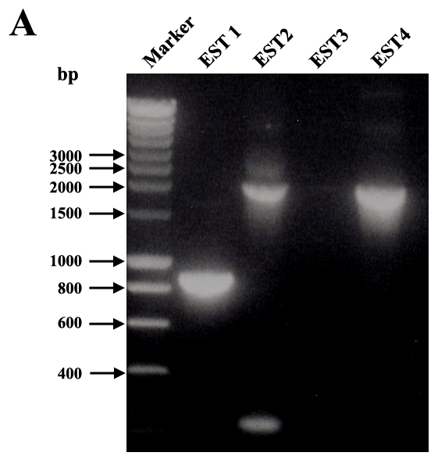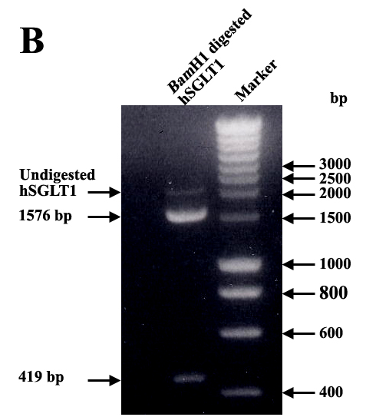
Figure 4.10 Different steps for the construction of pET22b-hSGLT1 clone. (A) PCR amplification of hSGLT1 gene by using EcoR1 and Xho1 restriction sites containing primers from EST clones. Only EST4 clone contains full-length hSGLT1 gene. (B) Agarose gel of BamH1 digested hSGLT1 gene resulted in 2 DNA fragments of 1576 and 419 bp (total 1995 bp).
In addition to the evidence mentioned above, the construct was also sequenced by using appropriate sequencing primer. The full sequence of the construct revealed that the cloning process was successful. Other constructs of hSGLT1 in pET22b expression vector were made with help of the same strategy by using their respective set of primers and restriction enzymes. Some-times it is difficult to express full-length transporter but the expression of small parts as functional domains of the transporters can be favored by using suitable hosts. Domains are known as the regions along a single polypeptide chain that can act as independent units. To that extent, they can be excised from the chain, still be shown to fold correctly, and often exhibit biological activity (Kachalsky et al., 1995; Li de La Sierra et al., 2000). So we tried to express the last seven domain of hSGLT (with 11 amino acids N-terminal part) in pET22b expression vector. Sequence encoding ΔN12-377hSGLT1 was amplified by QuikChangeSite-Directed Mutagenesis method by using ΔN12-377SGLT sense and ΔN12-377SGLT antisense primers. pET22b-ΔN12-377 hSGLT1 clone was confirmed by DNA sequencing. The same clones as mentioned in the pET22b series were also prepared using the pBAD24 vector.

Construction of pET22b-Unc-F and pET22b-Unc-F-hSGLT1 clones
Unc-F gene encodes the subunit β of F₀ membrane sector of E. coli ATP synthase (Walker et al., 1982). Fusion of Unc-F gene at the N-terminal of gene of interest resulted in a polycistronic gene, which encodes two different proteins. Over- expression of β-subunit of the E. coli ATP synthase induces a massive proliferation of membranes in E. coli C43 (DE3) strain, which helps in the proper insertion of membrane proteins (Arechaga et al., 2000), sometimes this means help in the expression of eukaryotic membrane proteins. To test this idea for the expression of hSGLT1 protein, we constructed pET22b-Unc-F (control) and pET22b-Unc-F-hSGLT1 clones by the ligation of Xba1 digested purified Unc-F gene fragment (511 bp) with similarly treated dephophorylated pET22b and pET22b-hSGLT1 expression vectors. The resulting expression plasmids pET22b-Unc-F and pET22b-Unc-F-hSGLT1 were transformed into DH5α cells for replication and for DNA isolation. It is a single enzyme ligation so the Unc-F gene can ligate into pET22b and pET22b-hSGLT1 vector into two ways, right orientation or reverse orientation. For the identification of clones containing Unc-F gene in the right orientation we performed colony PCR of these clones with primers: forward T7 promoter and reverse UncF. Clones with right orientation of Unc-F gene only shows amplification of Unc-F fragment (Figure 4.11).
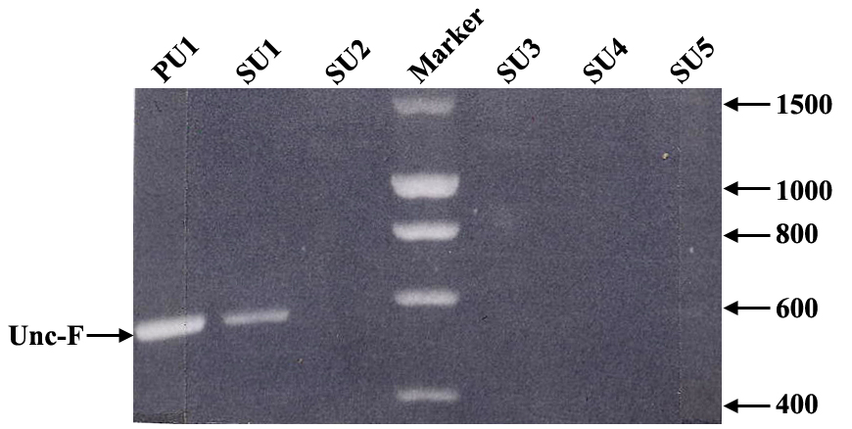
Figure 4.11 Agarose gel of PCR amplified Unc-F gene product from the clones pET22b-Unc-F and pET22b-Unc-F-hSGLT1 for the identification of positive clones with right orientation of Unc-F gene. Lane PU1 and SU1 indicate the clone containing Unc-F gene in correct orientation.

hSGLT1 expression in E.coli
Since E. coli is the first choice for heterologous expression of any foreign gene, heterologous expression of hSGLT1 was tried in E. coli. For the expression of hSGLT1 each clone was transformed into following E. coli strains (Rosetta, C41, C43, and C43Rosetta) except pET22b-Unc-F-hSGLT1 clone, which was transformed, into C43 and C43Rosetta cells. For the analytical purpose each clone was grown in 10 ml culture volume in different expression conditions (mentioned in the section 3.6.1 of Material and Methods). When O.D₆₀₀ of culture reached between 0.4-0.6, protein expression was induced by IPTG (in case of pET22b vector) and by L- (+) arabinose (pBAD24 vector). 1 ml culture was withdrawn before and after 4 h of protein induction and protein expression was probed by Western blot analysis by using anti-His tag, anti-SGLT1 and anti-FLAG tag antibodies but none of the clones tested positive for hSGLT1 expression (Table 4.5).
Table 4.5 Expression of hSGLT1 in different clones of E. coli
Clone | E. coli strain | Outcome
pET22b-hSGLT1 | R, C41, C43 and C43R* | Expression not observed
pET22b-hSGLT1-Spacer | Same | Same
pET22b-ΔN12-377 hSGLT1 | Same | Same
pET22b-ΔN12-377 hSGLT1-Spacer | Same | Same
pET22b-Unc-F-hSGLT1 | C43 and C43R | Same
pET22b-Unc-F-hSGLT1-Spacer | Same | Same
pET22b-Unc-F-ΔN12-377 hSGLT1 | Same | Same
pET22b-hSGLT1-FLAG-Spacer | R, C41, C43 and C43R | Same
pBAD24-hSGLT1-FLAG-Spacer | R, C41, C43 and C43R | Same
pBAD24-ΔN12-377 hSGLT1-FLAG-Spacer | R, C41, C43 and C43R | Same
R, Rosetta; C41, C41 (DE3); C43, C43 (DE3); C43R, C43 (DE3) Rosetta.Conditions for expression are described in Material and Methods.
However in all Western blot probed by anti- His tag antibody a specific band around 72 kDa (expected molecular weight region of hSGLT1) appears but this band is also present in control as well as in uninduced samples.
The rationale for preparing the various plasmids is briefly summarised in the following paragraph. First we constructed full-length hSGLT1 clone in pET22b vector (pET22b-hSGLT1 series), in which the sequence encoding His tag was just after C-terminal of hSGLT1 gene but in this case we could not see any expression of hSGLT1. Thus we were thinking about highly charged His tag might interfere with the proper insertion of newly synthesized protein into the membrane, which would result in degradation of protein. In order to test this possibility we constructed a second series of clones in pET22b vector (pET22b-hSGLT1-spacer series), in which we added a 10 amino acids long spacer between hSGLT1 gene and the His tag, but also in this case protein expression results were negative.
Because bacterial cotransporter posses significantly shorter N-terminal hydrophilic extensions than those in eukaryotes (Turk and Wright, 1997), we deleted the first seven helices (pET22b-ΔN12-377hSGLT1 series) but also in vain. Taking into consideration a possible advantage associated with co-expression of outer membrane protein Unc-F with our gene of interest, we constructed a new series of expression plasmid in pET22b vector (pET22b-Unc-F-hSGLT1). Results of hSGLT1 expression in this type of clones were also negative.

β-subunit of E.coli ATPase expression in pET22b-Unc-F and pET22b-Unc-F-hSGLT1 plasmids
We tested pET22b-Unc-F and pET22b-Unc-F-hSGLT1 plasmids for the expression of β-subunit of E. coli ATPase in C43 and C43Rosetta strains (Unc-F is toxic for other strains of E. coli). In this case we could not detect expression of hSGLT1 but SDS-PAGE analysis of uninduced and induced samples from pET22b-Unc-F and pET22b-Unc-F-hSGLT1 indicates quite interesting and unique band pattern (Figure 4.12). pET22b-Unc-F clone indicates very good expression of the β-subunit of E. coli ATPase around 20 kDa in the induced sample (lane 3) while as expected there was no protein band detected in the uninduced sample (lane 2) at this molecular weight. To our surprise this protein band was completely absent in case of pET22b-Unc-F-hSGLT1 clone, uninduced (lane 4) and induced (lane 5). The most interesting thing with these results is that we constructed a polycistronic gene in which protein translation is independent from each other but in one case we are getting expression of β-subunit of E. coli ATPase but when we fused the Unc-F gene with hSGLT1 gene the expression of β-subunit of E. coli ATPase was completely abolished. These results lets assume that mRNA of hSGLT1 might be unstable in E. coli and that therefore when expressed simultaneously also the mRNA of the Unc-F gene is destroyed.
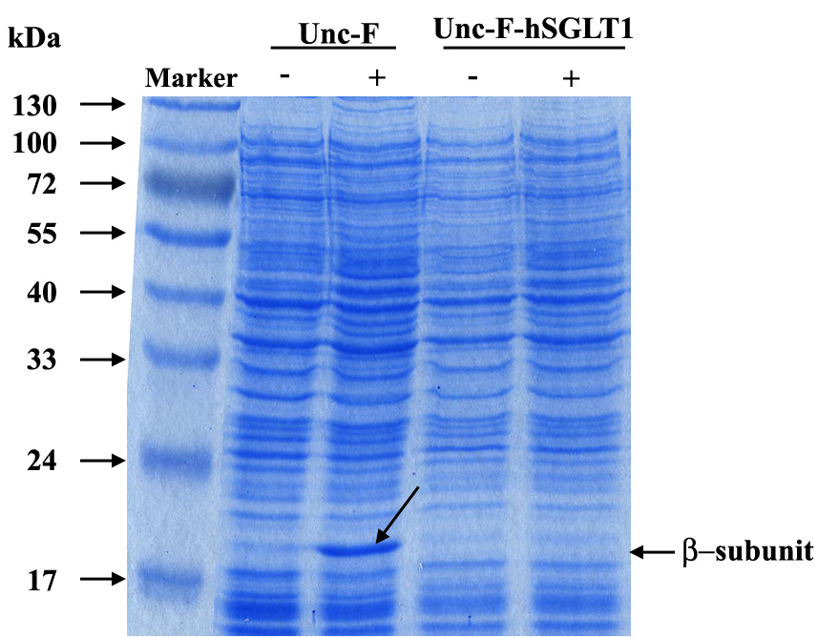
Figure 4.12 Coomassie- stained SDS-PAGE gel for the expression of β- subunit of E. coli ATPase in pET22b-Unc-F and pET22b-Unc-F-hSGLT1 plasmids. M, marker protein; PU0, pET22b-Unc-F uninduced; PU1, pET22b-Unc-F induced by 0.5 mM IPTG after 4 h of induction (position of arrow is indicating expression of β- subunit of E. coli ATPase around 20 kDa); SU0, pET22b-Unc-F-hSGLT1 uninduced; SU1, pET22b-Unc-F-hSGLT1 induce by 0.5 mM IPTG after 4 h of induction.

Messenger RNA stability of hSGLT1 in E.coli
In order to further shed light on mRNA stability of hSGLT1 and its possible implication in heterologous expression of hSGLT1 in E. coli, we performed computational analysis of hSGLT1 mRNA by RNAdraw V1.1B program, which predicts secondary structure and minimum energy (Figure 4.13). Calculated secondary structure of hSGLT1 mRNA shows energy of –541.99 kCal at 37°C with 323 CG pairs, 225 AU pairs and 96 GU pairs. Computational analysis revealed that hSGLT1 mRNA sequence contains 5 potential RNase E sites at nucleotide sequence 576, 600, 1488, 1500, and 1558 (Table 4.6). RNase E is an endoribonuclease, which degrades mRNA from 5´- to 3´ direction (Mackie, 1998). RNase E is known to cleave mRNA substrates in single stranded regions that are proceeded or followed by a stable stem-loop structure (Carpousis et al., 1994; Lin-Chao and Cohen, 1991; Melefors and von Gabain, 1988). Moreover, the stem-loop structures adjacent to the cleavages site do not affect the specificity of cleavages but can influence the rate of cleavage indirectly (McDowall et al., 1995).
While originally suggested that an RNase E cleavages site encompasses a 10 nucleotide region (ACAGA/UAUUUG) (Tomcsanyi and Apirion, 1985), subsequent analysis of many more sites indicate that RNase E prefers single-stranded regions that are typically, but not always A-U rich (Coburn and Mackie, 1999). Additionally, it is known that RNase E is a 5´-end-dependent endoribonuclease (Mackie, 1998) that prefer substrates with monophosphorylated 5´ ends to triphosphorylated termini (Lin-Chao and Cohen, 1991). The predicted RNase E sites in the mRNA of hSGLT1 are thus at positions 1488, 1500, and 1558 (see Table 4.6) and the discussion section.

Table 4.6 Predicted RNase E sites in the mRNA of hSGLT1
Cleavage site | Nucleotide sequence | Stem-loop structure adjacent to cleavage site
576 | ACAAUUACAG | Absent
600 | GUGAUUUACA | Absent
1488 | GGGAUUUCAC | Present
1500 | UAUGAUUACU | Present
1558 | GAUUAUCUGU | Present
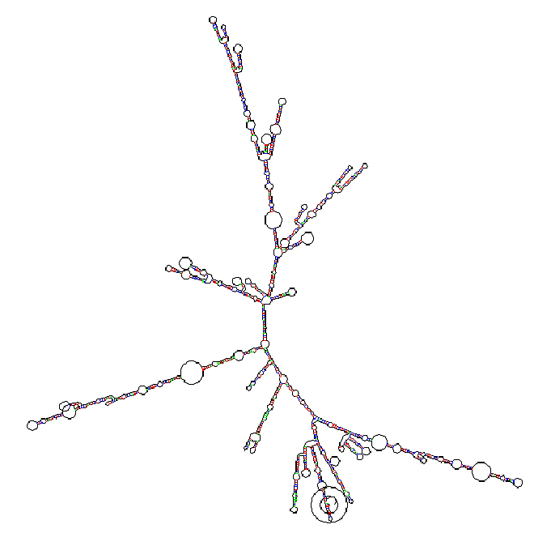
Figure 4.13 Secondary structure of hSGLT1 mRNA as calculated by RNAdraw V1.1B program.

Pichia pastoris as an expression host

Construction of expression plasmid pPICZB-hSGLT1
hSGLT1 gene was PCR amplified using an EST clone (DKFZp686N20230Q2) as a template. The cDNA coding for the human sodium/glucose cotransporter hSGLT1 was cloned into the plasmid pPICZB that uses the AOX promoter, which is able to drive over-expression of the hSGLT1 gene in P. pastoris. hSGLT1 was cloned into pPICZB vector under ´AOX´ promoter. EcoR1 and NotI restriction sites were introduced upstream and downstream of the hSGLT1 gene by PCR and the EcoR1 and Not1 containing gene fragment was cloned into the respective sites of the pPICZB vector (Figure 4.14). To facilitate immunological detection and protein purification, the FLAG epitope and 6His tag were attached to the C-terminus of the hSGLT1. In order to resolve the potential effect of 6 His tag on the proper targeting of hSGLT1 in the membrane we placed a 10 amino acids long spacer (VLYKSGGSPG) between the His tag and the hSGLT1 gene sequence. In the resulting expression vector pPICZB-hSGLT1 the hSGLT1 gene was under the transcriptional control of the AOX1 promoter, which is inducible by methanol (Figure 4.14). For further propagation and growth this plasmid was transformed into TOP10F⁻ E. coli strain and five colonies were grown in 10 ml low salt LB with 100 μg/ml Zeocin and 10 μg/ml Tetracycline for 12 h at 37°C for plasmid isolation, which was used for the identification of positive clones by EcoR1 and Not1 restriction digestion (Figure 4.15) and by DNA sequencing.
MCS hSGLT1-FLAG-Spacer-His MCS
EcoR1
Not1
AOX1
pPICZB

Figure 4.14 hSGLT1 expression construct. cDNA sequence encoding full-length hSGLT1 cloned into pPICZB vector in EcoR1 and NotI restriction sites in the multiple cloning site (MCS), for the expression of hSGLT1.
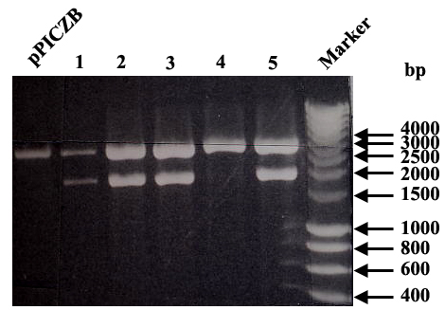
Figure 4.15 EcoR1 and Not1 restriction digestion for the identification of positive colony of pPICZB-hSGLT1 clone. Lane pPICZB E/N, pPICZB vector digested by EcoRI and NotI restriction enzymes; Lane1-5, colonies of pPICZB-hSGLT1 clone digested by EcoR1 and Not1 restriction enzymes. Only positive colonies (1, 2, 3, and 5) yield fragments of 2000 bp after EcoR1 and Not1 restriction digestion.

Identification of positive clones of hSGLT1 showing protein expression
Recombinant derivates of plasmid pPICZB linearized by digestion with Pme1 typically integrate at the AOX locus as a single copy, but multiple copy integration occurs with a frequency of 1 to 10%. Resistance to higher levels of Zeocin correlates with higher copy number for the integrated plasmid, which usually (Romanos et al., 1998) but not always (Clare et al., 1991) correlates with higher levels of expression of the recombinant protein of interest. In our case clones selected on 1000 μg/ml Zeocin concentration give the highest yield of hSGLT1 as judged by Western blot analysis by anti-FLAG antibody (Figure 4.16), so for further expression we used the clone of this plate.

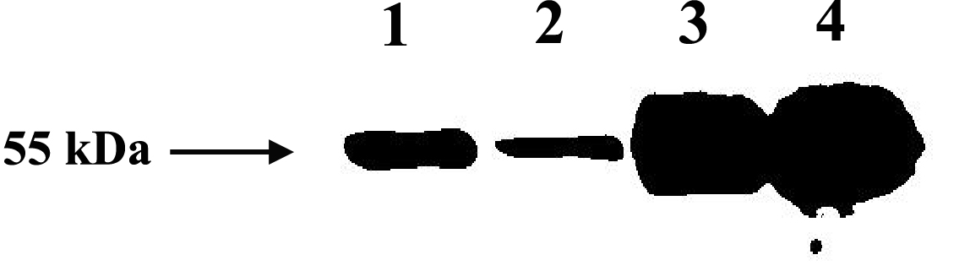
Figure 4.16 Western blot analysis by anti-FLAG antibody for the identification of positive clones for hSGLT1 expression. Clones 1 and 2 were selected from 500 μg/ml Zeocin plate whereas 3 and 4 were selected from 1000 μg/ml Zeocin plate. Clones 1, 2, 3, and 4 show expression of hSGLT1. Clones from 1000 μg/ml Zeocin plate shows highest expression of hSGLT1.

Optimization of feeding and induction in the shake flask cultures
For expression of proteins using the AOX1 promoter it is important to keep the methanol level within a relatively narrow range. In bioreactors this can be achieved by different control methods (Cereghino and Cregg, 2000). For expression in shake flasks Guarna (Guarna et al., 1997) introduced a technique for on-line monitoring of methanol concentration. This still requires significant technical effort. Our aim was to empirically optimize a feeding protocol for our host strain (GS115, methanol using genotype), which works without any measuring devices and is, therefore, suitable for optimization. Sofar most expression protocols for shake flask scale are based on the recommendations by Invitrogen Corporation, USA, where 0.5% methanol (v/v) are added to start induction and the rest addition of 0.5% (v/v) methanol occurs after 24 h.
To determine the optimum course of methanol feeding we varied the amount of methanol added to the culture. We decided to add methanol twice a day instead of 24 h to minimize concentration shifts in the medium. The medium used was BMMY. Our results shows that after 24 h of induction a methanol feed of 1% twice a day led to a 2 times higher protein expression than a methanol feed of 0.5% (v/v) twice a day as judged by Western blot by anti-FLAG antibody (Figure 4.17). Sofar induction with 1% (v/v) methanol and feeding with 1% (v/v) methanol twice a day gave optimal results in our expression system.

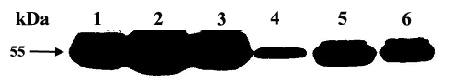
Figure 4.17 Western blot analysis by anti-FLAG antibody for the optimization of feeding and induction in shake flasks. Clones from 1000 μg/ml Zeocin plate were grown in the same condition but induced in different conditions. 1, 2, 3 induced and feed with 1% methanol twice in 24 h. 4, 5, 6 same clones (1, 2, 3) induced and feed with 0.5% methanol once in 24 h.

Purification of hSGLT1 from Pichia pastoris
The clone with the highest protein yield was grown in BMGY medium supplemented by 100 μg/ml Zeocin for 30-36 h at 28°C for O.D₆₀₀ of 2-4/ml and then transferred to methanol containing medium (BMMY with 100 μg/ml Zeocin) to induce protein expression for 24 h. After expression, cells were disrupted in breaking buffer containing protease inhibitor cocktail with vigorous vortexing with acid washed chilled 0.5 mm glass beads. The cell pellet obtained by high-speed ultra centrifugation was washed with 4 M urea to remove peripheral membrane proteins. The stripped membranes were solublized in 1.2% FosCholine-12 in TG buffer at 4°C overnight and the solublized material was removed by high-speed centrifugation. The clear supernatant was applied to a preequilibrated Protino Ni-resin column for the purification of hSGLT1 by using buffer TG with 250 mM imidazole. The obtained protein was more than 95% pure as judged from Coomassie stained SDS gels (Figure 4.18A). Western blot analysis of different steps of hSGLT1 purification by anti-FLAG antibody (Figure 4.18B, lane I, L1, P1, and S4) reveal some proteolytic degradation of the recombinant transporter (protein bands around 30 kDa range), even though all purification steps were carried out at 0-4°C. These degradation products were completely absent in purified hSGLT1 (Figure 4.18B, lane hSGLT1).
Purified hSGLT1 migrates on SDS-PAGE at an apparent mass of 55 kDa (Figure 4.18A, lane hSGLT1), which corresponds to that of the nonglycosylated transporter (Firnges et al., 2001; Panayotova-Heiermann et al., 1997; Quick and Wright, 2002) and is recognized by anti-FLAG antibody (Figure 4.18B) and by anti-hSGLT1 and anti-His tag antibodies. The 1-liter culture of P. pastoris gives 3 mg of purified protein.
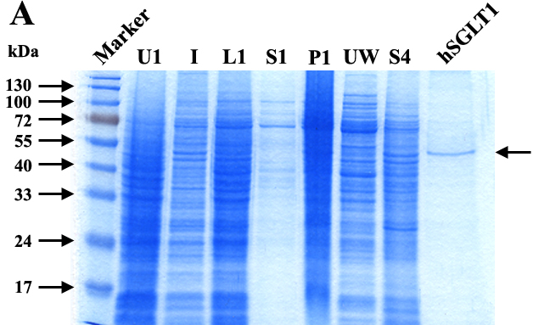

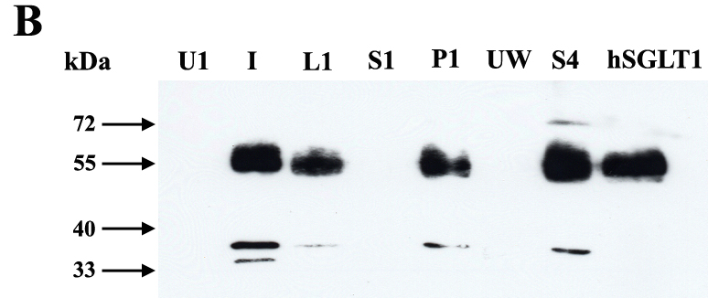
Figure 4.18 Coomassie- stained SDS-PAGE gel and immunoblot of it with anti-FLAG antibody during different stages of hSGLT1 purification. (A) M, protein marker; UI, uninduced sample; I, induced sample after induction of 1% methanol; L, whole cell lysate after lysis of Pichia pastoris cells expressing hSGLT1; S1, supernatant; P1, pellet after high-speed centrifugation; UW, washing obtained after 4 M urea wash to pellet P1; S4, supernatant obtained after solublization of urea wash pellet in 1.2% FosCholine-12; and hSGLT1, Protino column purified hSGLT1 which shows an apparent molecular mass of 55 kDa (marked by arrow). (B) Western blot of above mentioned SDS-PAGE gel with anti-FLAG antibody.

Functional analysis of recombinant hSGLT1 in right-side-out membrane vesicles
Functionality of hSGLT1 was confirmed by determining sugar uptake (50 μM α-MDG) by right-side-out vesicles of P. pastoris GS115 producing hSGLT1, shown in Figure 4.10, when stimulated by sodium a rate of 273 ± 11 nmol × mg of membrane protein⁻¹ × min⁻¹ is observed. The uptake is almost completely blocked by phlorizin (29 ± 4 nmol × mg of membrane protein⁻¹ × min⁻¹). For the control vesicles, there was no significant difference in sugar uptake in the presence or absence of Na⁺ (33 ± 3 nmol × mg of membrane protein⁻¹ × min⁻¹), transport was also not affected by the addition of phlorizin.

Figure 4.19 Sugar uptake by right-side-out vesicles of P. pastoris expressing hSGLT1. 50 μM α-MDG uptake by right-side-out vesicles of P. pastoris GS115 producing hSGLT1 is stimulated by sodium (Na⁺, 100 mM) and inhibited by phlorizin (Phlz, 10 μM). No sodium-dependent, phlorizin-sensitive uptakes were observed with vesicles of GS115 harboring plasmid pPICZB as a control. For the control vesicles, there was no significant difference in sugar uptake in the presence or absence of Na⁺ (33 ± 3 nmol × mg of membrane protein⁻¹ × min⁻¹), transport was also not affected by the addition of phlorizin.

Functional analysis of recombinant hSGLT1 in prteoliposomes
For reconstitution of purified hSGLT1, performed liposomes made of 90% (w/v) asolectin soy lecithin and 10% (w/v) cholesterol were titrated with Triton X-100 and solublization was followed by turbidity measurements. The detergent concentration was adjusted to the onset or total solublization of lipid. After mixing of the detergent-destabilized liposomes with the purified transporter, detergent was removed by addition of Bio-Beads SM-2 in three steps, first two steps at room temperature and third step at 4°C overnight.
The time course of 10 μM α-MDG uptake into the proteoliposomes in the presence and absence 100 mM Na⁺, and in the presence of 100 μM phlorizin is shown in Figure 4.20. In the presence of 100 mM Na⁺, sugar transport peaked within 30 min at 313 ± 13 nmol α-MDG per mg of recombinant hSGLT1 before falling to the concentration equilibrium of about 60 nmol α-MDG per mg of recombinant hSGLT1 in more than 5 h time. The time course of α-MDG uptake in proteoliposomes demonstrated a classical overshoot (Kinne, 1976; Lucke et al., 1978) in the presence of Na⁺, indicating that sugar was concentrated within the proteoliposomes and that uptake was energised by the Na⁺electrochemical gradient via secondary active cotransport. The overshoot is absent if there is no sodium gradient across the membrane. These finding indicate a coupling of sodium flux to glucose flux.
Figure 4.20 Time course of sugar uptake into proteoliposomes containing purified recombinant hSGLT1. The time course of 10 μM α-MDG in the presence of 100 mM sodium () shows a 35 fold of increase in the initial rate of sugar uptake before reaching concentration equilibrium in 5 h. After addition of 100 μM phlorizin () or removal of Na⁺ (), the initial rate was identical to control liposomes () and sugar accumulation above the equilibrium was not observed.
In order to further check the functionality of purified recombinant hSGLT1, we performed sugar uptake in the proteoliposomes composed of hSGLT1 asolectin soy lecithin and cholesterol. Proteoliposomes take-up 1874 ± 65 nmol × mg⁻¹hSGLT1 × min⁻¹ (Figure 4.21) as compared to 125 ± 24 nmol × mg⁻¹hSGLT1 × min⁻¹ by liposomes alone. Sodium-dependent α-MDG uptake was completely blocked by 10 μM phlorizin (Figure 4.21).
Phlorizin is a potent high-affinity competitive inhibitor of sugar transport by SGLT1 in native tissue, brush border membrane vesicles, Xenopus oocytes, and reconstituted in proteoliposomes (Diedrich, 1966; Diez-Sampedro et al., 2001; Ikeda et al., 1989; Quick and Wright, 2002; Schultz and Curran, 1970) with a half-maximum inhibition constant (K_{i}^{Phlorizin}) in the micromoler range. In our study, 10 μM phlorizin inhibited the initial rate of α-MDG transport in membrane vesicles by 89% (Figure 4.10), whereas the same concentration of phlorizin in proteoliposomes inhibits uptake by 86% (Figure 4.21).
Figure 4.21 Sugar uptake kinetics of proteoliposomes containing purified recombinant hSGLT1. 50 μM α-MDG uptake by proteoliposomes made of purified hSGLT1 transport 1874 ± 65 nmol × mg of hSGLT1⁻¹ × min⁻¹ in a sodium-dependent manner (when 100 mM Na⁺ was replaced by 100 mM K⁺ transport slows down to 598 ± 3 nmol × mg of hSGLT1⁻¹ × min⁻¹) and 10 μM phlorizin inhibited sugar transport upto 251 ± 39 nmol × mg of hSGLT1⁻¹ × min⁻¹), whereas liposomes (control) transported only 125 ± 24 nmol × mg of hSGLT1⁻¹ × min⁻¹.
The sugar selectivity of recombinant hSGLT1 in proteoliposomes was measured by determining the uptake of 100 μM α-MDG in the presence of 10 mM D-Glucose (D-Glc), D-Galactose (D-Gal), 2-Deoxy-D-Glucose (2Doglc), Mannose (Man), Allose (All), L- Glucose (L-Glc), and 100 μM phlorizin (Phlz) in the presence of 100 mM Na⁺. High-affinity substrates of hSGLT1 D-Glc and D-Gal inhibited Na⁺-dependent α-MDG by 70% and 72%, while low affinity substrates 2Doglc, Man, All, and L-Glc inhibited sugar uptake 44%, 18%, 15%, and 2% respectively and in the presence of 100 μM phlorizin the Na⁺-dependent sugar uptake was reduced to 84% of original value (Figure 4.13, Table 4.7). hSGLT1 in proteoliposomes exhibits substrate specificity in the following order, Phlz >> α-MDG ≈ D-Glc ≈ D-Gal >> 2Doglc > Man > All > L-Glc.
Recombinant reconstituted hSGLT1 shows sterospecificity as it preferred D-Glu over L-Glu, D-Glu inhibited 75% α-MDG uptake L-Glu, inhibited only 2%. Furthermore, the sugar selectivity of the reconstituted recombinant hSGLT1 appears to be similar to that reported for transporter in different systems (Diez-Sampedro et al., 2000; Firnges et al., 2001; Kinne, 1976; Quick and Wright, 2002). The equatorial orientation of the OH-group at the positions C-2 and C-3 of the D-glucose seems to be important for its recognition by hSGLT1 since in the presence of mannose, 2-Deoxy-D-glucose and allose the significant inhibitory effect on α-MDG uptake was observed. The importance of the equatorial OH-group orientation at the C-2 and C-3 was also reported for the renal SGLT1 (Burckhardt and Kinne, 1992). The 78% inhibition of α-MDG uptake in the presence of D-galactose indicates that the orientation of OH-group at C-4 (equatorial in D-glucose and axial in D-galactose) is not that important for the recognition by cotransporter because D-Glu and D-Gal inhibited sugar uptake by transporter upto equal extent (Table 4.7), Phlz inhibited 84% of α-MDG uptake in proteoliposomes.
Figure 4.22 Sugar uptake kinetics of proteoliposomes containing purified recombinant hSGLT1. Uptake of 100 μM α-MDG is inhibited by high-affinity substrates or inhibitors of hSGLT1 (10 mM D-glucose, D-Glc; 10 mM D-galactose, D-Gal; 100 μM phlorizin, Phlz) but not by low-affinity substrates (e.g., 10 mM 2-deoxy-D-glucose, 2Doglc; 10 mM mannose, Man; 10 mM allose, All; 10 mM L- glucose, L-Glc).
Table 4.7 Effect of various substrates and inhibitors on the uptake of 100 μM α-MDG as shown in Figure 4.13.
Substrate/ Inhibitor Concentration used % of α-MDG uptake inhibition
None 100 μM 0
D- Glu 10 mM 75
D- Gal 10 mM 78
2- Doglc 10 mM 44
Man 10 mM 18
All 10 mM 15
L- Glu 10 mM 2
Phlz 100 μM 84
For the determination of sugar uptake kinetics parameters, 1 min α-MDG uptake assays were performed by varying α-MDG concentration from 0.01 to 25 mM. A half–saturation constant (K_{m} ^{sugar}) of 0.4 ± 0.05 mM/L and a maximum velocity (Vmax) of 3.4 ± 0.34 μmol × mg hSGLT1⁻¹ × min⁻¹ was observed (Figure 4.23). The carrier catalytic turnover number (King et al., 1993; Napoli et al., 1995), an index of number of sugar molecules transported per transporter was calculated by dividing the sugar transport Vmax by the total number of transporter present in the proteoliposomes. Catalytic turnover of hSGLT1 based on the Vmax of 3.4 μmol × mg hSGLT1⁻¹ × min⁻¹ is 6 s⁻¹ (Table 4.8), which is in good agreement with that obtained in previous studies (Quick and Wright, 2002) and other Na⁺-dependent transporter [e.g., the Na⁺/glucose transporter of Vibrio parahaemolyticus (vSGLT) (Turk et al., 2000), and the Na⁺/ proline transporter of Escherichia coli (PutP) (Jung et al., 1998)].
Figure 4.23 Sugar uptake kinetics of proteoliposomes containing purified recombinant hSGLT1. Concentration dependence of the initial-rate sugar uptake shows a half-saturation constant ((K_{m} ^{sugar}) of 0.4 ± 0.05 mM/L and maximum velocity (Vmax) of 3.4 ± 0.34 μmol × mg hSGLT1⁻¹ × min⁻¹.
Table 4.8 Kinetics of hSGLT1 in different systems.
Kinetic parameters | Xenopus oocytes∗ | Proteoliposomes• | Proteoliposomes  This study
Kinetic parameters | hSGLT1 hSGLT1ΔN-GFP hSGLT1
K_{m} ^{sugar}, mM/L 0.41 ± 0.03 0.38 ± 0.1 0.4 ± 0.05
Turnover number, s⁻¹ 50 4 6
•Reported values in previous studies(Quick and Wright, 2002).

Synthesis and Characterization of different photoaffinity probes
In order to study the functional domains of SGLT1 photoaffinity labels were synthesized. They were derived from phlorizin a non-transported inhibitor, from arbutin, a transported inhibitor of SGLT1 and a D-glucose based label. The aim of these studies is to obtain information about the important contact points within the transporter at different depth and in various conformations.
In the following section we describe the synthesis, photochemical properties, stability, effects of these probes on SGLT1 mediated glucose uptake in natural membranes and photoaffinity labeling of an isolated recombinant functional domain of SGLT1. In the future above labels will be employed for the photoaffinity labeling of whole recombinant hSGLT1.

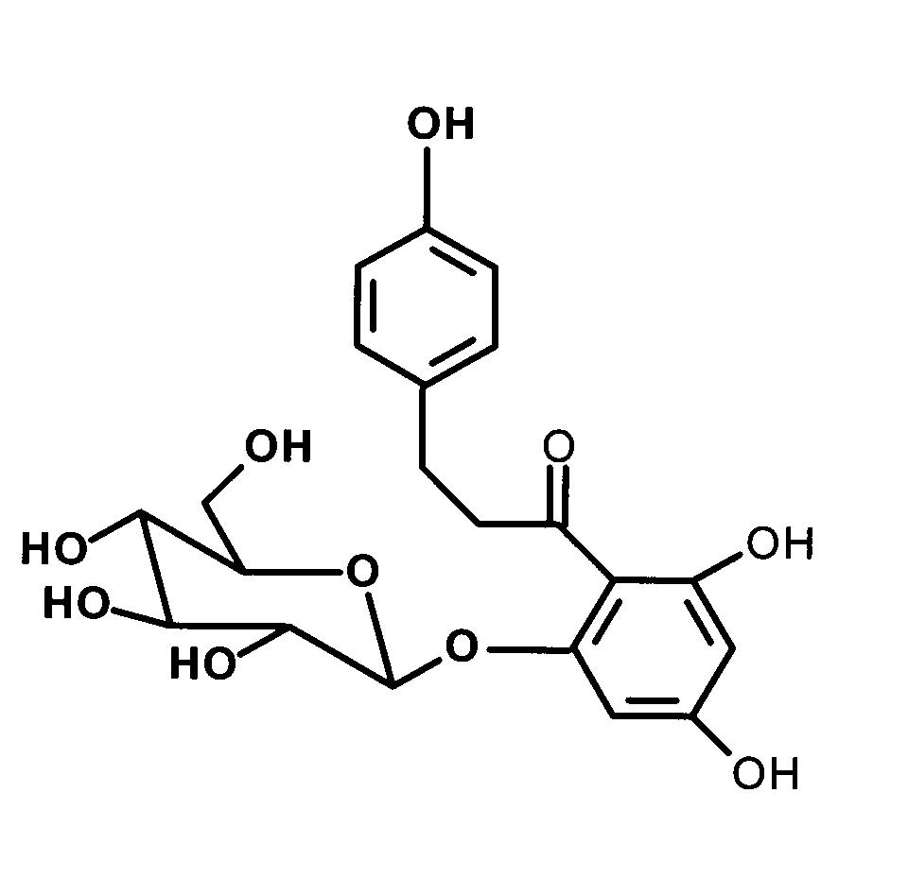
Synthesis of labels BzG and 3-AP for the identification of phlorizin interaction sites
A

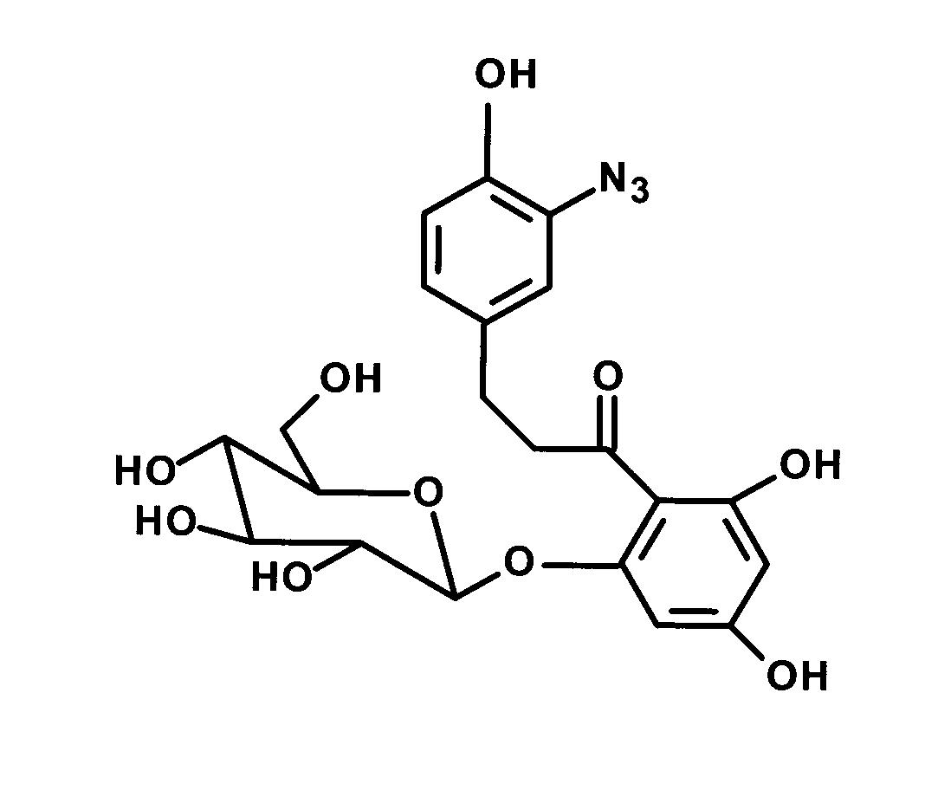
B
C
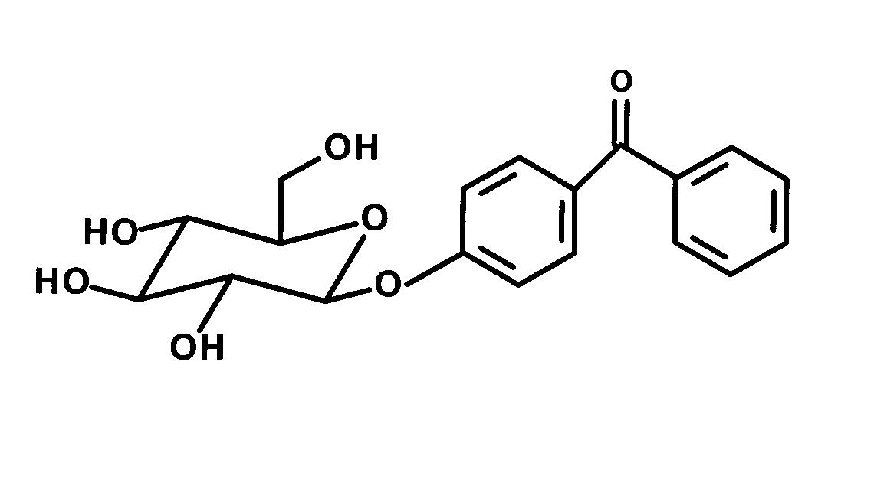

Figure 4.24 Chemical structure of photoaffinity probes and their sibling. (A) Phlorizin highest-affinity inhibitor of sugar uptake by SGLT1, (B) [(4´-Benzoyl) phenoxy]-D- glucopyranoside (BzG), (C) 3-Azidophlorizin (3-AP).
BzG and 3-AP were synthesized to identify phlorizin interactions sites in the cotransporter. The scheme for BzG synthesis (compound 12) is given in Figure 3.3. Compound 11 was obtained by the reaction of α-D-acetobromoglucose 4 with 4-hydroxybenzophenone 10 in the presence of mercuric cyanide, which was further deacetylated to give final compound 12 in 98% yield.
The synthesis scheme for 3-AP (compound 16) was shown in Figure 3.8. 3-Nitrophlorizin (compound 14) was obtained by simple nitration of phlorizin, which was subsequently reduced to 3-aminophlorizin (compound 15). The transformation of 3-aminophlorizin into 3-azidophlorizin by reacting it in the cold with dilute hydrochloric acid and sodium nitrite followed by addition of sodium azide to the diazonated phlorizin represents a classical reaction in organic chemistry. The infrared absorption at 2170 cm⁻¹ of the final product is characteristics for the azido group.

Synthesis of label TIPDG for the identification of arbutin ineraction sites
In order to get information about arbutin binding sites in cotransporter we have synthesized TIPDG. The reaction scheme for the synthesis of TIPDG 9 is presented in Figure 3.6. The coupling of α-D-acetobromoglucose 4 with 4-hydroxy-3-iodo-trifluoroacetophenone 3 gave the corresponding keto compound 5, in 75% yield. Keto compound 5 on reaction with hydroxylamine hydrochloride gave oxime 6, which was finally converted into aceto TIPDG 8 by the reaction of oxime 6 with triethylamine, DMAP, P-toluenesulfonyl chloride, and NH₃ and oxidation of diaziridine 7 with iodine. TIPDG 9 was obtained after deacetylation of compound 8.
A
B
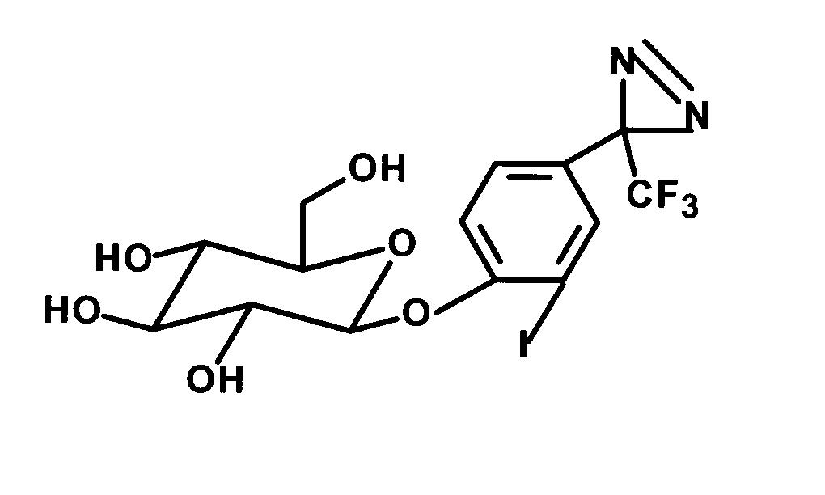
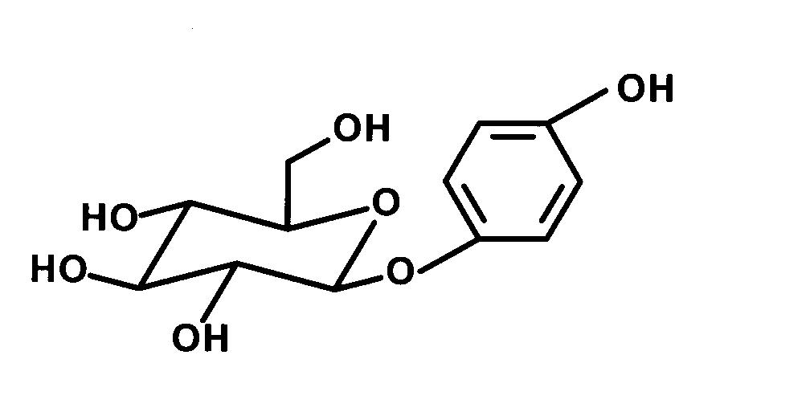

Figure 4.25 Chemical structure of photoaffinity probe and its sibling. (A) Arbutin, a high-affinity sibling of TIPDG transported by SGLT1, (B) [(2’-Iodo-4’-(3’’-trifluoromethyldiazirinyl) phenoxy]-D-glucopyranoside (TIPDG).

Synthesis of label 6-AG for the identification of D-glucose interaction sites
D-Glucose is a high-affinity transported substrate of SGLT1, in order to identify its binding sites in cotransporter we have synthesized 6-AG photoprobe. The synthesis of 6-AG (compound 22) is depicted in Figure 3.5. The direct conversion of the debenzylated aldehyde 17 into the diazirine as described (Lehmann and Thieme, 1986) gave only unsatisfactory results. Therefore the aldehyde 17 was converted into the corresponding methyl ketone 19 by reacting with methylmagnesium iodide followed by oxidation of the formed secondary alcohol. The less-reactive keto compound 19 could be easily converted into the diazirine group with the NH₃, Hydroxylamine-O-sulfonic acid reagent and subsequent oxidation of the intermediate diaziridine with iodine (Church et al., 1972; Church and Weiss, 1970).

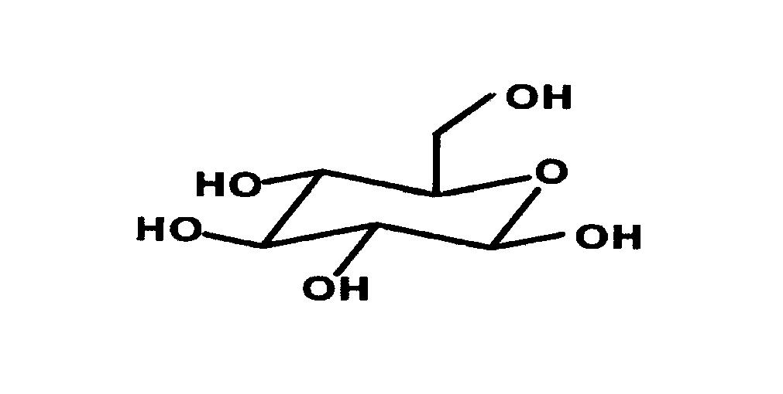
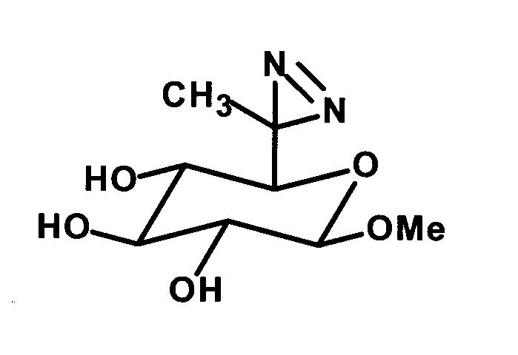
A
B

Figure 4.26 Chemical structure of photoaffinity probe and its sibling. (A) D-glucose transported ligand by SGLT1, (B) n-Methyl-6C-(Azimethyl)-D- glucopyranoside (6-AG).

Photochemical properties and stability of TIPDG, BzG, 3-AP and 6-AG
Consistent with the spectral properties of other 3-(trifluoromethyl)-3-phenyldiazirine (Brunner et al., 1980; Delfino et al., 1993; Fang et al., 1998; Hatanaka et al., 1994; Nassal, 1984; Platz et al., 1991), the TIPDG described here shows a characteristic absorption maximum at 358 nm (ε = 290 M⁻¹.cm⁻¹). This is depicted in Figure 4.27 for TIPDG 9 photolysis studies. When a 0.5 mM solution of 9 in methanol was irradiated in a Rayonet photochemical reactor RPR-100 fitted with 16, 3500Å lamps at 22°C, the diazirine absorption band at 358 nm decreased with a half-life of 20.1 s following apparent first-order kinetics. Upon photolysis, the solution turned slightly orange (absorbance maximum at around 460 nm), a result of the well documented partial rearrangement of the diazirine to the diazo isomer.
There have been reports on the reduction of photoactivable reagents containing azido groups (Bayley and Knowles, 1978) or 2-diazo-3, 3,3-trifluoropropionyloxy groups (Takagaki et al., 1983) by commonly used reducing agents like dithiothreitol, 2-mercaptoethanol and reduced glutathione. To check the stability of TIPDG in the presence of these reducing agents, a methanolic solution of TIPDG was treated with 2- mercaptoethanol and dithiothreitol at an equimolar concentration or in the presence of a 5-fold excess of these reagents at 25°C. The reaction was followed spectrophotometrically wherein no change was observed up to 1 h. The diazirine moiety of TIPDG is also stable under hydrogenation with 10% Pd on carbon, which leads to a non-iodinated TIPDG derivative.
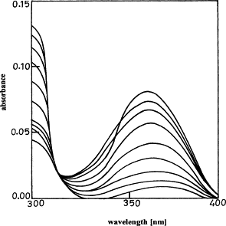
Figure 4.27 UV spectra of the reaction products from photolysis of TIPDG 9. A solution (0.5 mM) in methanol was irradiated for different times (0, 5, 10, 15, 20, 25, 30, 35, 40, and 45 s). The spectra show the decay of the characteristic diazirine absorption with a maximum at 358 nm. The half-life of decomposition was calculated from a logarithmic plot of the absorbance data against the irradiation time. The half-life t_{1/2} was 20.1 s.
BzG shows absorption maximum at 293 nm (ε = 22500 M⁻¹.cm⁻¹) and reveals other characteristic features of benzophenone photochemistry (Dorman and Prestwich, 1994; Dorman and Prestwich, 2000). The half-life of photolysis of BzG was determined by irradiating a 0.5 mM solution in isopropanol in an Oriel photochemical reactor fitted with 200 W medium pressure Hg lamp at 25°C. The characteristic absorption band of benzophenone in BzG at 293 nm disappeared with an approximate half-life of 25.4 min following first order reaction kinetics.
3-AP exhibits photochemical properties similar to other aryl azide compounds. The absorption maxima of azide group of 3-AP are at 211 nm (ε = 28150 M⁻¹.cm⁻¹), 258 nm (ε = 6700 M⁻¹.cm⁻¹), and 288 nm (ε = 16800 M⁻¹.cm⁻¹). Half-life of decomposition of this compound was not determined.
The absorption maximum of the diazirine group of 6-AG is at 330 nm (ε = 45 M⁻¹.cm⁻¹). On irradiation with long wavelength UV light (λ_{max} around 350 nm) in a Rayonet photochemical reactor, the 6-AG decompose with a half-life of 1.3 min.

Inhibition of glucose uptake in rabbit small intestine BBMV by BzG and 3-AP
To determine the affinity of BzG towards the SGLT1 cotransporter we measured its inhibitory potential on sodium-dependent D-glucose uptake into rabbit intestinal BBMV according to the method of Dixon. The effect of BzG on Na⁺-dependent glucose uptake in small intestine BBMV is shown in Figure 4.28. BzG clearly acts as a fully competitive inhibitor. The apparent K_{i} value 12 ± 2 µM is only slightly higher than the previously reported K_{i} value of 8 ± 1.2 µM (Evers et al., 1978; Gibbs et al., 1982) phlorizin.
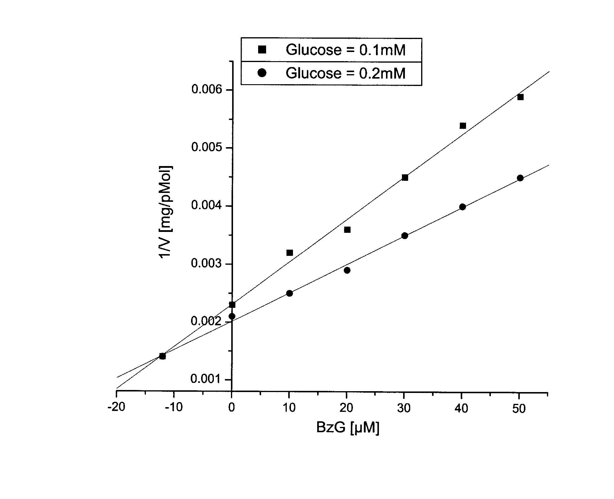

Figure 4.28 Inhibitory effects of 0, 10, 20, 30, 40, and 50 μM BzG on 5 s sodium-dependent D-glucose uptake into rabbit small intestine BBMV measured at two substrate concentrations, 0.1 mM (squares) and 0.2 mM (circles) D-glucose according to the method of Dixon. Representative experiments are shown. An inhibition constant (K_{i}) of 12 ± 2 μM was calculated from three independent experiments.
The affinity of 3-AP for the SGLT1 cotransporter was measured according to method of Dixon. 3-AP strictly act as a high affinity inhibitor of sugar uptake by Na⁺/D-glucose cotransporter with a K_{i} value of 8.6 ± 1.6 µM. The calculated K_{i} value for 3-AP is exactly similar to its parent compound phlorizin (K_{i} of 8 ± 1.2 µM). 3-AP exhibits all characteristics features similar to phlorizin so we used this compound for the identification of phlorizin-binding sites in truncated loop 13 protein which is predicted to be region involved in inhibitor binding (Novakova et al., 2001; Xia et al., 2003).

Inhibition of glucose uptake in rabbit small intestine BBMV by TIPDG
As shown in Figure 4.20 TIPDG exhibits a fully competitive inhibition with respect to D-glucose with a K_{i} of 22 ± 5µM, this affinity is almost identical to the one of its parent compound arbutin (25 ± 6 µM). The modification of the phenyl ring OH group into a trifluoromethyl diazirine group and the mono iodination of its phenyl ring thus did not significantly alter the affinity to the transporter.

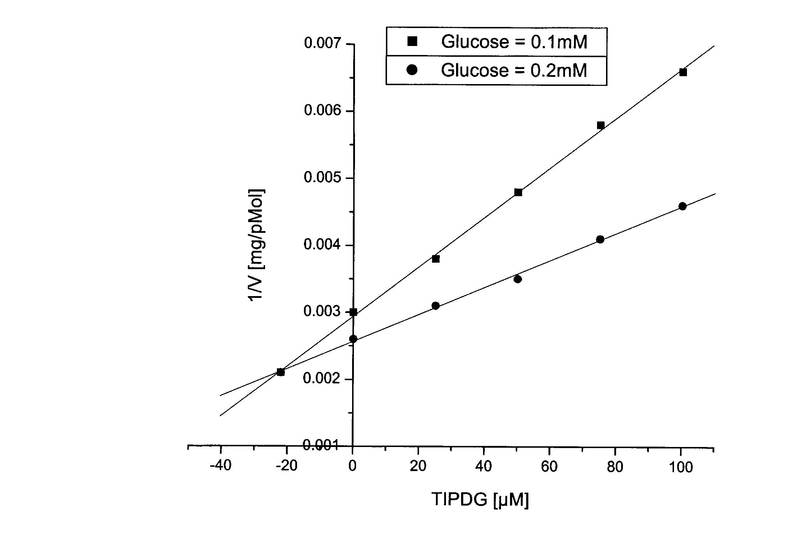

Figure 4.29 Inhibitory effects of 0, 25, 50, 75, and 100 μM TIPDG on 5 s sodium-dependent D-glucose uptake into rabbit small intestine BBMV measured at two substrate concentrations, 0.1 mM (squares) and 0.2 mM (circles) D-glucose according to the method of Dixon. Representative experiments are shown. From three independent experiments a K_{i} value of 22 ± 5 μM for TIPDG was calculated.

Inhibition of glucose uptake in rabbit small intestine BBMV by 6-AG
The affinity of 6-AG for the SGLT1 cotransporter was also evaluated by measuring its inhibitory potential on sodium-dependent D-glucose uptake into rabbit small intestine BBMV according to method of Dixon. As shown in Figure 4.30, 6-AG exhibits a fully competitive inhibition characteristic with respect to D-glucose with a K_{i} of 40 ± 5 µM. Compared to the inhibitory effect of D-glucose (K_{i} of 1 mM) the modification of the molecule with the photolabile diazirine group and methyl group at position C-6 of the D-glucose moiety drastically increase the affinity for the transporter. These results indicate that presence of alkyl and diazirine group (hydrophobic interaction) increase the affinity of 6-AG 25 fold as compared to its parent compound.

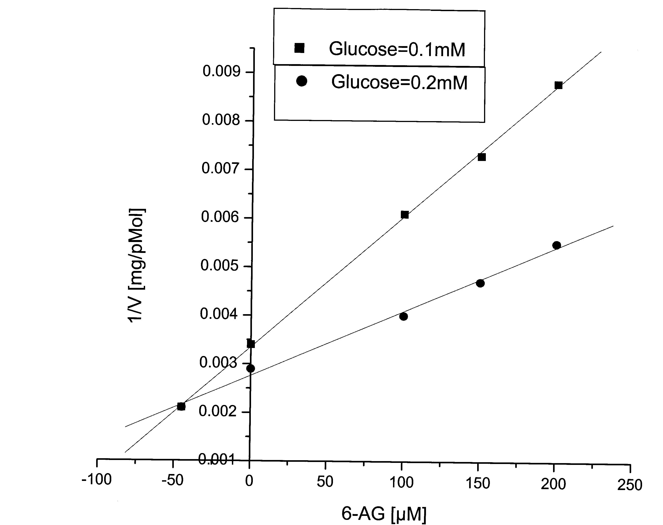

Figure 4.30 Inhibitory effect of 0, 100, 150, and 200 μM 6-AG on 5-s D-glucose uptake into rabbit small intestine BBMV measured at two substrate concentrations, 0.1 mM (squares) and 0.2 mM (circles) D-glucose according to the method of Dixon. Representative experiments are shown. From three independent experiments K_{i} value of 40 ± 5 µM for 6-AG was calculated.

Table 4.9 Photochemical and biochemical properties of different photoaffinity probes.
Photoaffinity  probe | Sibling | λ_{max} nm  (ε = M⁻¹.cm⁻¹) | Half-life of photolysis (t_{1/2}) | Inhibition constant (K_{i}) photoaffinity probe | Inhibition constant (K_{i}) of sibling
TIPDG | Arbutin^{S} | 358(290)ª | 20.1 s | 22 ± 5 µM | 25 ± 6 µM
BzG | Phlorizin^{I} | 293(22500)^{b} | 25.4 min | 12 ± 2 µM | 8 ± 1.2 µM
3-AP | Phlorizin | 211(28150)^{c} 258(6700)^{c}  288(16800)^{c} | ND^{d} | 8.6 ± 1.6 µM | 8 ± 1.2 µM
6-AG | D-Glucose^{S} | 330 (45 )ª | 1.3 min | 40 ± 5 µM | 1 mM
^{S} Substrate ^{I} Inhibitor
ª Methanol ^{b} Isopropanol ^{c} Ethanol ^{d} not determined

Photoaffinity labeling of truncated loop 13 with TIPDG, BzG, and 3-AP
According to studies employing site-directed mutagenesis (Novakova et al., 2001) and molecular recognition atomic force microscopy (Wielert-Badt et al., 2002), the extra-membranous loop 13 of SGLT1 appears to be involved in substrate and inhibitor recognition of SGLT1 (Panayotova-Heiermann et al., 1997; Panayotova-Heiermann et al., 1996; Xia et al., 2003). We therefore used this functional domain of SGLT1 (a model system loop 13 in its truncated form that has amino acids sequence 564-638 of SGLT1) for the identification of substrates and inhibitor sites.

Photoaffinity labeling of truncated loop 13 with TIPDG and BzG
A
B
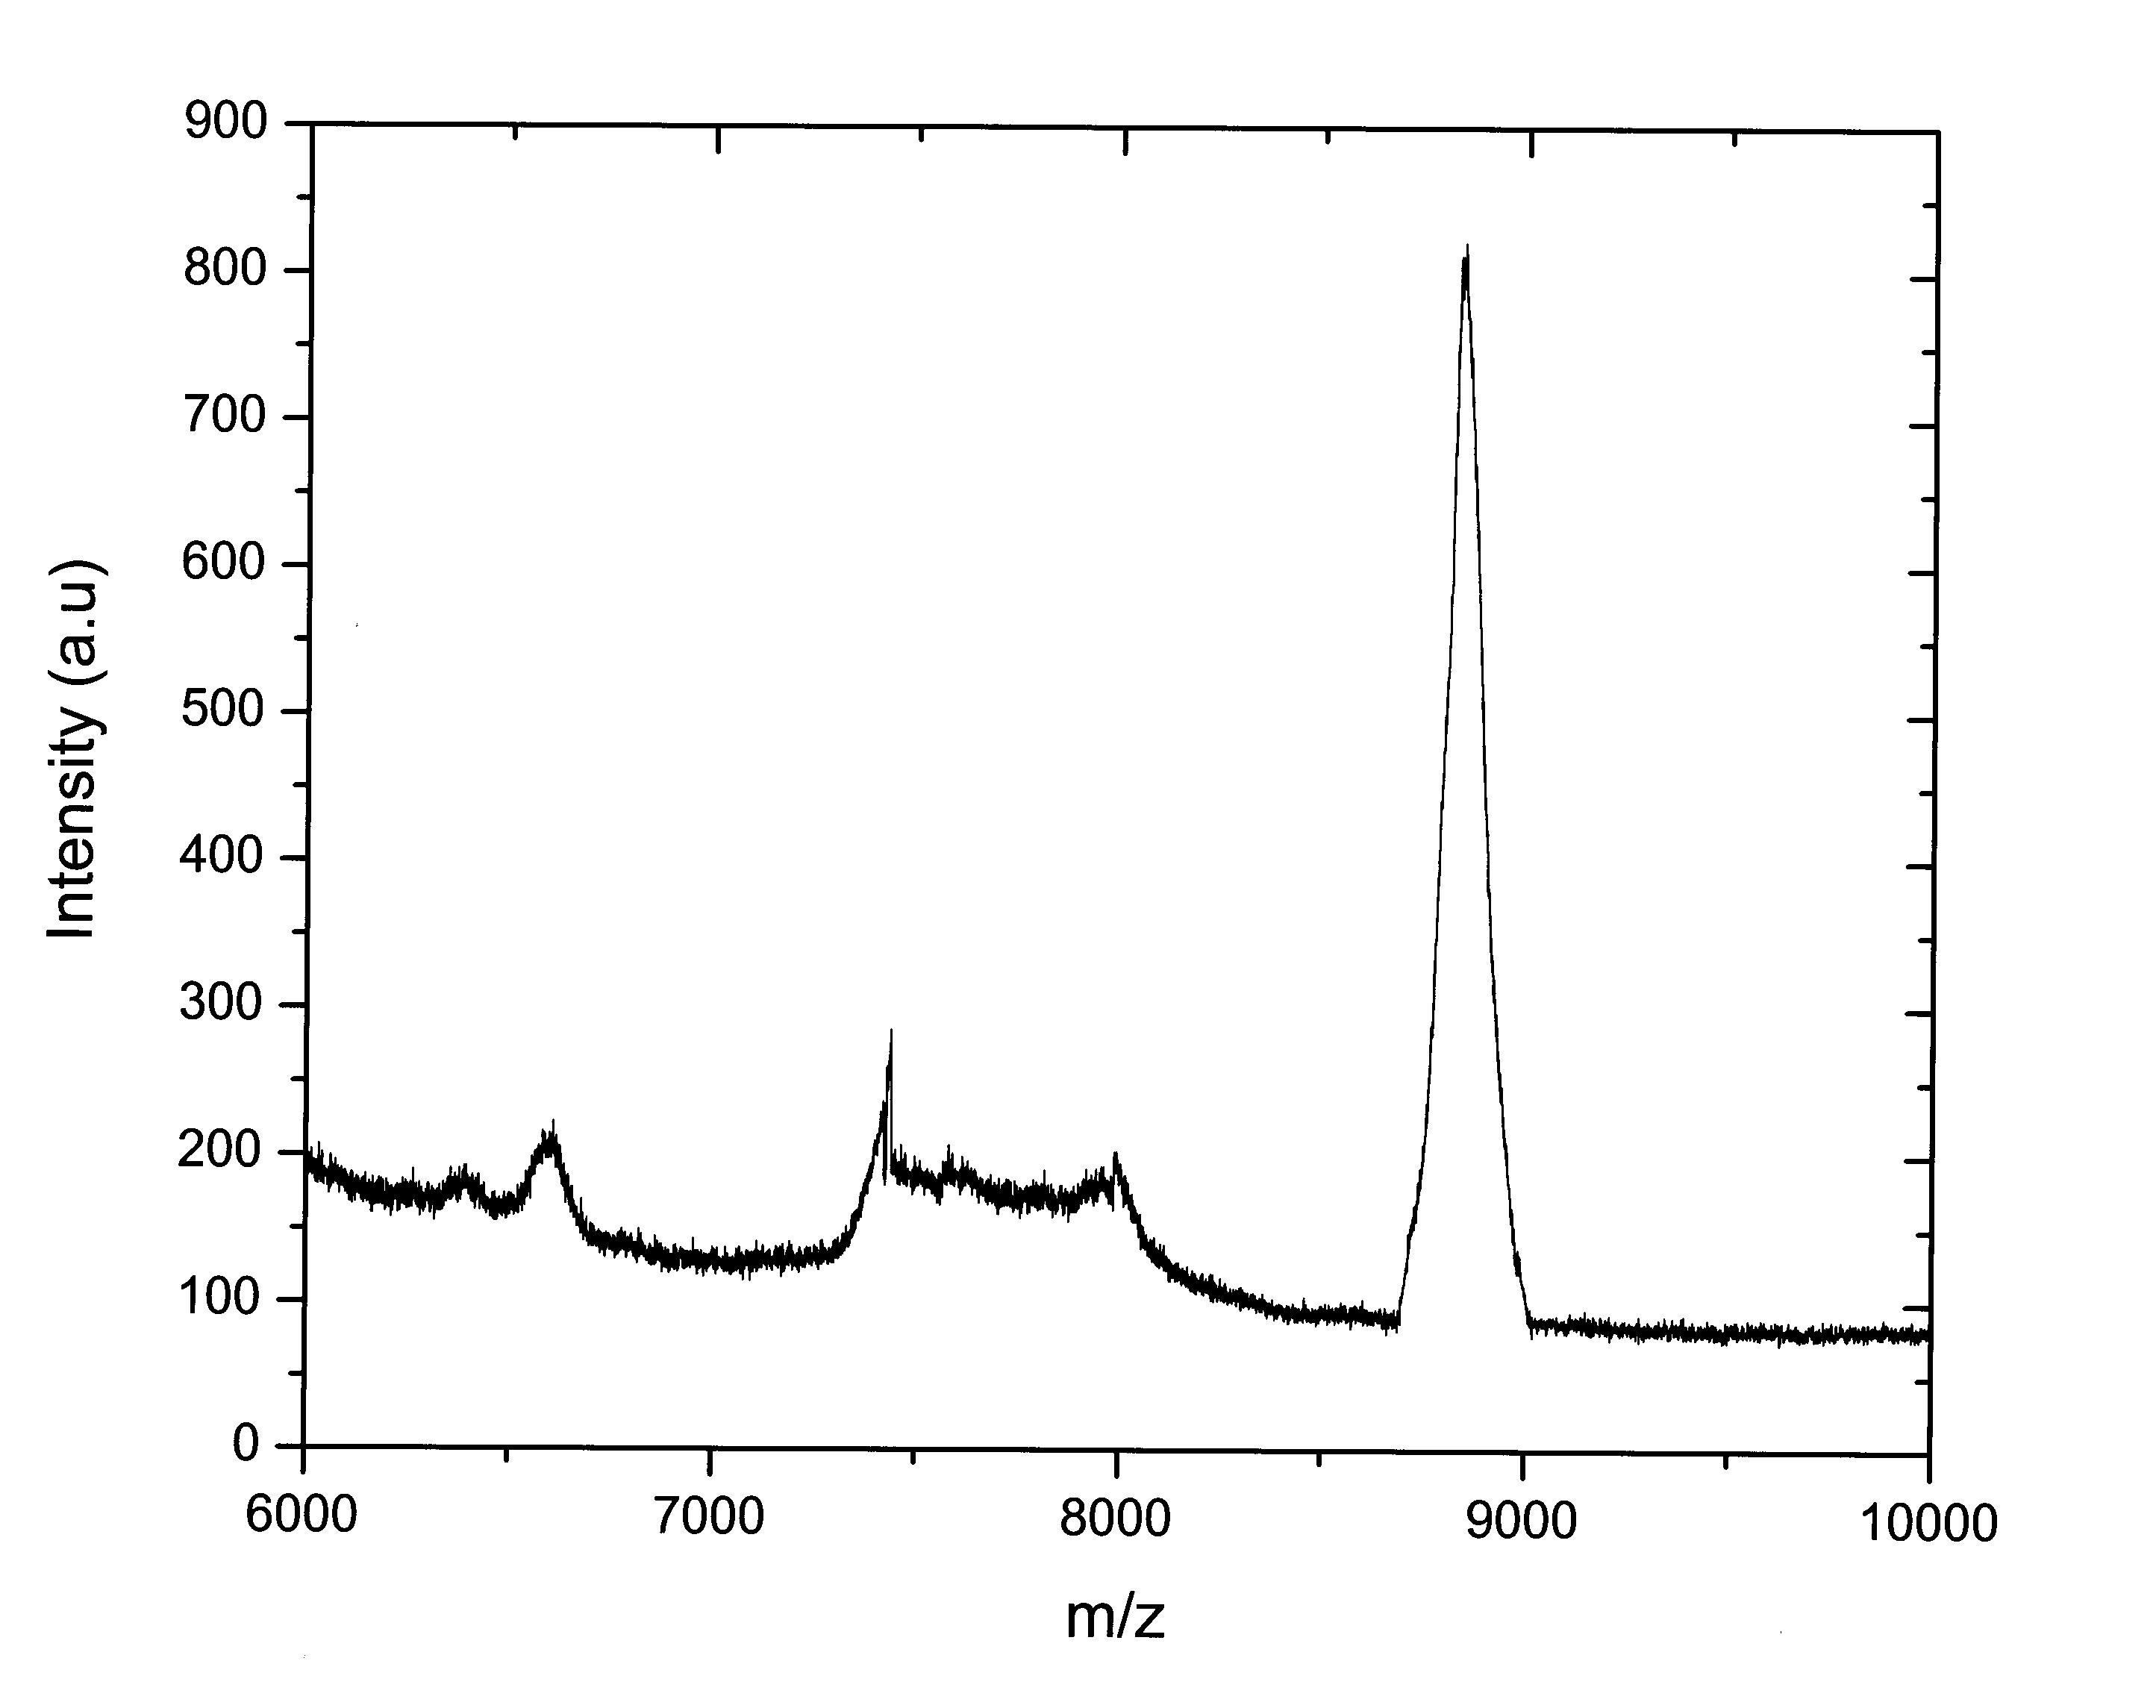
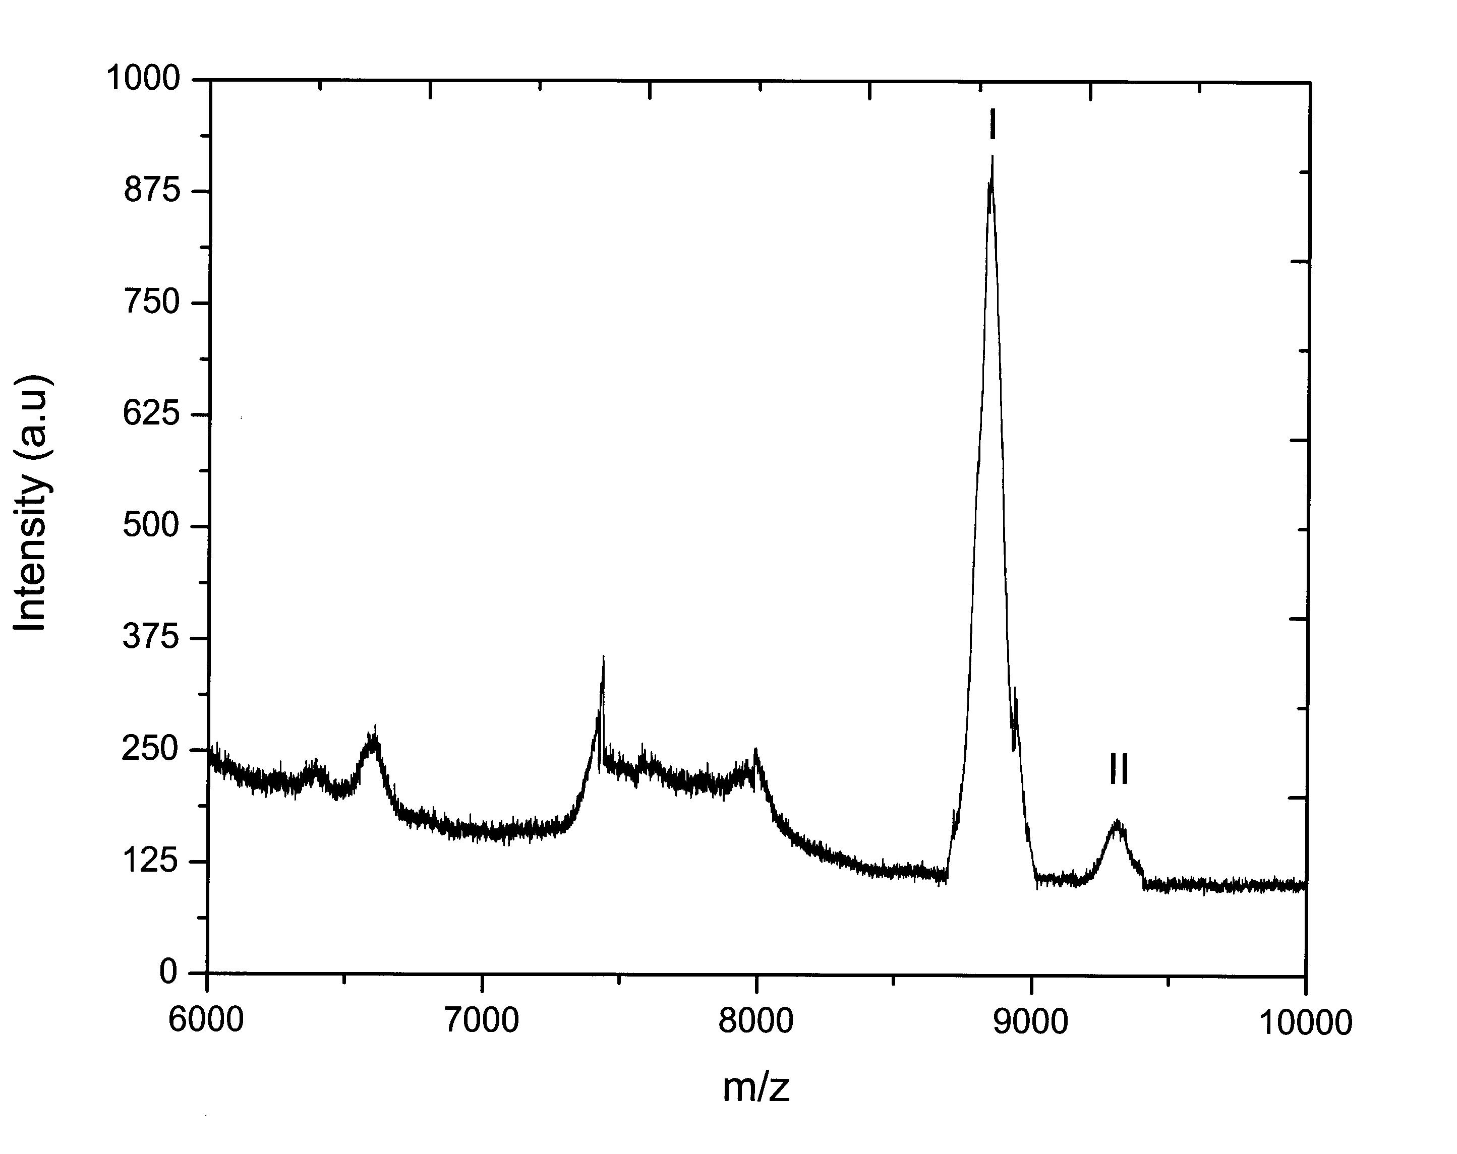

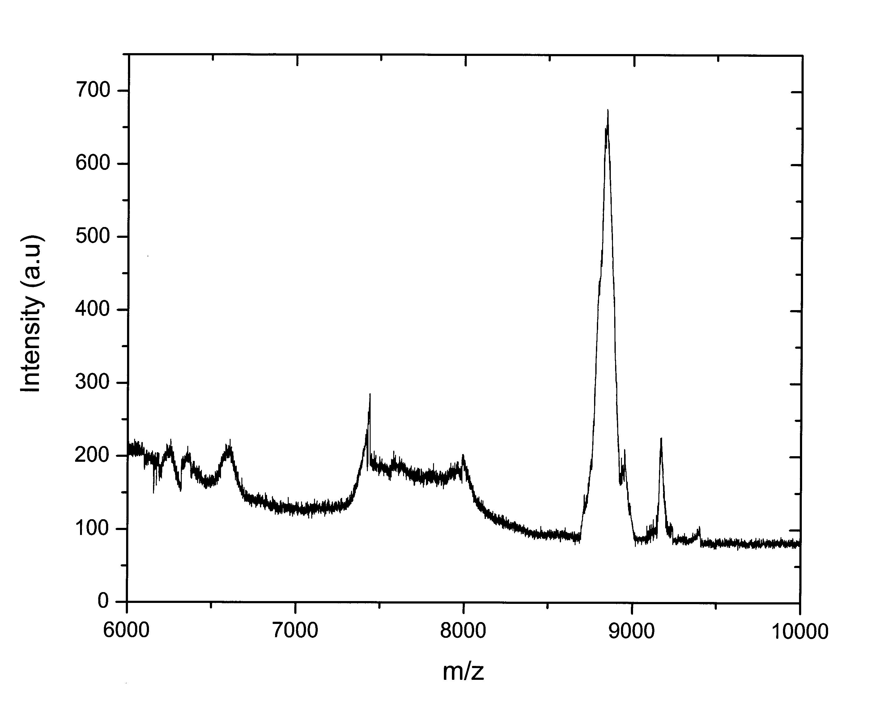
C

Figure 4.31 MALDI-mass spectrometry of photoaffinity labeled truncated loop 13. (A) Truncated loop 13 before labeling, (B) Photoaffinity labeling with TIPDG and (C) Photoaffinity labeling with BzG. Truncated loop 13 protein (200 µg) was incubated with 1 mM TIPDG or with 0.5 mM BzG in 200 µl of PBS buffer for 5 min in the dark at room temperature followed by irradiation at 350 nm for 5 min (TIPDG) and 30 min (BzG). After separation from noncovalently bound TIPDG or BzG by chloroform/methanol extraction, protein was dissolved in SA matrix at a concentration of 50 pmol/µl and subjected to MALDI- mass spectrometry, (A) peak I, truncated loop 13 protein; (B) peak I, truncated loop 13 protein; peak II, truncated loop 13 protein cross-linked with TIPDG; (C) peak I, truncated loop 13 protein; peak II, truncated loop 13 protein labeled with BzG.
Photoincorporation of TIPDG into truncated loop 13 proteins was complete within 1 min of light exposure under our condition. Figure 4.31A shows the expected mass peak at m/z 8825.6 Figure 4.31B demonstrates that after photoaffinity labeling with TIPDG two peaks of m/z 8825.6 and 9287.5 can be observed. Peak I corresponds to truncated loop 13 protein and peak II to the photolabeled truncated loop 13 protein (9287.5). The mass difference between peak I and peak II (Figure 4.31B) corresponds to the mass of photolysed TIPDG (461.9).
MALDI-mass spectra of photolabeled loop 13 proteins with BzG are shown in Figure 4.31C. Two intense ion signals at m/z 8825.6 and at m/z 9187.2 are observed. The ion signal at m/z 9187.2 was absent in the MALDI-mass spectrum of control truncated loop 13 protein Figure 4.31A. The mass increment of 361.6 amu suggests a simple carbon bond insertion of the photoaffinity label BzG into the protein (Figure 4.31C, peak II).

Photoaffinity labeling of truncated loop 13 with 3- Azidophlorizin
The reaction product of photolabeling of the truncated loop 13 with 3-azidophlorizin was also analysed by MALDI-mass spectrometry. Figure 4.32A shows the expected mass peak for loop 13 at m/z 8825.60 and in Figure 4.32B the product after photoaffinity labeling of the loop with 3-azidophlorizin is depicted. Peak I corresponds to truncated loop 13 (8825.60) and peak II to the photolabeled truncated loop 13 protein (9275.10). The mass difference between peak I and peak II (Figure 4.32B) corresponds to the mass of photolysed 3-azidophlorizin (449.5).

A
B
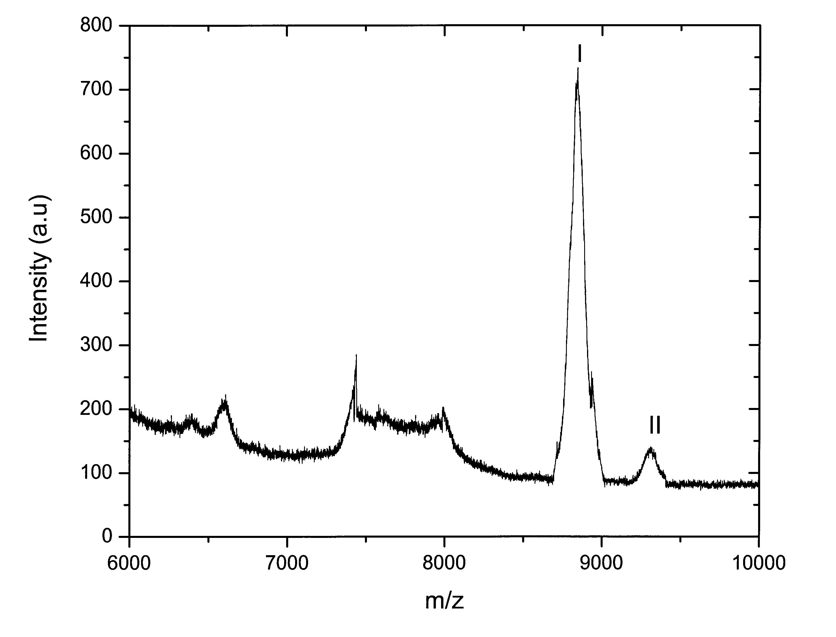

Figure 4.32 MALDI-mass spectrometry of photoaffinity labeled truncated loop 13. Protein (200 µg) was incubated with 1 mM 3-azidophlorizin in 200 µl of PBS buffer for 5 min in the dark at room temperature followed by irradiation at 280 nm for 10 min. After separation from noncovalently bound 3-azidophlorizin by chloroform/ methanol extraction, protein was dissolved in DHB matrix at a concentration of 50 pmol/µl and subjected to MALDI-mass spectrometry, (A) Control experiment; peak I, truncated loop 13, (B) Products after photolabeling; peak I, truncated loop 13; peak II, truncated loop 13 cross-linked with 3-azidophlorizin.

Identification of the ligand contact points
As a next step in identification of the ligand contact points, the photolabeled-truncated loop 13 was digested in gel with trypsin. After extraction of the peptides from the gel, the resulting mixture was analyzed by MALDI-TOF mode with unlabeled-truncated loop 13 as a reference (Table 4.10). The only additional peak observed in the labeled probe was at m/z 624.52 (Figure 4.33B). This can be explained as an adduct peak to m/z 175.11 (corresponding to Arg-602) with a difference of 449.41. The latter is equal to the mass of photolysed 3-azidophlorizin. All other peaks appear also in the control as shown in Figure 4.33A.
A

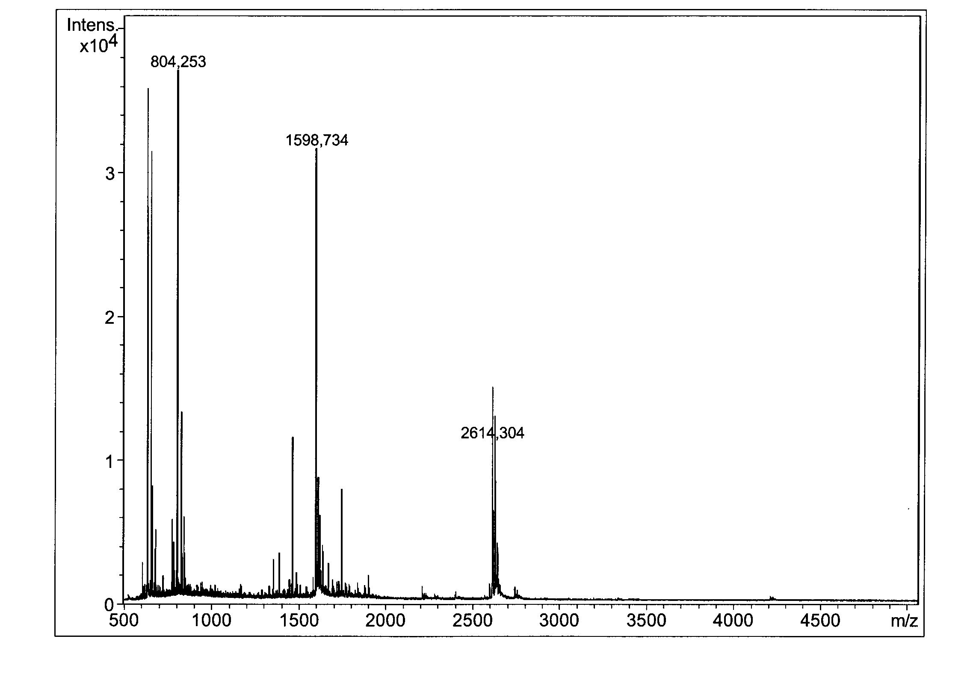

B

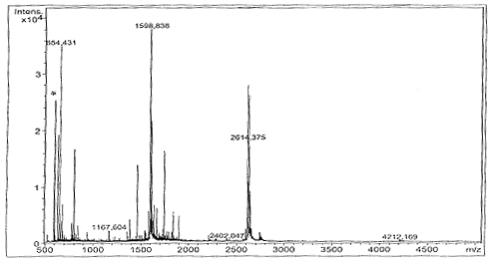
Figure 4.33 MALDI-mass spectrum of in-gel trypsin cleaved truncated loop 13. 200 µg of truncated loop 13 was photolabeled with 3-azidophlorizin, proteins were separated on SDS-PAGE and protein bands of interest were excised, destained and digested in gel with trypsin. The peptides were extracted from the gel pieces with acetonitrile. Subsequently 0.5 µl aliquots of the generated cleavage products were dispensed onto the sample support, followed by 0.5 µl of CHCA matrix solution and the MALDI- mass spectra were recorded. (A) Truncated loop 13 before photoaffinity labeling, (B) truncated loop 13 after photoaffinity labeling with 3-azidophlorizin. (*) peak indicates the mass shift due to modification of Arg-602 with 3-azidophlorizin.
Table 4.10 Theoretical and measured masses of photolabeled truncated loop 13 digested with trypsin as shown in Figure 4.33.
Fragment | Amino acids | Sequence | Theoretical mass  (M+H)⁺  monoisotopic | Measured  mass  (M+H)⁺ | Additional peaks
1 | 1-3 | PER | 401.21 | NDª
2 | 4-6 | NSK | 348.18 | ND
3 | 7-9 | EER | 433.20 | ND
4 | 10-33 | IDLDAGEEDIQEAPEEATDTEVPK | 2614.18 | 2614.37
5 | 34 | K | 147.11 | 147.27
6 | 35 | K | 147.11 | 147.27
7 | 36 | K | 147.11 | 147.27
8 | 37-40 | GFFR | 526.27 | 526.11
9 | 41 | R (602) | 175.11 | 175.35 | 624.52^{b}
10 | 42-53 | AYDLFCGLDQDK | 1387.61 | 1387.63
11 | 54-56 | GPK | 301.18 | ND
12 | 57-59 | MTK | 379.20 | 380.85
13 | 60-66 | EEEAAMK | 807.35 | 807.26
14 | 67-68 | LK | 260.19 | ND
15 | 69-77 | LTDTSEHPL | 1012.49 | ND
ª not determined.
^{b} Denominates a peptide plus label

We also performed photoaffinity labeling of truncated loop 13 with 1 mM 3-AP in the presence of 15 μM phlorizin under the same conditions that were employed in the other photolabeling experiments. MALDI- mass spectrum of photolabeled truncated loop 13 did not show any additional peak in intact truncated loop 13 and also no additional peak was present in the Trypsin digested samples.
In order to further strengthen our results that labeling of residue Arg (602) is specific and it is not an artifact, we chemically modified the guanidino moiety of arginine with phenylglyoxal treatment. Photoaffinity labeling of arginine-modified protein with 3-AP did not resulting any additional peak in the MALDI- mass spectrum of trypsin digested photolabeled protein.
Taking these evidences into consideration we can claim that the ortho position of ring B of phlorizin labeled amino acid Arg-602 of truncated loop 13, which thus forms part of a phlorizin-binding site.

Discussion

Integral membrane proteins such as channels and transporters are essential for all living organisms as they mediate the passage of ions and molecules across the membrane. The understanding of how membrane proteins work in health and disease has been restricted hitherto largely due to lack of purified protein. Most membrane proteins are present in very low concentrations in their native tissue, and their over-expression is a prerequisite for purification. The use of eukaryotic expression system has illuminated mechanistic features of human membrane proteins, but these are unsuitable for their large-scale purification (Fleming, 2000; Tate, 2001). In addition, genetic disorders of membrane proteins are frequently caused by improper trafficking in cells, and it is not known whether missorted proteins retain their catalytic activity.
The first crystal structures of membrane proteins were obtained with proteins isolated from naturally abundant sources, and recombinant proteins still represent minority of the membrane proteins that have been crystallized to date. In the case of soluble proteins, over 90% have been crystallized using recombinant protein, which is in contrast to the 21 recombinant of 50 total structures for membrane proteins (Loll, 2003). Only three mammalian membrane proteins to date have had crystal structures determined using recombinant protein: prostaglandin H₂ synthase-2 (COX-2), produced in insect cells (Barnett et al., 1994; Kurumbail et al., 1996), monoamine-oxidase B, produced in yeast (Binda et al., 2002) and fatty acid amide hydrolase, produced in bacteria (Bracey et al., 2002). All three proteins are monotopic membrane proteins and therefore have little hydrophobic surface. It should also be noted that the only GPCR crystallized to date, bovine rhodopsin, was obtained from natural source, from bovine retina where it is found in large amounts. These statistics reflect the fact that active recombinant membrane proteins are difficult to obtain.
It is not surprising that heterologous production of membrane proteins poses big challenges. Unlike their cytoplasmic counterparts, membrane proteins have a longer way to the fully functional form. Once their synthesis begins, the complicated secretory machinery is engaged in order to achieve proper targeting and insertion into the membrane. The majority of proteins synthesized in many cells are cytoplasmic proteins; such cells have no sufficient capacity to handle large amounts of newly synthesized membrane proteins. Therefore, when produced in a heterologous system, membrane proteins can “saturate” the secretory pathway of cell, leading to protein aggregation inside different cell compartments.
Therefore, the choice of expression system is a crucial step towards obtaining large amounts of transporter in its active form. Devising a successful strategy for its subsequent purification is nonetheless important. For the expression of hSGLT1, various animal heterologous expression systems have been widely used but major disadvantages associated with these systems are that modified protein are frequently not trafficked properly to plasma membrane (Lam et al., 1999; Lostao et al., 1995; Martin et al., 1997; Martin et al., 1996) and that it is costly to produce sufficient amounts of protein for structural studies. Recently functional expression of hSGLT1ΔN-GFP was reported in E. coli (Quick and Wright, 2002), but hSGLT1 expression in E. coli was not reproducible in our lab as reported in the results section.

E. coli as an expression host
Among the many systems available for heterologous protein production, the Gram-negative bacterium E. coli remains one of the most attractive because of its ability to grow rapidly and at high density on inexpensive substrates, its well-characterized genetics and the availability of an increasingly large number of cloning vectors and mutant host strains. Taking advantages of E. coli expression system into consideration, first we attempted expression of hSGLT1 in this system. For the expression of hSGLT1, we used two types of vectors, pET22b (T7 promoter based) and pBAD24 (P_{BAD} promoter), both having some advantages and disadvantages. We constructed different clones of hSGLT1 in pET22b and pBAD24 and tested hSGLT1 expression in different E. coli strains and at different conditions (Table 4.5) but we were not able to express hSGLT1 in E. coli.

Probable reasons for not getting hSGLT1 expression in E. coli
There are some probable reasons for not getting expression of hSGLT1 in E. coli.

Codon usage
E. coli and indeed all cells, use a specific subset of the 61 available amino acid codons for the production of most mRNA (Zhang et al., 1991). So-called major codons are those, which occur, in highly expressed genes, whereas the minor or rare codons tend to be in genes expressed at low level. The hSGLT1 gene was directly amplified from human genome and cloned into different expression vectors in E. coli, therefore, the codons of this gene are not optimized for E. coli expression host. Codon degeneracy analysis shows that the hSGLT1 gene contains 23% codons, which cannot be translated efficiently, due to the low frequency of the corresponding tRNAs in E. coli. Therefore, a special host strain Rosetta (DE3) was used for the expression of hSGLT1 in prokaryote. Rosetta host strains are BL21 derivatives, designed to enhance the expression of eukaryotic proteins that contain codons rarely used in E. coli. These strains supply tRNA genes for AGG (Arg), AGA (Arg), AUA (Val), CUA (Leu), CCC (Pro), GGA (Gly) on a Col-E1 compatible chloroamphenicol-resistant plasmid. Thus, the Rosetta strains provide for “universal” translation, which is otherwise limited by the codon usage of E. coli. Transcription of the tRNAs genes is driven by their native promoters. The use of this strain did not solve the problem of expression. Thus, codon usage does not appear to be a hurdle for the expression of hSGLT1. This signifies the importance of some other factors, which are responsible for the expression of human membrane proteins in E. coli.

Signal sequences
Signal sequences or signal peptides are a well-characterized but heterogeneous group of cleavable N-terminal peptide extensions that direct the newly synthesized proteins to specific subcellular compartments. In E. coli ~20 aa signal peptides direct secretion of proteins to the periplasma and outer membrane (Arkowitz and Bassilana, 1994; Driessen, 1994; Driessen et al., 2001). In eukaryotes, signal peptides are more variable in length and direct secretion to the endoplasmic reticulum lumen and the general secretory pathway (Sakaguchi, 1997). There are however, distinctions between the prokaryotic and eukaryotic systems; most notable are differences in the amino acid sequences of the signal peptide itself (Nielsen et al., 1997). In addition there are differences in the process of secretion: i.e., the function of the signal recognition particle (SRP), a more highly evolved secretion apparatus, and the use of different chaperones (Pohlschroder et al., 1997). If E. coli signal sequences were not working for hSGLT1 protein we should get hSGLT1 expression either in the form of aggregated protein in inclusion bodies, or in degraded forms, but our results indicate that this was not the case since we could not detect any sign of protein expression in the E. coli expression system. We also attempted expression of hSGLT1 at different conditions by changing the protein inducer and temperature from 37 to 16°C to change folding and degradation, but in all cases no expression was observed. Therefore in our experiments it seems that some phenomena other than those mentioned above could be the real cause for not getting expression of hSGLT1 in E. coli.

Degradation of hSGLT1 mRNA in E.coli
As already shown by the results obtained by SDS-PAGE analysis of β- subunit of E. coli ATPase expression in pET22b-Unc-F and pET22b-Unc-F-hSGLT1 plasmids (Figure 4.12), the expression of this protein was completely abolished when simultaneous expression of both the β-subunit and hSGLT1 was attempted. Subsequent computational analysis of the mRNA sequence of hSGLT1 revealed that it contains 5 potential RNase E sites at position 576, 600, 1488, 1500, and 1558 (Table 4.6). The position 576 (ACAAUUACAG) and 600 (GUGAUUUACA) contains the preferred nucleotide sequence (Figure 5.1) for degradation by RNase E but they are lacking a stem-loop structure adjacent to the cleavage site. RNase E prefers AU rich nucleotide sequences with adjacent secondary structure (stem-loop) for degradation. So these two sites may not be all that prone for RNase E degradation. The three predicted RNase E sites at position 1488 (GGGAUUUCAC), 1500 (UAUGAUUACU), and 1558 (GAUUAUCUGU) (Table 4.6) contain extended stem loop structures adjacent to these sites (Figure 5.35), so these sites are highly susceptible for degradation by RNase E. Once the RNase E degradation process is initiated in E. coli, it activates other exonucleases which further degrade mRNA of the Unc-F gene. Thus the lack of hSGLT1 expression may be due to the instability of the mRNA.
The role of cyclic nucleotide regulation of Na⁺/glucose cotransporter (SGLT1) mRNA stability for the expression in LLC-PK1 cells was reported in the literature (Lee et al., 2000), same observations for the effect of mRNA stability on glucose transporter (GLUT1) gene expression were also mentioned in previous studies in mammalian cell lines (Qi and Pekala, 1999).
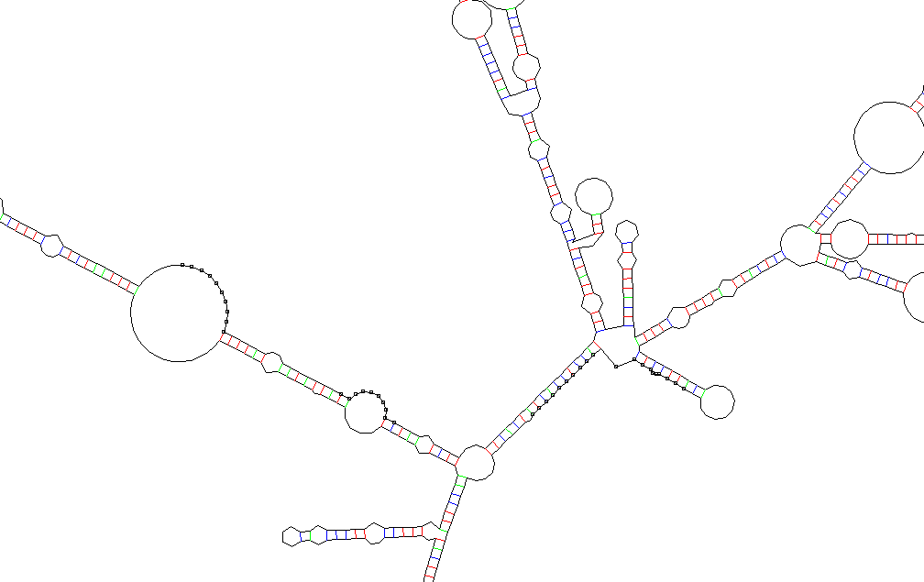
I
II
III
IV

Figure 5.34 Part of hSGLT1 mRNA secondary structure indicating the positions of RNase E sites. Nucleotide sequences in this structure marked as 576, I (ACAAUUACAG); 600, II (GUGAUUUACA); 1488, III (GGGAUUUCAC); and 1500, IV (GAUUAUCUGU) indicates the positions of RNase E susceptible site in the mRNA of hSGLT1.
To our knowledge, this is the first time that possible implications of mRNA stability of hSGLT1 on its expression into E. coli are reported. The reason given by most of membrane protein molecular biologists to explain their unsuccessful attempts is that the membrane protein is synthesized in E. coli but due to the absence of specialized membrane protein folding machinery (Molecular Chaperones) and proper membrane targeting machinery in bacteria, expressed protein either accumulates as insoluble aggregates of improperly folded species called inclusion bodies, or proteolytic degradation of newly synthesized protein takes place due to improper targeting of protein. In our opinion, this statement does not hold true in all conditions and the major culprit of our failure for hSGLT1 expression in E. coli is the mRNA stability of hSGLT1.

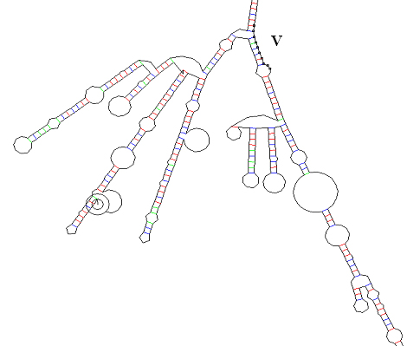
Figure 5.35 Part of hSGLT1 mRNA secondary structure indicating the position of RNase E site. Nucleotide sequence 1558 of hSGLT1 mRNA marked as V (GAUUAUCUGU) in this structure is highly prone for RNase E degradation due to presence of very high stem-loop structure adjacent to this site.
According to our mRNA degradation hypothesis, cDNA of hSGLT1 is transcribed into mRNA of hSGLT1 without any problem. At this point as mentioned above since hSGLT1 mRNA contains 5 RNase E sites, RNase E and other endoribonucleases start to degrade hSGLT1 mRNA from the 5´-3´ end. RNase E degradation also activates other exonucleases like PNPase, RNase II, and RNase R. These active exonucleases start mRNA degradation from 3´-5´ end of oligoribonucleotides generated by RNase E degradation into smaller parts. These smaller parts are further degraded into mononucleotides by oligoribonucleases.

Comparison to other attempts to express hSGLT1 in E. coli
In the year 2002, Quick and Wright (Quick and Wright, 2002) reported functional expression of hSGLT1 in E. coli. The authors of this study claimed that they obtained 1 mg functional hSGLT1 protein from 3-liters of bacterial culture. These results are only apparently contradictory to the results we obtained in E. coli expression host in the present study. We analysed their plasmid construction strategy and results in a step by step manner to find out the probable reasons for their success. They used pTMH-6FH expression vector (Quick and Jung, 1998), a derivative of pT7-5 (lacY) (Bibi and Kaback, 1990) and it works under the lac promoter/operator (Bibi and Kaback, 1990; Quick and Jung, 1998), which is a mild promoter. Use of mild promoter does not seem to be real reason for their success because we also used pBAD expression vector, which works on the mild promoter P_{BAD} of the araBAD operon. The second important thing in their methodology was the use of growing temperatures below 20°C and the use of BL21 E. coli strains but we employed same growth conditions with same and different E. coli strains and could not get expression of hSGLT1 even in a small amount.
The most interesting and important aspect of their study is that, they shortened the N-terminal of hSGLT1 by 16 amino acids (sequence of hSGLT1 from 12-28 aa), this deletion increases the amount of hSGLT1 inserted into the membrane of E. coli by about fivefold. They reported that bacterial cotransporters possess significantly shorter N-terminal hydrophobic extensions than those in eukaryotes (Turk and Wright, 1997) so this deletion makes hSGLT1 more similar to its bacterial counterpart and its helps in hSGLT1 proper insertion into membrane. Another reason behind the fivefold increment in hSGLT1 expression and insertion into the membrane might, however, be stability of ΔN12-28hSGLT1 mRNA. Deletion of 48 nucleotide sequences at the N-terminal of hSGLT1 resulted in a secondary structure, which contains stem-loops at the N-terminal of gene (Figure 5.36). These N-terminal stem-loop structures prevent or delay the mRNA degradation by RNase E. Recently with the help of stem-loop addition at 5´end of mRNA, increased expression of genes has been described, which are either not possible to express (Paulus et al., 2004) or express at very low-level (Carrier et al., 1998; Carrier and Keasling, 1997a; Carrier and Keasling, 1997b; Carrier and Keasling, 1999; Smolke et al., 2000; Smolke and Keasling, 2002) in E. coli. Another important point of their strategy is the addition of glycophorin A transmembrane span (as a 15th transmembrane domain in hSGLT1 sequence) and of the green fluorescence protein (GFP) at the 3´end of hSGLT1 gene. It is a well-documented fact that GFP mRNA does not contain any RNase E sites (Smolke and Keasling, 2002). Presence of stem-loop structure at the 5´of ΔN12-28hSGLT1-Gly-GFP gene, protects it from RNase E degradation and due to the addition of GFP at the 3´of gene, provides protection to the gene from the exoribonuclease degradation, which acts from 3´-5´end. There are again evidences that indicate that mRNA stability was the decisive factor.

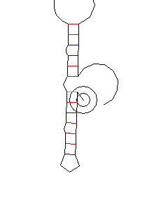
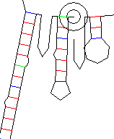
A
B

Figure 5.36 Secondary structure of a part of hSGLT1 mRNA, and ΔN12-28 hSGLT1 mRNA. (A) mRNA of hSGLT1 does not contains any stem-loop structure at its N-terminal so it is highly susceptible for RNase E degradation. (B) Deletion of amino acids from N-terminal of hSGLT1 results in a secondary structure, which contains stem-loop at N-terminal of gene, and these stem-loop structure protects the RNase E sites from RNase E degradation.

P. pastoris as an expression host
The methylotropic yeast P. pastoris is a powerful tool for the heterologous expression of protein (Cereghino and Cregg, 2000). This system combines several advantages of prokaryotic and eukaryotic expression systems. The techniques needed for molecular genetic manipulation are similar to those well established for S. cerevisiae. P. pastoris can be easily grown to high cell densities using defined minimal media and is able to introduce eukaryotic posttranslational modifications. Another advantage of the P. pastoris expression system for structural analysis is the possibility of ¹³C labeling of expressed proteins for nuclear magnetic resonance analysis. Feeding ¹³C labeled methanol provides a cost-effective possibility to achieve incorporation levels of up to 98%.

Expression of hSGLT1 in P. pastoris
For the functional expression of hSGLT1 in P. pastoris FLAG tag was introduced in hSGLT1 by changing the native peptide sequence D₅₇₄ AEEEN to D₅₇₄YKDDDDK and a 10 amino acids long spacer was placed at C-terminal. Addition of spacer at C-terminal helps in the proper targeting of hSGLT1 in the membrane because if the His tag is directly present at the C-terminal of hSGLT1 it interferes with the insertion of proteins into the membrane (Turk et al., 2000) after its synthesis in the cytosol and we observed degradation of most of the protein under this condition. P. pastoris GS115 harboring a plasmid with hSGLT1 cDNA under the control of the AOX promoter proved to be most suitable for the high-level expression and stability of recombinant hSGLT1. The transporter was detected in the yeast cells by using a FLAG antibody against the engineered FLAG epitope (Figure 4.18B), and it is active as judged by sodium-stimulated sugar (D-glucose) uptake.

Protein purification
For the purification of hSGLT1 we adopted a new strategy, which includes washing of hSGLT1 containing membranes with 4 M urea to get rid of most of peripheral and outer membrane proteins, which helps in the enrichment of hSGLT1. As judged by Western blot analysis during different stages of hSGLT1 purification, the hSGLT1 was properly inserted into the membrane because in the supernatant (Figure 4.18B, lane S1) and in urea washing (Figure 4.18B, lane UW), we could not detect any hSGLT1 protein, whereas all hSGLT1 was present in the pellet (Figure 4.18B, lane P1), and could be released into supernatant (Figure 4.18B, lane S4), which was obtained after solublization of membranes in 1.2% FosCholine-12.
A variety of molecular signals or mechanisms have been reported for the specific localization of particular membrane proteins to specific membrane compartments (Bibi et al., 1992; Matter et al., 1992; Sandoval and Bakke, 1994; Weinglass and Kaback, 2000) but the mechanism by which hSGLT1 inserts into the membrane is still unclear. Recently, Quick and Wright (Quick and Wright, 2002) showed that shorter N-terminal of hSGLT1 increases the amount of hSGLT1 inserted into the E. coli membrane because bacterial cotransporters posses significantly shorter N-terminal hydrophilic extensions than those in eukaryotes (Turk and Wright, 1997). However in P. pastoris most of hSGLT1 inserted into membrane without any modification at its N-terminal as judged by Western blot analysis (Figure 4.18B). These results indicate that signal sequences encoded within hSGLT1 sequence are fully functional in the P. pastoris.
Purified hSGLT1 shows an apparent molecular mass of 55 kDa, which corresponds to the nonglycosylated transporter. Despite the apparent nonglycosylated status of hSGLT1 in P. pastoris, its shows biochemical properties that are indistinguishable from glycosylated hSGLT1. This finding also supports previous observations that N- glycosylation is not required for hSGLT1 activity (Quick and Wright, 2002; Turk et al., 1996).
Recombinant hSGLT1 was purified by Ni-affinity chromatography on a Protino column to more than 95% purity as judged by Coomassie Blue staining SDS-PAGE gel (Figure 4.18A). No degradation product was observed in the purified hSGLT1 (Figure 4.18A and B). About 3 mg of hSGLT1 was purified from 1 liter of P. pastoris culture. The yield of hSGLT1, which we obtained in this study, was higher than those reported for other membrane protein in P. pastoris expression system. The yield for other membrane protein reported in literature are as following, 2 mg of multidrug resistance protein1 (Cai et al., 2001), 0.7 mg of ATP-binding cassette transporter (Cai and Gros, 2003), 2.2 mg of NOP-1 (Bieszke et al., 1999), and 1 mg of 5HT_{5A}-serotoninergic receptor (Weiss et al., 1998).

Reconstitution and functional analysis of recombinant hSGLT1
Purified recombinant hSGLT1 was reconstituted into performed detergent-destabilized liposomes made of 90% (w/v) asolectin soy lecithin and 10% (w/v) cholesterol with a detergent concentration adjusted to the onset of solublization (Jung et al., 1998; Panayotova-Heiermann et al., 1999; Rigaud and Levy, 2003). 100 mM sodium stimulated uptake of 50 μM α-MDG is completely blocked by 10 μM phlorizin (Figure 4.10, Figure 4.20, Figure 4.21, and Figure 4.13). In order to further characterize recombinant hSGLT1 in proteoliposomes, we performed competitive uptake studies of 100 μM α-MDG in the presence of inhibitor (100 μM phlorizin) high-affinity substrates (10 mM D-glucose and D-galactose) and low-affinity substrates (10 mM 2-Deoxy-D-glucose, mannose, allose, and L-glucose) inhibited sugar uptake according to their affinity towards transporter (Table 4.7). hSGLT1 in proteoliposomes exhibits substrate specificity in the following order, Phlz >> α-MDG ≈ D-Glc ≈ D-Gal >> 2Doglc > Man > All > L-Glc. Catalytic turnover of hSGLT1 based on the Vmax of 3.4 μmol × mg hSGLT1⁻¹ × min⁻¹ is 6 s⁻¹ (Table 4.8), which is in good agreement with that obtained in previous studies (Quick and Wright, 2002) and other Na⁺-dependent transporters [e.g., the Na⁺/ glucose transporter of Vibrio parahaemolyticus (vSGLT) (Turk et al., 2000), and Na⁺/ proline transporter of Escherichia coli (PutP) (Jung et al., 1998)]. The kinetics of recombinant hSGLT1 in intact cells or membrane vesicles, and reconstituted proteoliposomes, mirror those determined for hSGLT1 in native tissue and Xenopus oocytes.

Reasons for getting functional expression of hSGLT1 in P. pastoris
One obvious question that comes into mind, if mRNA of hSGLT1 is unstable in E. coli and contains five potential RNase E sites why did we get expression of hSGLT1 in P. pastoris. The best possible explanation of this question is that the mRNA half-life and underlying degradation mechanisms are different in P. pastoris as compared to E. coli. In yeast, the degradation of the transcript begins with the shortening of the poly (A) tail at the 3´end of mRNA (Muhlrad and Parker, 1992; Shyu et al., 1991). Shortening of the poly (A) tail primarily leads to removal of the 5´-cap structure (decapping), thereby exposing the transcript to digestion by a 5´-3´exonuclease. In addition to decapping and 5´-3´decay, transcripts can also be degraded in a 3´-5´direction following deadenylation (Anderson and Parker, 1998; Muhlrad et al., 1995). This process is catalyzed by a conserved complex of multiple 3´-5´exonucleases, termed the exosome that also performs a wide variety of RNA processing events. Currently, the available data suggest that the major mechanism of mRNA decay in yeast is by decapping and 5´-3´degradation (Beelman et al., 1996). Yeast mRNA can also be degraded by mechanisms that involve specific cleavage of transcript independent of prior poly (A) shortening.
Decapping is a key step in the yeast mRNA degradation for several reseaons. First, in the 5´-3´pathway of mRNA degradation, it both precedes and permits the decay of the transcript body. Second, since individual mRNAs are decapped at different rates, decapping is also an important control point in mRNA decay. Third, decapping also plays a critical role in the process of mRNA surveillance wherein aberrant mRNAs containing nonsense codons are very rapidly decapped and degraded in a 5´-3´direction. The major difference in the mRNA degradation mechanism in E. coli and P. pastoris is that the decapping is the most crucial step in the mRNA degradation in yeast but in bacteria this step is not necessary for mRNA degradation. Average half-life of mRNA in yeast is around 3 h while in case of bacteria it is only 1.5 min.
Second explanation for hSGLT1 expression in P. pastoris can be given on the basis of difference in the codon usages in both expression systems. As mentioned previously, codon usage in E. coli are ~23% bias for hSGLT1 gene as compared to H. sapiens, while codon usage in P. pastoris are only 9.7% bias as compared to H. sapiens. Third possible explanation is that P. pastoris as a eukaryote organism shares many similarities with H. sapiens at the cellular level and molecular mechanisms underlying transcription, translation and membrane trafficking of membrane proteins compared to their prokaryote counterpart E. coli.

Advantages of our expression method
Our method of expression of hSGLT1 in P. pastoris has certain advantages over other methods of hSGLT1 expression. We expressed full-length hSGLT1 protein without any significant modification in hSGLT1 as compared to previously reported hSGLT1 in E. coli (Quick and Wright, 2002), in which N-terminal of hSGLT1 was shortened by deleting amino acid residues 12-28 and GFP was fused to its C-terminal but in our opinion hSGLT1ΔN-GFP is not suitable for most of the biochemical and biophysical applications due to its very high molecular weight (≈100 kDa) and due to intense modifications in it. The amount of hSGLT1 (3 mg hSGLT1 per 1-liter of yeast culture) obtained in our expression system is the highest yield reported so far for hSGLT1 protein expression. The yield obtained in E. coli is only 1 mg of purified recombinant protein per 3-liter of cultured bacterial cells. For the better immunological detection and to provide ease in the purification two affinity tags are present in our protein. Our protein purification method is very simple and efficient. The initial step involving washing of the protein pellet with 4 M urea resulted in a much more enriched hSGLT1 protein pellet which was further solublized in 1.2% FosCholine-12. Thus resultant solublized supernatant gave more than 95% purified hSGLT1 protein without any degradation product on Ni-affinity purification on a Protino column, while the other reported procedure includes two steps protein purification, immuno-affinity chromatography followed by gel filtration (Quick and Wright, 2002). Advantages of our hSGLT1 expression methods clearly demonstrate that our method is novel and unique, as it provides purified protein in less time with less expenditure.

Photoaffinity labeling of truncated loop 13
A photoaffinity probe should satisfy the following criteria for its successful utilization in target site identification. It should be small, so as not to cause unacceptable steric perturbation to the system under examination. It should be stable in the dark, and highly susceptible to light at a wavelength that does not cause photolytic damage to the biological sample. Finally, the reaction with biological targets should lead to stable products to enable their isolation, purification and analysis. Both diazirine and benzophenone based photo probes exhibit these major advantages over frequently used azido photoprobes (Bayley and Knowles, 1978; Gibbs et al., 1982; Lin et al., 1982). TIPDG, 6-AG and BzG come closer to satisfying the chemical and biological criteria required for most photo reagents (Brunner et al., 1980; Delfino et al., 1993; Dorman and Prestwich, 1994; Fang et al., 1998; Hatanaka et al., 1994; Nassal, 1984; Platz et al., 1991; Prestwich et al., 1997). All three photoprobes TIPDG, 6-AG and BzG can be photolysed at 350-360 nm, avoiding protein-damaging wavelengths. In TIPDG the electron withdrawing trifluoromethyl group may lead to an increased stability of the C-I bond. That this type of iodinated phenyldiazirine makes promising photolabeling reagents is inferred also from a number of studies with 3-(trifluoromethyl)-3-(3-[¹²⁵I]iodophenyl) diazirine, a reagents widely used in the past for labeling of the apolar phase of membranes (Brunner, 1989; Brunner and Semenza, 1981; Brunner et al., 1983). The superb selectivity of this reagent in labeling integral (versus peripheral) proteins may be a direct reflection of the C-I bond stability during diazirine photolysis.
Despite the early concerns about the photochemistry of aliphatic as opposed to aromatic diazirines (Brunner, 1993), they have now been successfully employed in the design of minimally perturbing photoaffinity probes (Kipp et al., 1997; Liessem et al., 1995). We, therefore, recently developed a novel photoreactive aliphatic diazirine-containing photoprobe 6-AG that mimic glucose, a high-affinity substrate transport by hSGLT1. In contrast to the bipolar azido group, no polarization of the aliphatic diazirine group can be observed. The carbon atom of the three membered aliphatic diazirine ring has a chemical shift of ~15 ppm in ¹³C NMR spectra, and the hydrogen atoms of vicinal methyl group have a chemical shift of ~1 ppm in ¹H NMR spectra. This data is typical for the chemical shifts usually observed in nonpolar alkyl groups. The nonpolar character of 6-AG seems to have a special benefit for the binding of modified substrates to hydrophobic membrane proteins.
BzG exhibits three distinct chemical and biochemical advantages over previously reported azido derivatives of phlorizin (Gibbs et al., 1982; Lin et al., 1982), which gave very inconsistent poor labeling results due to harsh photolysis conditions and low labeling efficiency caused by undesired side reactions. First BzG is more stable than azido derivatives of phlorizin. Second BzG can be manipulated in ambient light and can be activated at 350-360 nm. Third BzG reacts preferentially with unreative C-H bonds, even in the presence of solvent water and bulk nucleophiles. The relative inertness of the BzG triplet state to the water should guarantee that no BzG photoaffinity label will be lost to reaction with water, in contrast to carbene photoaffinity labels, where immediately or delayed hydrolysis has frequently been observed (Galardy et al., 1974; Hexter and Westheimer, 1971; Shafer et al., 1966).
Aryl azides are the most widely used photochemical reagents in the strategy of photoaffinity labeling receptors sites on proteins. Photoactivation of aryl azide yields several reactive intermediates, including singlet (half-life on the order of milliseconds) plus small fractions of the relatively long-lived triplet nitrenes. Special attention must, therefore, be given to minimize spurious labeling attendant with reactive species that can migrate from the original binding sites. Nitrenes are also thought to react preferentially with nucleophilic groups and rarely are involved in random, near-neighboring hydrogen extractions and insertion into C-H bonds. However, this feature is not necessarily a disadvantage in the employment of the phlorizin aryl azide derivative. For example, the receptor for 3-AP probably includes a polar group that serves as the specific interaction site for the –N₃ moiety. Our rationale for the synthesis of 3-AP photoprobe was based on previous results reported by Diedrich group (Diedrich, 1990; Gibbs et al., 1982; Hosang et al., 1981), using 4-azidophlorzin that introduction of the azido group into the phlorizin backbone neither changes its interactions mode with Na⁺/D-glucose cotransporter nor its inhibition kinetics.
The synthesis of the new photoactivable analogue of arbutin 9 features several noteworthy steps: (a) regioselective introduction of an iodine atom into the aromatic ring of compound 1 (Figure 3.6) in the presence of excess HgO affording aryl iodide 2 in high yield (Brunner et al., 1980; Hatanaka et al., 1994), (b) O-Demethylation of 2, followed by coupling of phenol 3, in the presence of mercuric cyanide to give keto compound 5 in very high yield (Ambroise et al., 2000). Regioselective introduction of the iodine atom into the aromatic ring of TIPDG can also serve the purpose of producing a radioactive analogue of TIPDG with a high specific activity by using the tritiodeiodination reaction (Ambroise et al., 2000) To check this possibility, we performed hydrodeiodination of TIPDG in the presence of molecular hydrogen and 10% Pd/C, which gave non iodinated form of TIPDG within 1 h without any significant loss of the diazirine moiety. Ambroise (Ambroise et al., 2000) synthesized [(4’-(3’’-trifluoromethyldiazirinyl)phenoxy]-D-galactopyranoside by stannic tetrachloride-catalyzed glycosylation of β-D-galactose pentaacetate with [3-(4-hydroxyphenyl)-3-(trifluoromethyl)-3H-diazirine in 43% yield. The phenol [3-(4-hydroxy phenyl)-3-(trifluoromethyl)-3H-diazirine was synthesized in six steps by the previously reported procedure (Hatanaka et al., 1994), but the major drawback of this synthesis was the low yield (26%) of demethylation of [3-(4-methoxyphenyl)-3-(trifluoromethyl)-3H-diazirine with trimethylsilyl iodide and a prolonged reaction time 65 h (Hatanaka et al., 1994). In our method, demethylation of 3-Iodo-4-methoxy-trifluoroacetophenone 2 with LiCl gives phenol 3 in 88% yield and the coupling reaction of phenol 3 with α-D-acetobromoglucose 4 in the presence of mercuric cyanide gives [(2’-Iodo-4’-trifluoroacetyl)phenoxy]-2,3,4,6-tetra-O-acetyl-D-glucopyranoside 5 in 75% yield. Thus, our method provides a simple and versatile approach for the synthesis of different sugar based photoaffinity probes.
The results on Na⁺-dependent glucose uptake show that TIPDG (Figure 4.20), BzG (Figure 4.28), 3-AP, and 6-AG (Figure 4.30) interact with the high affinity Na⁺/D-glucose cotransporter. It was further demonstrated that the K_{i} values of TIPDG (22 ± 5 µM) and its prototype compound arbutin (25 ± 6 µM), BzG (12 ± 2 µM) and its respective model compound phlorizin (8 ± 1.2 µM), 3-AP (8.6 ± 1.6 µM) and its parent compound phlorizin (8 ± 1.2 µM) and of 6-AG (40 ± 5 µM) and its sibling D-glucose (1 mM) were essentially identical. Modification of phenyl ring OH group in arbutin into a trifluoromethyl diazirine group and mono iodination of its phenyl ring neither altered the affinity to the Na⁺/D-glucose cotransporter nor the mode of inhibition.
To further test the potential of TIPDG and BzG as a selective photoaffinity probe for SGLT1, we labeled the truncated loop 13 (amino acid 564-638 of SGLT1 amino acid sequence). MALDI-mass spectrometry analysis of photoaffinity labelled truncated loop 13 protein with TIPDG and with BzG clearly indicates that our probes successfully labeled the part of SGLT1 protein.
Site-directed mutagenesis studies suggest that a hydrophobic region located in the C-terminal loop 13 (amino acids 604-610) is critically involved in the binding of phlorizin (Novakova et al., 2001). The binding of phlorizin to loop 13 could be confirmed in solution by monitoring phlorizin-dependent fluorescence quenching of the endogenous tryptophan residue (Trp-561). It has been further demonstrated that the phloretin (but not the glucose) moiety of phlorizin interacts with loop13 (Xia et al., 2003). Phlorizin consists of a pyranoside ring and two aromatic rings joined by an alkyl spacer. The conformation of phlorizin in aqueous solutions was previously studied by two-dimensional NMR and pharmacophore analysis by Wielert-Badt (Wielert-Badt et al., 2000). Their model indicates that the interactions via hydrogen bonds from the 2-, 3-, 4-, and 6-hydoxyl groups of the pyranoside and the 4- and 6-OH groups of aromatic ring A are essential for phlorizin binding. This information can now be combined with the Trp fluorescence data (Raja et al., 2003) to estimate the dimensions of the phlorizin-binding and recognition region. We can assume that phlorizin binds to the region very close to position 611 by H-bonding probably with 4-OH group by acceptor/donor atom O-4 of aromatic ring A. Thus, position 611 is supposed to be very important in phlorizin recognition, as also suggested by the lower affinity of D611W mutant. The H-bonding of any one hydrophobic amino acid located in region 606-609 with 6-OH group by acceptor/donor atom O-6 of aromatic ring A of phlorizin also causes a strong interaction.
The combination of photoaffinity labeling, SDS-PAGE, enzymatic fragmentation, and MALDI-mass spectrometry analysis with resulting allocation of the attachment site of the ortho position of ring B of phlorizin to amino acid Arg-602 now defines directly the phlorizin binding site in loop 13. Thus, an interaction of this region with the B ring of phlorizin can be assumed. Thereby the binding pocket could accommodate the phlorizin molecule in the predicted conformation. On the basis of photoaffinity labeling pattern of truncated loop 13 with 3-azidophlorizin, we could provide a generalized mechanism by which phlorizin inhibits sugar transport by SGLT1. According to our assumption, a phlorizin-binding region in SGLT1 is located between amino acids 601-611, in this region aromatic rings (A and B) of phlorizin interact with hydrophobic amino acids and the glucoside moiety of phlorizin is free to interact with sugar interaction sites of SGLT1 (Lo and Silverman, 1998; Panayotova-Heiermann et al., 1997).
In summary, this study provides first example of large-scale functional expression and purification of full-length human Na⁺/D-glucose cotransporter. Recombinant hSGLT1 retains full functionalities when reconstituted into proteoliposomes. The ability to purify functional cotransporter enables a battery of biochemical and biophysical experiments to probe the structure and function of hSGLT1, with results possibly relevant to other cotransporters in the SGLT family. We hope that our method of functional human membrane protein expression in P. pastoris presented in this study may also provide guidelines for the expression of other medically important human membrane proteins which thus far could not be expressed in prokaryote hosts.

Future prospective
In the life of a membrane protein molecular biologist the happiest day is the day when he/she gets functional expression of target protein. Our success in the functional expression of hSGLT1 open doors of new opportunities to work on hSGLT1. It would be an interesting and challenging task to decipher the molecular basis of the sugar transport and inhibitor binding. What are the responsible amino acids in the protein for sugar transport and inhibitor binding? What would be sugar translocation and inhibitor binding mechanisms? These and many other questions can now be readily answered because now we have an expression system, which provides sufficient amount of functional hSGLT1.
Photoaffinity labeling provides a promising approach for the identification of sugar translocation pathway and inhibitor binding sites (Raja et al., 2004; Raja et al., 2003; Tyagi and Kinne, 2003), so it would be a challenging and interesting task to performed equilibrium and time-dependent photoaffinity labeling studies with reconstituted recombinant hSGLT1 for the identification of critical amino acids responsible for sugar selectivity, uptake and for inhibitor binding.
It would be interesting to address the questions related to sugar translocation pathway and inhibitor binding mechanism by means of luminescence spectroscopy, which has proven informative in the case of some other transporter (Vazquez-Ibar et al., 2003) and which could ultimately provide interesting insight concerning molecular mechanisms responsible for transport activity.
The ultimate goal of protein biologist working on structure-functional relationship of protein is to get the information about target protein structure by X-ray crystallography or Nuclear magnetic resonance spectroscopy, so it would be interesting and challenging tasks to work on this aspect of hSGLT1 structure with the help of protein obtained from our expression system.

Summary

Human sodium/D-glucose cotransporter (hSGLT1) is a member of solute carrier family (SLC5) and plays a central role in the homeostasis of glucose, salt, and water. During the course of this work, first the production of recombinant hSGLT1 transporter in E. coli and P. pastoris was evaluated.
A number of different expression vector constructs of hSGLT1 for its production in E. coli were prepared. Various affinity tags were appended to the transporter C-terminal to enable transporter detection and purification. We attempted expression of transporter in different expression vectors, in different conditions and in different E. coli strains but we could not get the expression of hSGLT1. During this process, we constructed clone pET22b-Unc-F-hSGLT1 containing Unc-F gene (encoding the β-subunit of E. coli ATP synthase), in this case also we could not find out any hSGLT1 expression but also no expression of β-subunit of the E. coli ATP synthase, which was expressed in large amounts in the control clone (pET22b-Unc-F). This finding along with the fact that hSGLT1 mRNA contains 5 RNase E sites suggests that in E. coli hSGLT1 mRNA is unstable and all mRNA is degraded by RNase E and other exoribonucleases before its translation into protein.
Heterologous expression of hSGLT1 was also carried out in P. pastoris. hSGLT1 gene containing FLAG tag and a 10 amino acids long spacer at its C-terminal was cloned into pPICZB plasmid and the resulted expression vector pPICZB-hSGLT1 was transformed into P. pastoris strain GS115 by electroporation. Purification of recombinant hSGLT1 by Nickel-affinity-chromatography yields about 3 mg of purified recombinant hSGLT1 per 1-liter of cultured P. pastoris cells. The purity of the hSGLT1 was more than 95% pure, as judged from Coomassie stained gels. Purified hSGLT1 migrates on SDS-PAGE at an apparent mass of 55 kDa, which corresponds to that of the nonglycosylated transporter. Reconstitution of purified hSGLT1 yields proteoliposomes active in Na⁺-dependent glucose uptake and sodium-stimulated uptake of 50 μM α-MDG is completely blocked by 10 μM phlorizin. The 1 min time course of α-MDG uptake in the proteoliposomes demonstrated a characteristic overshoot in the presence of Na⁺, indicating that sugar was concentrated within the proteoliposomes and that uptake was energised by Na⁺electrochemical gradient. In order to further characterize recombinant hSGLT1 in proteoliposomes, we performed competitive uptake studies of 100 μM α-MDG in the presence of inhibitor (100 μM phlorizin) high-affinity substrates (10 mM D-glucose and D-galactose) and low-affinity substrates (10 mM 2-Deoxy-D-glucose, mannose, allose, and L- glucose) that inhibited sugar uptake according to their affinity towards the transporter in cells and membranes. hSGLT1 in proteoliposomes exhibits substrate specificity in the following order, Phlz >> α-MDG ≈ D-Glc ≈ D-Gal >> 2Doglc > Man > All > L-Glc. Recombinant reconstituted hSGLT1 shows sterospecificity as its preferred D-Glu over L-Glu, D-Glu inhibited 75% of α-MDG uptake L-Glu, inhibited only 2%. The equatorial orientation of the OH-group at the positions C-2 and C-3 of the D-glucose seems to be important for its recognition by hSGLT1 since the presence of mannose, 2-Deoxy-D-glucose and allose significant inhibitory effect on α-MDG uptake was observed. The 78% inhibition of α-MDG uptake in the presence of D-galactose indicates the orientation of OH-group at C-4 (equatorial in D-glucose and axial in D-galactose) is not that important for their recognition by cotransporter because D-Glu and D-Gal inhibited sugar uptake by transporter upto equal extent. Phlz inhibited 84% of α-MDG uptake in proteoliposomes.
Catalytic turnover of hSGLT1 based on the Vmax of 3.4μmol × mg hSGLT1⁻¹ × min⁻¹ is 6 s⁻¹. These results clearly indicate that purified recombinant hSGLT1 posses the full functionalities in this reconstituted system.
For the identification of sugar-binding sites and phlorizin interactions sites in the transporter four new photoprobes were synthesized and subsequently evaluated for their effects on SGLT1 mediated α-MDG transport in rabbit small intestine brush border membrane vesicles. Results of these experiments shows that [(2’-Iodo-4’-(3’’-trifluoromethyldiazirinyl) phenoxy]-D-glucopyranoside (TIPDG), [(4´-Benzoyl) phenoxy]-D-glucopyranoside (BzG), 3-Azidophlorizin (3-AP), n-Methyl-6C-(Azimethyl)-D-glucopyranoside (6-AG) inhibit α-MDG uptake. The K_{i} values of TIPDG (22 ± 5µM) and its prototype compound arbutin (25 ± 6µM), BzG (12 ± 2µM) and its respective model compound phlorizin (8 ± 1.2µM), 3-AP (8.6 ± 1.6µM) and its parent compound phlorizin (8 ± 1.2µM) and of 6-AG (40 ± 5µM) and its sibling D-glucose (1 mM) were essentially identical. Photoaffinity labeling were performed with a functional domain of SGLT1 (amino acids 564-638 of the SGLT1 amino acid sequence, loop 13) with TIPDG, BzG, and 3-AP clearly demonstrated that our probes successfully labeled part of the SGLT1 protein.
3-AP was further used to identify phlorizin-binding sites in the truncated loop 13 by the combination of photoaffinity labeling, SDS-PAGE, enzymatic fragmentation, and MALDI-mass spectrometry analysis. The attachment site of the ortho position of ring B of phlorizin could be allocated to amino acid Arg-602, thus, an interaction of this region with the B ring of phlorizin can be assumed. Thereby the binding pocket could accommodate the phlorizin molecule in the previously predicted conformation.
To summarize, this study provides first example of large-scale functional expression and purification of full-length human Na⁺/D-glucose cotransporter. Recombinant hSGLT1 retains full functionalities when reconstituted into proteoliposomes. The ability to purify functional cotransporter enables a battery of biochemical and biophysical experiments to probe the structure and function of hSGLT1, with results possibly relevant to other cotransporters in the SGLT family. The synthesis of four new photoaffinity probes provides tools for the identification of sugar translocation pathway and inhibitor binding in the recombinant hSGLT1.

Zusammenfassung

Der humane Na⁺/D-Glucose Kotransporter (hSGLT1) gehört zur Transporerfamilie SCL (solute carrier) 5 und spielt eine zentrale Rolle bei der Homöostase von Glucose, Salz und Wasser.
Ziel der vorliegenden Arbeit war zunächst die heterologe Expression des Transporters in E. coli und P. pastoris. Für die Expression in E. coli wurden verschiedene Expressionsvektoren verwendet und zur Detektion und Reinigung des Transporters unterschiedliche Affinitäts Tags an dessen C-Terminus angehängt.
Wir haben die Expression des Transporters mit verschiedenen Expressionsvektoren und E. coli Stämmen unter zahlreichen Bedingungen versucht, ohne dass die Expression von hSGLT1 gelang. Während dieser Versuche haben wir den Klon pET22b-Unc-F-hSGLT1 hergestellt, welcher das Unc-F Gen für die β-Untereinheit der E. coli ATP Synthase enthält. In diesem Fall konnten weder hSGLT1 noch ATPase Expression nachgewiesen werden, obwohl letztere in hohem Ausmaß im Kontrollklon (pET22b-Unc-F) exprimiert wurde. Zusammen mit der Tatsache, dass die mRNA des hSGLT1 5 RNasE Sequenzen enthält, lässt dies den Schluß zu, dass die mRNA des hSGLT1 in E. coli instababil ist und dass die mRNA durch RNase E und andere Exoribonucleasen abgebaut wird, noch bevor die Translation zum Protein erfolgen kann.
Desweiteren wurde die heterologe Expression von hSGLT1 in P. pastoris durchgeführt. Das hSGLT1 Gen wurde mit einem C-terminalen FLAG Tag und einem 10 Aminosäuren langen Spacer in das Plasmid pPICZB kloniert. Mit dem erhaltenen Expressionsvektor pPICB-hSGLT1 wurde der P. pastoris Stamm GS115 durch Elektroporation transformiert. Durch Aufreinigung des hSGLT1 mittels Nickel-Affinitätschromatographie konnten 3 mg gereinigtes rekombinantes hSGLT1 Protein pro Liter P. pastoris Kultur angereichert werden. Die Reinheit des hSGLT1 lag bei über 95%.
Gereinigter hSGLT1 hat in SDS-PAGE Gelen ein scheinbares Molekulargewicht von 55 kDa, welches der Größe eines nicht-glykosilierten Transporters entspricht.
Nach Rekonstitution des gereinigten SGLT1 in Proteoliposomen konnte eine natriumgetriebene Akkumulation von α-Methyl-D-Glucose (α-MDG) nachgewiesen werden, die vollkommen durch 10 μM Phlorizin gehemmt wurde.
Um rekombinanten hSGLT1 in Proteoliposomen näher zu charakterisieren, wurden kompetitive Aufnahmestudien mit 100 μM α-MDG in der Gegenwart von Inhibitor (100 μM Phlorizin), Substraten mit hoher Affinität (10 mM D-Glucose und D-Galactose) und Substraten mit geringer Affinität (10 mM 2-Deoxy-D-Glucose, Mannose, Allose und L-Glucose) durchgeführt, welche die Zuckeraufnahme entsprechend ihrer Affinität zum nativen Transporter inhibierten.
hSGLT1 in Proteoliposomen weist folgende Substratspezifität auf: Phlz >> α-MDG ≈ D-Glc ≈ D-Gal >> 2DoGlc > Man > All > L-Glc.
Die katalytische Umsatzrate des hSGLT1 beträgt 6 s⁻¹ auf der Basis von Vmax = 3,4 μmol × mg hSGLT1⁻¹ × min⁻¹. Diese Ergebnisse zeigen deutlich dass gereinigter rekombinanter hSGLT1 in dem verwendeten System volle Funktionalität aufweist.
Für die Identifizierung der Bindungsstellen des Transporters für Zucker und der Interaktionsstellen mit Phlorizin wurden vier neue Photo-Proben synthetisiert und deren Wirkung auf den SGLT1-vermittelten α-MDG Transport in Vesikeln der Bürstensaummembran des Kaninchen-Dünndarms untersucht. Die Ergebnisse zeigten dass [(2’-Iodo-4’-(3’’-trifluoromethyldiazirinyl) phenoxy]-D-glucopyranoside (TIPDG), [(4´-Benzoyl) phenoxy]-D- glucopyranoside (BzG), 3-Azidophlorizin (3-AP), n-Methyl-6C- (Azimethyl)-D- glucopyranoside (6-AG) die α-MDG Aufnahme inhibierten. Die K_{i} Werte der Ausgangsverbindungen und deren Derivate waren nahezu identisch; 25 ± 6 μM für Arbutin und 22 ± 5 μM für TIPDG, 8 ± 1,2 μM für die Ausgangsverbindung Phlorizin und 12 ± 2 μM für BzG und 8,6 ± 1,2 μM für 3-AP als deren Derivate und 1 mM für die Ausgangsverbindung D-Glucose und 40 ± 5 μM für 6-AG.
Photoaffinitäts-Markierungen wurden mit einer funktionellen, rekombinant exprimierten Domäne des SGLT1 (Aminosären 564-638 des loop 13) mit TIPDG, BzG und 3-AP durchgeführt. Es konnte deutlich gezeigt werden, dass die Proben erfolgreich Teile des SGLT1 Proteins markierten.
Um die Phlorizin-Bindestellen des Loop 13 zu identifizieren wurde im weiteren 3-AP in einer Kombination von Photoaffinitäts Markierungen, SDS-PAGE, enzymatischer Fragmentierung und MALDI Massenspektrometrie verwendet. Die Anlagerungsstelle des Ring B von Phlorizin konnte der Aminosäure Arg-602 zugeordnet werden. Folglich kann eine Wechselwirkung dieser Region mit dem Phlorizin B-Ring angenommen werden. Dadurch könnte die Bindungstasche das Phlorizinmolekül in der zuvor vorhergesagten Konformation beherbergen.
In dieser Studie konnte zum ersten mal der humane Na⁺/D-Glucose Kotransporter in großem Maßstab funktionell exprimiert und gereinigt werden. Dabei konnte gezeigt werden, dass rekombinanter hSGLT1 bei der Rekonstitution in Proteoliposomen die volle Funktionalität beibehält. Die Fähigkeit den funktionellen Kotransporter zu reinigen, eröffnet viele Möglichkeiten die Struktur und Funktion des hSGLT1 mit Hilfe biochemischer und biophysikalischer Methoden zu untersuchen. Durch die Herstellung von vier neuen Photoaffinitäts-Proben ist es in Zukunft möglich den Transportweg von Zucker zu verfolgen und Inhibitor Bindestellen zu identifizieren. Die daraus resultierenden Erkenntnisse sind möglicherweise übertragbar auf andere Ko-Transporter der SGLT Familie.

Reference list

Addona, G. H., Husain, S. S., Stehle, T., and Miller, K. W. (2002). Geometric isomers of a photoactivable general anesthetic delineate a binding site on adenylate kinase. J Biol Chem 277, 25685-25691.
Ambroise, Y., Mioskowski, C., Leblanc, G., and Rousseau, B. (2000). Syntheses and properties of photoactivatable sugar derivatives designed to probe the sugar-binding site of melibiose permease. Bioorg Med Chem Lett 10, 1125-1127.
Anderson, J. S., and Parker, R. P. (1998). The 3' to 5' degradation of yeast mRNAs is a general mechanism for mRNA turnover that requires the SKI2 DEVH box protein and 3' to 5' exonucleases of the exosome complex. Embo J 17, 1497-1506.
Arechaga, I., Miroux, B., Karrasch, S., Huijbregts, R., de Kruijff, B., Runswick, M. J., and Walker, J. E. (2000). Characterisation of new intracellular membranes in Escherichia coli accompanying large scale over-production of the b subunit of F₁F_{o} ATP synthase. FEBS Lett 482, 215-219.
Arkowitz, R. A., and Bassilana, M. (1994). Protein translocation in Escherichia coli. Biochim Biophys Acta 1197, 311-343.
Armstrong, C. M. (2003). Voltage-gated K channels. Sci STKE, re10.
Barnett, J., Chow, J., Ives, D., Chiou, M., Mackenzie, R., Osen, E., Nguyen, B., Tsing, S., Bach, C., Freire, J., and et al. (1994). Purification, characterization and selective inhibition of human prostaglandin G/H synthase 1 and 2 expressed in the baculovirus system. Biochim Biophys Acta 1209, 130-139.
Bayley, H. (1983). Photogenerated Reagents in Biochemistry and Molecular Biology (Amsterdam, Elsevier Science publisher B.V.).
Bayley, H., and Knowles, J. R. (1977). Photoaffinity labeling. Methods Enzymol 46, 69-114.
Bayley, H., and Knowles, J. R. (1978). Photogenerated reagents for membrane labeling. 1. Phenylnitrene formed within the lipid bilayer. Biochemistry 17, 2414-2419.
Beelman, C. A., Stevens, A., Caponigro, G., LaGrandeur, T. E., Hatfield, L., Fortner, D. M., and Parker, R. (1996). An essential component of the decapping enzyme required for normal rates of mRNA turnover. Nature 382, 642-646.
Bibi, E., and Kaback, H. R. (1990). In vivo expression of the lacY gene in two segments leads to functional lac permease. Proc Natl Acad Sci U S A 87, 4325-4329.
Bibi, E., Stearns, S. M., and Kaback, H. R. (1992). The N-terminal 22 amino acid residues in the lactose permease of Escherichia coli are not obligatory for membrane insertion or transport activity. Proc Natl Acad Sci U S A 89, 3180-3184.
Bieszke, J. A., Spudich, E. N., Scott, K. L., Borkovich, K. A., and Spudich, J. L. (1999). A eukaryotic protein, NOP-1, binds retinal to form an archaeal rhodopsin-like photochemically reactive pigment. Biochemistry 38, 14138-14145.
Binda, C., Newton-Vinson, P., Hubalek, F., Edmondson, D. E., and Mattevi, A. (2002). Structure of human monoamine oxidase B, a drug target for the treatment of neurological disorders. Nat Struct Biol 9, 22-26.
Birnir, B., Lee, H. S., Hediger, M. A., and Wright, E. M. (1990). Expression and characterization of the intestinal Na⁺/glucose cotransporter in COS-7 cells. Biochim Biophys Acta 1048, 100-104.
Borhan, B., Souto, M. L., Imai, H., Shichida, Y., and Nakanishi, K. (2000). Movement of retinal along the visual transduction path. Science 288, 2209-2212.
Borst, P., and Elferink, R. O. (2002). Mammalian ABC transporters in health and disease. Annu Rev Biochem 71, 537-592.
Bracey, M. H., Hanson, M. A., Masuda, K. R., Stevens, R. C., and Cravatt, B. F. (2002). Structural adaptations in a membrane enzyme that terminates endocannabinoid signaling. Science 298, 1793-1796.
Brunner, J. (1989). Photochemical labeling of apolar phase of membranes. Methods Enzymol 172, 628-687.
Brunner, J. (1993). New photolabeling and crosslinking methods. Annu Rev Biochem 62, 483-514.
Brunner, J., and Semenza, G. (1981). Selective labeling of the hydrophobic core of membranes with 3-(trifluoromethyl)-3-(m-[¹²⁵I]iodophenyl)diazirine, a carbene-generating reagent. Biochemistry 20, 7174-7182.
Brunner, J., Senn, H., and Richards, F. M. (1980). 3-Trifluoromethyl-3-phenyldiazirine. A new carbene generating group for photolabeling reagents. J Biol Chem 255, 3313-3318.
Brunner, J., Spiess, M., Aggeler, R., Huber, P., and Semenza, G. (1983). Hydrophobic labeling of a single leaflet of the human erythrocyte membrane. Biochemistry 22, 3812-3820.
Burckhardt, G., and Kinne, R. K. H. (1992). Transport Proteins – Co- and Counter-Transporters. In The Kidney: Physiology and Pathophysiology, D. W. Seldin, and G. Giebisch, eds. (New York, Raven Press), pp. 537-586.
Cai, J., Daoud, R., Georges, E., and Gros, P. (2001). Functional expression of multidrug resistance protein 1 in Pichia pastoris. Biochemistry 40, 8307-8316.
Cai, J., and Gros, P. (2003). Overexpression, purification, and functional characterization of ATP-binding cassette transporters in the yeast, Pichia pastoris. Biochim Biophys Acta 1610, 63-76.
Carpousis, A. J., Van Houwe, G., Ehretsmann, C., and Krisch, H. M. (1994). Copurification of E. coli RNAase E and PNPase: evidence for a specific association between two enzymes important in RNA processing and degradation. Cell 76, 889-900.
Carrier, T., Jones, K. L., and Keasling, J. D. (1998). mRNA stability and plasmid copy number effects on gene expression from an inducible promoter system. Biotechnol Bioeng 59, 666-672.
Carrier, T. A., and Keasling, J. D. (1997a). Controlling messenger RNA stability in bacteria: strategies for engineering gene expression. Biotechnol Prog 13, 699-708.
Carrier, T. A., and Keasling, J. D. (1997b). Engineering mRNA stability in E. coli by the addition of synthetic hairpins using a 5' cassette system. Biotechnol and Bioeng 55, 577-580.
Carrier, T. A., and Keasling, J. D. (1999). Library of synthetic 5' secondary structures to manipulate mRNA stability in Escherichia coli. Biotechnol Prog 15, 58-64.
Cereghino, J. L., and Cregg, J. M. (2000). Heterologous protein expression in the methylotrophic yeast Pichia pastoris. FEMS Microbiol Rev 24, 45-66.
Chen, T.-Y. (2003). Coupling gating with ion permeation in ClC channels. Sci STKE, pe23.
Chiara, D. C., Dangott, L. J., Eckenhoff, R. G., and Cohen, J. B. (2003). Identification of nicotinic acetylcholine receptor amino acids photolabeled by the volatile anesthetic halothane. Biochemistry 42, 13457-13467.
Church, R. F., Maleike, R. R., and Weiss, M. J. (1972). Diazirines. 3. Synthesis of a series of diazirine-containing molecules and their pharmacological evaluation. J Med Chem 15, 514-518.
Church, R. F. R., and Weiss, M. J. (1970). Diazirines. II. Synthesis and properties of small functionalized diazirine molecules. Observations on the reaction of a diaziridine with the iodine-iodide ion system. J Org Chem 35, 2465-2471.
Clare, J. J., Rayment, F. B., Ballantine, S. P., Sreekrishna, K., and Romanos, M. A. (1991). High-level expression of tetanus toxin fragment C in Pichia pastoris strains containing multiple tandem integrations of the gene. Biotechnology (N Y) 9, 455-460.
Coburn, G. A., and Mackie, G. A. (1999). Degradation of mRNA in Escherichia coli: an old problem with some new twists. Prog Nucleic Acid Res Mol Biol 62, 55-108.
Cregg, J. M., Cereghino, J. L., Shi, J., and Higgins, D. R. (2000). Recombinant protein expression in Pichia pastoris. Mol Biotechnol 16, 23-52.
Darbandi-Tonkabon, R., Hastings, W. R., Zeng, C. M., Akk, G., Manion, B. D., Bracamontes, J. R., Steinbach, J. H., Mennerick, S. J., Covey, D. F., and Evers, A. S. (2003). Photoaffinity labeling with a neuroactive steroid analogue. 6-azi-pregnanolone labels voltage-dependent anion channel-1 in rat brain. J Biol Chem 278, 13196-13206.
Decoursey, T. E. (2003). Voltage-gated proton channels and other proton transfer tathways. Physiol Rev 83, 475-579.
Delfino, J. M., Schreiber, S. L., and Richards, F. M. (1993). Design, synthesis, and properties of a photoactivatable membrane-spanning phospholipidic probe. J Am Chem Soc 115, 3458-3474.
Diedrich, D. F. (1966). Competitive inhibition of intestinal glucose transport by phlorizin analogs. Arch Biochem Biophys 117, 248-256.
Diedrich, D. F. (1990). Photoaffinity-labeling analogs of phlorizin and phloretin: synthesis and effects on cell membranes. Methods Enzymol 191, 755-780.
Diez-Sampedro, A., Loo, D. D., Wright, E. M., Zampighi, G. A., and Hirayama, B. A. (2004). Coupled sodium/glucose cotransport by SGLT1 requires a negative charge at position 454. Biochemistry 43, 13175-13184.
Diez-Sampedro, A., Lostao, M. P., Wright, E. M., and Hirayama, B. A. (2000). Glycoside binding and translocation in Na⁺-dependent glucose cotransporters: comparison of SGLT1 and SGLT3. J Membr Biol 176, 111-117.
Diez-Sampedro, A., Wright, E. M., and Hirayama, B. A. (2001). Residue 457 controls sugar binding and transport in the Na⁺/glucose cotransporter. J Biol Chem 276, 49188-49194.
Do, H., Falcone, D., Lin, J., Andrews, D. W., and Johnson, A. E. (1996). The cotranslational integration of membrane proteins into the phospholipid bilayer is a multistep process. Cell 85, 369-378.
Doring, F., Klapper, M., Theis, S., and Daniel, H. (1998). Use of the glyceraldehyde-3-phosphate dehydrogenase promoter for production of functional mammalian membrane transport proteins in the yeast Pichia pastoris. Biochem Biophys Res Commun 250, 531-535.
Dorman, G., and Prestwich, G. D. (1994). Benzophenone photophores in biochemistry. Biochemistry 33, 5661-5673.
Dorman, G., and Prestwich, G. D. (2000). Using photolabile ligands in drug discovery and development. Trends Biotechnol 18, 64-77.
Driessen, A. J. (1994). How proteins cross the bacterial cytoplasmic membrane. J Membr Biol 142, 145-159.
Driessen, A. J., Manting, E. H., and van der Does, C. (2001). The structural basis of protein targeting and translocation in bacteria. Nat Struct Biol 8, 492-498.
D'Silva, P. R., and Lala, A. K. (2000). Organization of diphtheria toxin in membranes. A hydrophobic photolabeling study. J Biol Chem 275, 11771-11777.
Dunbar, L. A., and Caplan, M. J. (2000). The cell biology of ion pumps: sorting and regulation. Eur J Cell Biol 79, 557-563.
Evers, C., Haase, W., Murer, H., and Kinne, R. (1978). Properties of brush border vesicles isolated from rat kidney cortex by calcium precipitation. Membr Biochem 1, 203-219.
Fang, K., Hashimoto, M., Jockusch, S., Turro, N. J., and Nakanishi, K. (1998). A bifunctional photoaffinity probe for ligand/receptor interaction studies. J Am Chem Soc 120, 8543-8544.
Firnges, M. A., Lin, J. T., and Kinne, R. K. (2001). Functional asymmetry of the sodium-D-glucose cotransporter expressed in yeast secretory vesicles. J Membr Biol 179, 143-153.
Fleming, K. G. (2000). Riding the wave: structural and energetic principles of helical membrane proteins. Curr Opin Biotechnol 11, 67-71.
Galardy, R. E., Craig, L. C., Jamieson, J. D., and Printz, M. P. (1974). Photoaffinity labeling of peptide hormone binding sites. J Biol Chem 249, 3510-3518.
Gibbs, E. M., Hosang, M., Reber, B. F., Semenza, G., and Diedrich, D. F. (1982). 4-Azidophlorizin, a high affinity probe and photoaffinity label for the glucose transporter in brush border membranes. Biochim Biophys Acta 688, 547-556.
Guarna, M. M., Lesnicki, G. J., Tam, B. M., Robinson, J., Radziminski, C. Z., Hasenwinkle, D., Boraston, A., Jervis, E., MacGillivray, R. T. A., Turner, R. F. B., and Kilburn, D. G. (1997). Online monitoring and control of methanol concentration in shake-flask cultures of Pichia pastoris. Biotechol Bioeng 56, 279-286.
Hagenbuch, B., and Meier, P. J. (2004). Organic anion transporting polypeptides of the OATP/ SLC21 family: phylogenetic classification as OATP/ SLCO superfamily, new nomenclature and molecular/functional properties. Pflugers Arch 447, 653-665.
Hatanaka, Y., Hashimoto, M., Kurihara, H., Nakayama, H., and Kanaoka, Y. (1994). A novel family of aromatic diazirines for photoaffinity labeling. J Org Chem 59, 383-387.
Hediger, M. A., Coady, M. J., Ikeda, T. S., and Wright, E. M. (1987). Expression cloning and cDNA sequencing of the Na⁺/glucose co-transporter. Nature 330, 379-381.
Hediger, M. A., Romero, M. F., Peng, J. B., Rolfs, A., Takanaga, H., and Bruford, E. A. (2004). The ABCs of solute carriers: physiological, pathological and therapeutic implications of human membrane transport proteins. Pflugers Arch 447, 465-468.
Heinrich, S. U., Mothes, W., Brunner, J., and Rapoport, T. A. (2000). The Sec61p complex mediates the integration of a membrane protein by allowing lipid partitioning of the transmembrane domain. Cell 102, 233-244.
Hexter, C. S., and Westheimer, F. H. (1971). S-carboxymethylcysteine from the photolysis of diazoacyl trypsin and chymotrypsin. J Biol Chem 246, 3934-3938.
Higgins, D. R., and Cregg, J. M. (1998). Introduction to Pichia pastoris. Methods Mol Biol 103, 1-15.
Hosang, M., Gibbs, E. M., Diedrich, D. F., and Semenza, G. (1981). Photoaffinity labeling and identification of (a component of) the small-intestinal Na⁺,D-glucose transporter using 4-azidophlorizin. FEBS Lett 130, 244-248.
Ikeda, T. S., Hwang, E. S., Coady, M. J., Hirayama, B. A., Hediger, M. A., and Wright, E. M. (1989). Characterization of a Na⁺/glucose cotransporter cloned from rabbit small intestine. J Membr Biol 110, 87-95.
Ishida, N., and Kawakita, M. (2004). Molecular physiology and pathology of the nucleotide sugar transporter family (SLC35). Pflugers Arch 447, 768-775.
Jahn, O., Eckart, K., Brauns, O., Tezval, H., and Spiess, J. (2002). The binding protein of corticotropin-releasing factor: ligand-binding site and subunit structure. Proc Natl Acad Sci U S A 99, 12055-12060.
Jiang, Y., Ruta, V., Chen, J., Lee, A., and MacKinnon, R. (2003). The principle of gating charge movement in a voltage-dependent K⁺ channel. Nature 423, 42-48.
Jung, H., Tebbe, S., Schmid, R., and Jung, K. (1998). Unidirectional reconstitution and characterization of purified Na⁺/proline transporter of Escherichia coli. Biochemistry 37, 11083-11088.
Kachalsky, S. G., Jensen, B. S., Barchan, D., and Fuchs, S. (1995). Two subsites in the binding domain of the acetylcholine receptor: an aromatic subsite and a proline subsite. Proc Natl Acad Sci U S A 92, 10801-10805.
Kasahara, M., Maeda, M., Hayashi, S., Mori, Y., and Abe, T. (2001). A missense mutation in the Na⁺/glucose cotransporter gene SGLT1 in a patient with congenital glucose-galactose malabsorption: normal trafficking but inactivation of the mutant protein. Biochim Biophys Acta 1536, 141-147.
King, P. A., Betts, J. J., Horton, E. D., and Horton, E. S. (1993). Exercise, unlike insulin, promotes glucose transporter translocation in obese Zucker rat muscle. Am J Physiol 265, R447-452.
Kinne, R. (1976). Properties of the glucose transport system in the renal brush border membrane. Current Topics in Membranes and Transport 8, 209-267.
Kipp, H., Kinne, R. K., and Lin, J. T. (1997). Synthesis of the photoaffinity label [1'-¹⁴C]-6C-(azimethyl)octylglucoside and its reaction with isolated renal brush border membranes. Anal Biochem 245, 61-68.
Kurumbail, R. G., Stevens, A. M., Gierse, J. K., McDonald, J. J., Stegeman, R. A., Pak, J. Y., Gildehaus, D., Miyashiro, J. M., Penning, T. D., Seibert, K., et al. (1996). Structural basis for selective inhibition of cyclooxygenase-2 by anti-inflammatory agents. Nature 384, 644-648.
Lam, J. T., Martin, M. G., Turk, E., Hirayama, B. A., Bosshard, N. U., Steinmann, B., and Wright, E. M. (1999). Missense mutations in SGLT1 cause glucose-galactose malabsorption by trafficking defects. Biochim Biophys Acta 1453, 297-303.
Lee, W. Y., Loflin, P., Clancey, C. J., Peng, H., and Lever, J. E. (2000). Cyclic nucleotide regulation of Na⁺/glucose cotransporter (SGLT1) mRNA stability. Interaction of a nucleocytoplasmic protein with a regulatory domain in the 3'-untranslated region critical for stabilization. J Biol Chem 275, 33998-34008.
Lehmann, J., and Thieme, R. (1986). Synthesis of 6-C-aza-6-deoxy-D-glucose and -D-galactose for photoaffinity labelling of carbohydrate-binding proteins. Liebigs Annalen der Chemie, 525-532.
Leite, J. F., Blanton, M. P., Shahgholi, M., Dougherty, D. A., and Lester, H. A. (2003). Conformation-dependent hydrophobic photolabeling of the nicotinic receptor: electrophysiology-coordinated photochemistry and mass spectrometry. Proc Natl Acad Sci U S A 100, 13054-13059.
Li de La Sierra, I. M., Gallay, J., Vincent, M., Bertrand, T., Briozzo, P., Barzu, O., and Gilles, A. M. (2000). Substrate-induced fit of the ATP binding site of cytidine monophosphate kinase from Escherichia coli: time-resolved fluorescence of 3'-anthraniloyl-2'-deoxy-ADP and molecular modeling. Biochemistry 39, 15870-15878.
Liessem, B., Glombitza, G. J., Knoll, F., Lehmann, J., Kellermann, J., Lottspeich, F., and Sandhoff, K. (1995). Photoaffinity labeling of human lysosomal beta-hexosaminidase B. Identification of Glu-355 at the substrate binding site. J Biol Chem 270, 23693-23699.
Lin, J., Kormanec, J., Homerova, D., and Kinne, R. K. (1999). Probing transmembrane topology of the high-affinity Sodium/Glucose cotransporter (SGLT1) with histidine-tagged mutants. J Membr Biol 170, 243-252.
Lin, J. T., Hahn, K. D., and Kinne, R. (1982). Synthesis of phlorizin derivatives and their inhibitory effect on the renal sodium/D-glucose cotransport system. Biochim Biophys Acta 693, 379-388.
Lin, J. T., Kormanec, J., Wehner, F., Wielert-Badt, S., and Kinne, R. K. (1998). High-level expression of Na⁺/D-glucose cotransporter (SGLT1) in a stably transfected Chinese hamster ovary cell line. Biochim Biophys Acta 1373, 309-320.
Lin-Chao, S., and Cohen, S. N. (1991). The rate of processing and degradation of antisense RNAI regulates the replication of ColE1-type plasmids in vivo. Cell 65, 1233-1242.
Lo, B., and Silverman, M. (1998). Cysteine scanning mutagenesis of the segment between putative transmembrane helices IV and V of the high affinity Na⁺/Glucose cotransporter SGLT1. Evidence that this region participates in the Na⁺ and voltage dependence of the transporter. J Biol Chem 273, 29341-29351.
Loll, P. J. (2003). Membrane protein structural biology: the high throughput challenge. J Struct Biol 142, 144-153.
Loo, D. D., Hazama, A., Supplisson, S., Turk, E., and Wright, E. M. (1993). Relaxation kinetics of the Na⁺/glucose cotransporter. Proc Natl Acad Sci U S A 90, 5767-5771.
Loo, D. D., Hirayama, B. A., Gallardo, E. M., Lam, J. T., Turk, E., and Wright, E. M. (1998). Conformational changes couple Na⁺ and glucose transport. Proc Natl Acad Sci U S A 95, 7789-7794.
Lostao, M. P., Hirayama, B. A., Panayotova-Heiermann, M., Sampogna, S. L., Bok, D., and Wright, E. M. (1995). Arginine-427 in the Na⁺/glucose cotransporter (SGLT1) is involved in trafficking to the plasma membrane. FEBS Lett 377, 181-184.
Lucke, H., Berner, W., Menge, H., and Murer, H. (1978). Sugar transport by brush border membrane vesicles isolated from human small intestine. Pflugers Arch 373, 243-248.
Lynch, B. A., Lambeng, N., Nocka, K., Kensel-Hammes, P., Bajjalieh, S. M., Matagne, A., and Fuks, B. (2004). The synaptic vesicle protein SV2A is the binding site for the antiepileptic drug levetiracetam. Proc Natl Acad Sci U S A 101, 9861-9866.
Mackie, G. A. (1998). Ribonuclease E is a 5'-end-dependent endonuclease. Nature 395, 720-723.
Mallee, J. J., Atta, M. G., Lorica, V., Rim, J. S., Kwon, H. M., Lucente, A. D., Wang, Y., and Berry, G. T. (1997). The structural organization of the human Na⁺/myo-inositol cotransporter (SLC5A3) gene and characterization of the promoter. Genomics 46, 459-465.
Mangroo, D., and Gerber, G. E. (1992). Photoaffinity labeling of fatty acid-binding proteins involved in long chain fatty acid transport in Escherichia coli. J Biol Chem 267, 17095-17101.
Martin, M. G., Lostao, M. P., Turk, E., Lam, J., Kreman, M., and Wright, E. M. (1997). Compound missense mutations in the sodium/D-glucose cotransporter result in trafficking defects. Gastroenterology 112, 1206-1212.
Martin, M. G., Turk, E., Lostao, M. P., Kerner, C., and Wright, E. M. (1996). Defects in Na⁺/glucose cotransporter (SGLT1) trafficking and function cause glucose-galactose malabsorption. Nat Genet 12, 216-220.
Matter, K., Hunziker, W., and Mellman, I. (1992). Basolateral sorting of LDL receptor in MDCK cells: the cytoplasmic domain contains two tyrosine-dependent targeting determinants. Cell 71, 741-753.
McDowall, K. J., Kaberdin, V. R., Wu, S. W., Cohen, S. N., and Lin-Chao, S. (1995). Site-specific RNase E cleavage of oligonucleotides and inhibition by stem-loops. Nature 374, 287-290.
Meinild, A. K., Loo, D. D., Hirayama, B. A., Gallardo, E., and Wright, E. M. (2001). Evidence for the involvement of Ala 166 in coupling Na⁺ to sugar transport through the human Na⁺/glucose cotransporter. Biochemistry 40, 11897-11904.
Melefors, O., and von Gabain, A. (1988). Site-specific endonucleolytic cleavages and the regulation of stability of E. coli ompA mRNA. Cell 52, 893-901.
Mothes, W., Heinrich, S. U., Graf, R., Nilsson, I., von Heijne, G., Brunner, J., and Rapoport, T. A. (1997). Molecular mechanism of membrane protein integration into the endoplasmic reticulum. Cell 89, 523-533.
Muhlrad, D., Decker, C. J., and Parker, R. (1995). Turnover mechanisms of the stable yeast PGK1 mRNA. Mol Cell Biol 15, 2145-2156.
Muhlrad, D., and Parker, R. (1992). Mutations affecting stability and deadenylation of the yeast MFA2 transcript. Genes Dev 6, 2100-2111.
Muller, V., and Gruber, G. (2003). ATP synthases: structure, function and evolution of unique energy converters. Cell Mol Life Sci 60, 474-494.
Napoli, R., Hirshman, M. F., and Horton, E. S. (1995). Mechanisms and time course of impaired skeletal muscle glucose transport activity in streptozocin diabetic rats. J Clin Invest 96, 427-437.
Nassal, M. (1984). 4'-(1-Azi-2,2,2-trifluoroethyl)phenylalanine, a photolabile carbene-generating analog of phenylalanine. J Am Chem Soc 106, 7540-7545.
Nielsen, H., Engelbrecht, J., Brunak, S., and von Heijne, G. (1997). Identification of prokaryotic and eukaryotic signal peptides and prediction of their cleavage sites. Protein Eng 10, 1-6.
Novakova, R., Homerova, D., Kinne, R. K., Kinne-Saffran, E., and Lin, J. T. (2001). Identification of a region critically involved in the interaction of phlorizin with the rabbit sodium-D-glucose cotransporter SGLT1. J Membr Biol 184, 55-60.
Okuda, T., Haga, T., Kanai, Y., Endou, H., Ishihara, T., and Katsura, I. (2000). Identification and characterization of the high-affinity choline transporter. Nat Neurosci 3, 120-125.
Panayotova-Heiermann, M., Eskandari, S., Turk, E., Zampighi, G. A., and Wright, E. M. (1997). Five transmembrane helices form the sugar pathway through the Na⁺/glucose cotransporter. J Biol Chem 272, 20324-20327.
Panayotova-Heiermann, M., Leung, D. W., Hirayama, B. A., and Wright, E. M. (1999). Purification and functional reconstitution of a truncated human Na⁺/glucose cotransporter (SGLT1) expressed in E. coli. FEBS Lett 459, 386-390.
Panayotova-Heiermann, M., Loo, D. D., Kong, C. T., Lever, J. E., and Wright, E. M. (1996). Sugar binding to Na⁺/glucose cotransporters is determined by the carboxyl-terminal half of the protein. J Biol Chem 271, 10029-10034.
Parent, L., Supplisson, S., Loo, D. D., and Wright, E. M. (1992a). Electrogenic properties of the cloned Na⁺/glucose cotransporter: I. Voltage-clamp studies. J Membr Biol 125, 49-62.
Parent, L., Supplisson, S., Loo, D. D., and Wright, E. M. (1992b). Electrogenic properties of the cloned Na⁺/glucose cotransporter: II. A transport model under nonrapid equilibrium conditions. J Membr Biol 125, 63-79.
Paulus, M., Haslbeck, M., and Watzele, M. (2004). RNA stem-loop enhanced expression of previously non-expressible genes. Nucleic Acids Res 32, e78.
Peerce, B. E., and Wright, E. M. (1984). Conformational changes in the intestinal brush border sodium-glucose cotransporter labeled with fluorescein isothiocyanate. Proc Natl Acad Sci U S A 81, 2223-2226.
Peterson, G. L. (1977). A simplification of the protein assay method of Lowry et al. which is more generally applicable. Anal Biochem 83, 346-356.
Platz, M., Admasu, A. S., Kwiatkowski, S., Crocker, P. J., Imai, N., and Watt, D. S. (1991). Photolysis of 3-aryl-3-(trifluoromethyl)diazirines: a caveat regarding their use in photoaffinity probes. Bioconjug Chem 2, 337-341.
Pohlschroder, M., Prinz, W. A., Hartmann, E., and Beckwith, J. (1997). Protein translocation in the three domains of life: variations on a theme. Cell 91, 563-566.
Pratt, M. B., Husain, S. S., Miller, K. W., and Cohen, J. B. (2000). Identification of sites of incorporation in the nicotinic acetylcholine receptor of a photoactivatible general anesthetic. J Biol Chem 275, 29441-29451.
Prestwich, G. D., Dorman, G., Elliott, J. T., Marecak, D. M., and Chaudhary, A. (1997). Benzophenone photoprobes for phosphoinositides, peptides and drugs. Photochem Photobiol 65, 222-234.
Qi, C., and Pekala, P. H. (1999). The influence of mRNA stability on glucose transporter (GLUT1) gene expression. Biochem Biophys Res Commun 263, 265-269.
Quick, M., and Jung, H. (1998). A conserved aspartate residue, Asp187, is important for Na⁺-dependent proline binding and transport by the Na⁺/proline transporter of Escherichia coli. Biochemistry 37, 13800-13806.
Quick, M., and Wright, E. M. (2002). Employing Escherichia coli to functionally express, purify, and characterize a human transporter. Proc Natl Acad Sci U S A 99, 8597-8601.
Raja, M. M., Kipp, H., and Kinne, R. K. (2004). C-terminus loop 13 of Na⁺ glucose cotransporter SGLT1 contains a binding site for alkyl glucosides. Biochemistry 43, 10944-10951.
Raja, M. M., Tyagi, N. K., and Kinne, R. K. (2003). Phlorizin recognition in a C-terminal fragment of SGLT1 studied by tryptophan scanning and affinity labeling. J Biol Chem 278, 49154-49163.
Rigaud, J. L., and Levy, D. (2003). Reconstitution of membrane proteins into liposomes. Methods Enzymol 372, 65-86.
Rigaud, J. L., Pitard, B., and Levy, D. (1995). Reconstitution of membrane proteins into liposomes: application to energy-transducing membrane proteins. Biochim Biophys Acta 1231, 223-246.
Roll, P., Massacrier, A., Pereira, S., Robaglia-Schlupp, A., Cau, P., and Szepetowski, P. (2002). New human sodium/glucose cotransporter gene (KST1): identification, characterization, and mutation analysis in ICCA (infantile convulsions and choreoathetosis) and BFIC (benign familial infantile convulsions) families. Gene 285, 141-148.
Romanos, M., Scorer, C., Sreekrishna, K., and Clare, J. (1998). The generation of multicopy recombinant strains. Methods Mol Biol 103, 55-72.
Rudnick, G., Kaback, H. R., and Weil, R. (1975). Photoinactivation of the beta-galactoside transport system in Escherichia coli membrane vesicles with 2-nitro-4-azidophenyl-1-thio-beta-D-galactopyranoside. J Biol Chem 250, 1371-1375.
Sakaguchi, M. (1997). Eukaryotic protein secretion. Curr Opin Biotechnol 8, 595-601.
Sambrook, J., and Russell, D. W. (2001). Molecular Cloning A Laboratory manual, 3 edn, Cold Spring Harbor Laboratory Press, New York).
Sandoval, I. V., and Bakke, O. (1994). Targeting of membrane proteins to endosomes and lysosomes. Trends Cell Biol 4, 292-297.
Sawyer, G. W., Chiara, D. C., Olsen, R. W., and Cohen, J. B. (2002). Identification of the bovine gamma-aminobutyric acid type A receptor alpha subunit residues photolabeled by the imidazobenzodiazepine [³H]Ro15-4513. J Biol Chem 277, 50036-50045.
Schultz, S. G., and Curran, P. F. (1970). Coupled transport of sodium and organic solutes. Physiol Rev 50, 637-718.
Shafer, J., Baronowsky, P., Laursen, R., Finn, F., and Westheimer, F. H. (1966). Products from the photolysis of diazoacetyl chymotrypsin. J Biol Chem 241, 421-427.
Shyu, A. B., Belasco, J. G., and Greenberg, M. E. (1991). Two distinct destabilizing elements in the c-fos message trigger deadenylation as a first step in rapid mRNA decay. Genes Dev 5, 221-231.
Smith, C. D., Hirayama, B. A., and Wright, E. M. (1992). Baculovirus-mediated expression of the Na⁺/glucose cotransporter in Sf9 cells. Biochim Biophys Acta 1104, 151-159.
Smolke, C. D., Carrier, T. A., and Keasling, J. D. (2000). Coordinated, differential expression of two genes through directed mRNA cleavage and stabilization by secondary structures. Appl Environ Microbiol 66, 5399-5405.
Smolke, C. D., and Keasling, J. D. (2002). Effect of gene location, mRNA secondary structures, and RNase sites on expression of two genes in an engineered operon. Biotechnol Bioeng 80, 762-776.
Staros, J. V., and Knowles, J. R. (1978). Photoaffinity inhibition of dipeptide transport in Escherichia coli. Biochemistry 17, 3321-3325.
Strugatsky, D., Gottschalk, K. E., Goldshleger, R., Bibi, E., and Karlish, S. J. (2003). Expression of Na⁺,K⁺-ATPase in Pichia pastoris: analysis of wild type and D369N mutant proteins by Fe²⁺-catalyzed oxidative cleavage and molecular modeling. J Biol Chem 278, 46064-46073.
Takagaki, Y., Radhakrishnan, R., Gupta, C. M., and Khorana, H. G. (1983). The membrane-embedded segment of cytochrome b5 as studied by cross-linking with photoactivatable phospholipids. J Biol Chem 258, 9128-9135.
Talmont, F., Sidobre, S., Demange, P., Milon, A., and Emorine, L. J. (1996). Expression and pharmacological characterization of the human mu-opioid receptor in the methylotrophic yeast Pichia pastoris. FEBS Lett 394, 268-272.
Tate, C. G. (2001). Overexpression of mammalian integral membrane proteins for structural studies. FEBS Lett 504, 94-98.
Terman, B. I., and Insel, P. A. (1986). Photoaffinity labeling of alpha 1-adrenergic receptors of rat heart. J Biol Chem 261, 5603-5609.
Thiele, C., Hannah, M. J., Fahrenholz, F., and Huttner, W. B. (2000). Cholesterol binds to synaptophysin and is required for biogenesis of synaptic vesicles. Nat Cell Biol 2, 42-49.
Tomcsanyi, T., and Apirion, D. (1985). Processing enzyme ribonuclease E specifically cleaves RNA I. An inhibitor of primer formation in plasmid DNA synthesis. J Mol Biol 185, 713-720.
Trosper, T., and Levy, D. (1977). Photocatalyzed labeling of adipocyte plasma membranes with an aryl azide derivative of glucose. J Biol Chem 252, 181-186.
Turk, E., Kerner, C. J., Lostao, M. P., and Wright, E. M. (1996). Membrane topology of the human Na⁺/glucose cotransporter SGLT1. J Biol Chem 271, 1925-1934.
Turk, E., Kim, O., le Coutre, J., Whitelegge, J. P., Eskandari, S., Lam, J. T., Kreman, M., Zampighi, G., Faull, K. F., and Wright, E. M. (2000). Molecular characterization of Vibrio parahaemolyticus vSGLT: a model for sodium-coupled sugar cotransporters. J Biol Chem 275, 25711-25716.
Turk, E., Martin, M. G., and Wright, E. M. (1994). Structure of the human Na⁺/glucose cotransporter gene SGLT1. J Biol Chem 269, 15204-15209.
Turk, E., and Wright, E. M. (1997). Membrane topology motifs in the SGLT cotranspoter family. J Membr Biol 159, 1-20.
Turk, E., Zabel, B., Mundlos, S., Dyer, J., and Wright, E. M. (1991). Glucose/galactose malabsorption caused by a defect in the Na⁺/glucose cotransporter. Nature 350, 354-356.
Tyagi, N. K., and Kinne, R. K. (2003). Synthesis of photoaffinity probes [2'-iodo-4'-(3"-trifluoromethyldiazirinyl)phenoxy]-D-glucopyranoside and [(4'-benzoyl)phenoxy]-D-glucopyranoside for the identification of sugar-binding and phlorizin-binding sites in the sodium/D-glucose cotransporter protein. Anal Biochem 323, 74-83.
van Veen, H. W., Margolles, A., Muller, M., Higgins, C. F., and Konings, W. N. (2000). The homodimeric ATP-binding cassette transporter LmrA mediates multidrug transport by an alternating two-site (two-cylinder engine) mechanism. Embo J 19, 2503-2514.
Vazquez-Ibar, J. L., Guan, L., Svrakic, M., and Kaback, H. R. (2003). Exploiting luminescence spectroscopy to elucidate the interaction between sugar and a tryptophan residue in the lactose permease of Escherichia coli. Proc Natl Acad Sci U S A 100, 12706-12711.
von Ballmoos, C., Brunner, J., and Dimroth, P. (2004). The ion channel of F-ATP synthase is the target of toxic organotin compounds. Proc Natl Acad Sci U S A 101, 11239-11244.
Walker, J. E., Saraste, M., and Gay, N. J. (1982). E. coli F1-ATPase interacts with a membrane protein component of a proton channel. Nature 298, 867-869.
Wang, D., Chiara, D. C., Xie, Y., and Cohen, J. B. (2000). Probing the structure of the nicotinic acetylcholine receptor with 4-benzoylbenzoylcholine, a novel photoaffinity competitive antagonist. J Biol Chem 275, 28666-28674.
Wang, H., Dutta, B., Huang, W., Devoe, L. D., Leibach, F. H., Ganapathy, V., and Prasad, P. D. (1999). Human Na⁺-dependent vitamin C transporter 1 (hSVCT1): primary structure, functional characteristics and evidence for a non-functional splice variant. Biochim Biophys Acta 1461, 1-9.
Weinglass, A. B., and Kaback, H. R. (2000). The central cytoplasmic loop of the major facilitator superfamily of transport proteins governs efficient membrane insertion. Proc Natl Acad Sci U S A 97, 8938-8943.
Weiss, H. M., Haase, W., and Reilander, H. (1998). Expression of an integral membrane protein, the 5HT_{5A} receptor. Methods Mol Biol 103, 227-239.
Wielert-Badt, S., Hinterdorfer, P., Gruber, H. J., Lin, J. T., Badt, D., Wimmer, B., Schindler, H., and Kinne, R. K. (2002). Single molecule recognition of protein binding epitopes in brush border membranes by force microscopy. Biophys J 82, 2767-2774.
Wielert-Badt, S., Lin, J. T., Lorenz, M., Fritz, S., and Kinne, R. K. (2000). Probing the conformation of the sugar transport inhibitor phlorizin by 2D-NMR, molecular dynamics studies, and pharmacophore analysis. J Med Chem 43, 1692-1698.
Wright, E. M., Hirayama, B. A., Loo, D. D. F., Turk, E., and Hager, K. (1994). Intestinal Sugar Transport. In Physiology of Gastrointestinal Tract, L. R. Johnson, ed. (New York, Raven Press), pp. 1751-1772.
Wright, E. M., and Loo, D. D. (2000). Coupling between Na⁺, sugar, and water transport across the intestine. Ann N Y Acad Sci 915, 54-66.
Wright, E. M., Martín, G. M., and Turk, E. (2001). Familial Glucose-Galactose Malabsorption and Hereditary Renal Glycosuria. In Metabolic Basis of Inherited Disease., C. R. Scriver, A. L. Beaudet, W. S. Sly, and D. Valle, eds. (McGraw-Hill, New-York), pp. 4891-4908.
Wright, E. M., and Turk, E. (2004). The sodium/glucose cotransport family SLC5. Pflugers Arch 447, 510-518.
Wright, E. M., Turk, E., and Martin, M. G. (2002). Molecular basis for glucose-galactose malabsorption. Cell Biochem Biophys 36, 115-121.
Xia, X., Lin, J. T., and Kinne, R. K. (2003). Binding of phlorizin to the isolated C-terminal extramembranous loop of the Na⁺/glucose cotransporter assessed by intrinsic tryptophan fluorescence. Biochemistry 42, 6115-6120.
Yu, F. H., and Catterall, W. A. (2003). Overview of the voltage-gated sodium channel family. Genome Biol 4, 207.
Zhang, S. P., Zubay, G., and Goldman, E. (1991). Low-usage codons in Escherichia coli, yeast, fruit fly and primates. Gene 105, 61-72.
Ziebell, M. R., Nirthanan, S., Husain, S. S., Miller, K. W., and Cohen, J. B. (2004). Identification of binding sites in the nicotinic acetylcholine receptor for [³H]azietomidate, a photoactivatable general anesthetic. J Biol Chem 279, 17640-17649.

A, T, G, C: number of the 2’-deoxyribonucleosides adenosine (A), thymidine (T)guanosine (G) and cytidine (C) with in the primer sequence
While plasmid DNA isolated from almost all the commonly used E.coli strains such as DH5α (dam⁺) is methylated and is suitable for mutagenesis, plasmid DNA isolated from the exceptional dam⁻ E.coli strains, including JM110 and SCS11, is not suitable.
The DH5α chemical competent cells prepared in our lab are also worked well with this protocol.
The primers were design according to the mutagenic primer design rules, which were given in instruction manual.

